CPU simulation & RISC-V

Wojciech Wojcik
25869720
2025

1. CPU Simulation 1
1.1 Calculating the sum of values 1
1.2 Completing the stop instruction 2
1.3 Bitwise Operations 4
1.4 Amending the ALU 5
1.5 Output Device 8
1.6 Branch instruction 13
1.7 Loop 17
1.8 Game 23
2. RISC-V Assembly Language Programming 49
2.1 Test the existing program with minor adjustments 49
2.2 Improve the messages that the program outputs 49
2.3 Enhancing the functionality of the program 51
2.4 Adding a subroutine 54
2.5 Swapping Numbers 56
2.6 Counting down with a loop 61
2.7 Making use of arrays 64
2.8 Designing a game 67
3. References 83
4. Appendix A: The CPU Simulation Code 84
5. Appendix B: The RISC-V Assembly Language Code 97
5.1 Tasks 2.1 to 2.3 97
5.2 Task 2.4 Including a subroutine 98
5.3 Task 2.5 Swapping numbers 100
5.4 Task 2.6 Loop 101
5.5 Task 2.7 Array 102
5.6 Task 2.8 Creating a console based game 104
6. Appendix C: Use of Generative AI 110

CPU Simulation

Calculating the sum of values

Test data
The two test numbers will be 97 and 20. In hexadecimal, these are 61 and 14, respectively.

Test program

v2.0 raw
1061 3000 # 1. put first value to ACC and address 00
1014 3001 # 2. put second value to ACC and address 01
2100 # 3. add ACC value to value from address 00
3002 # 4. store ACC value at address 02
f000 # 5. stop

Expected result
The sum of the test numbers will be 117 in decimal.
This is 75 in hexadecimal.

Circuit with program loaded

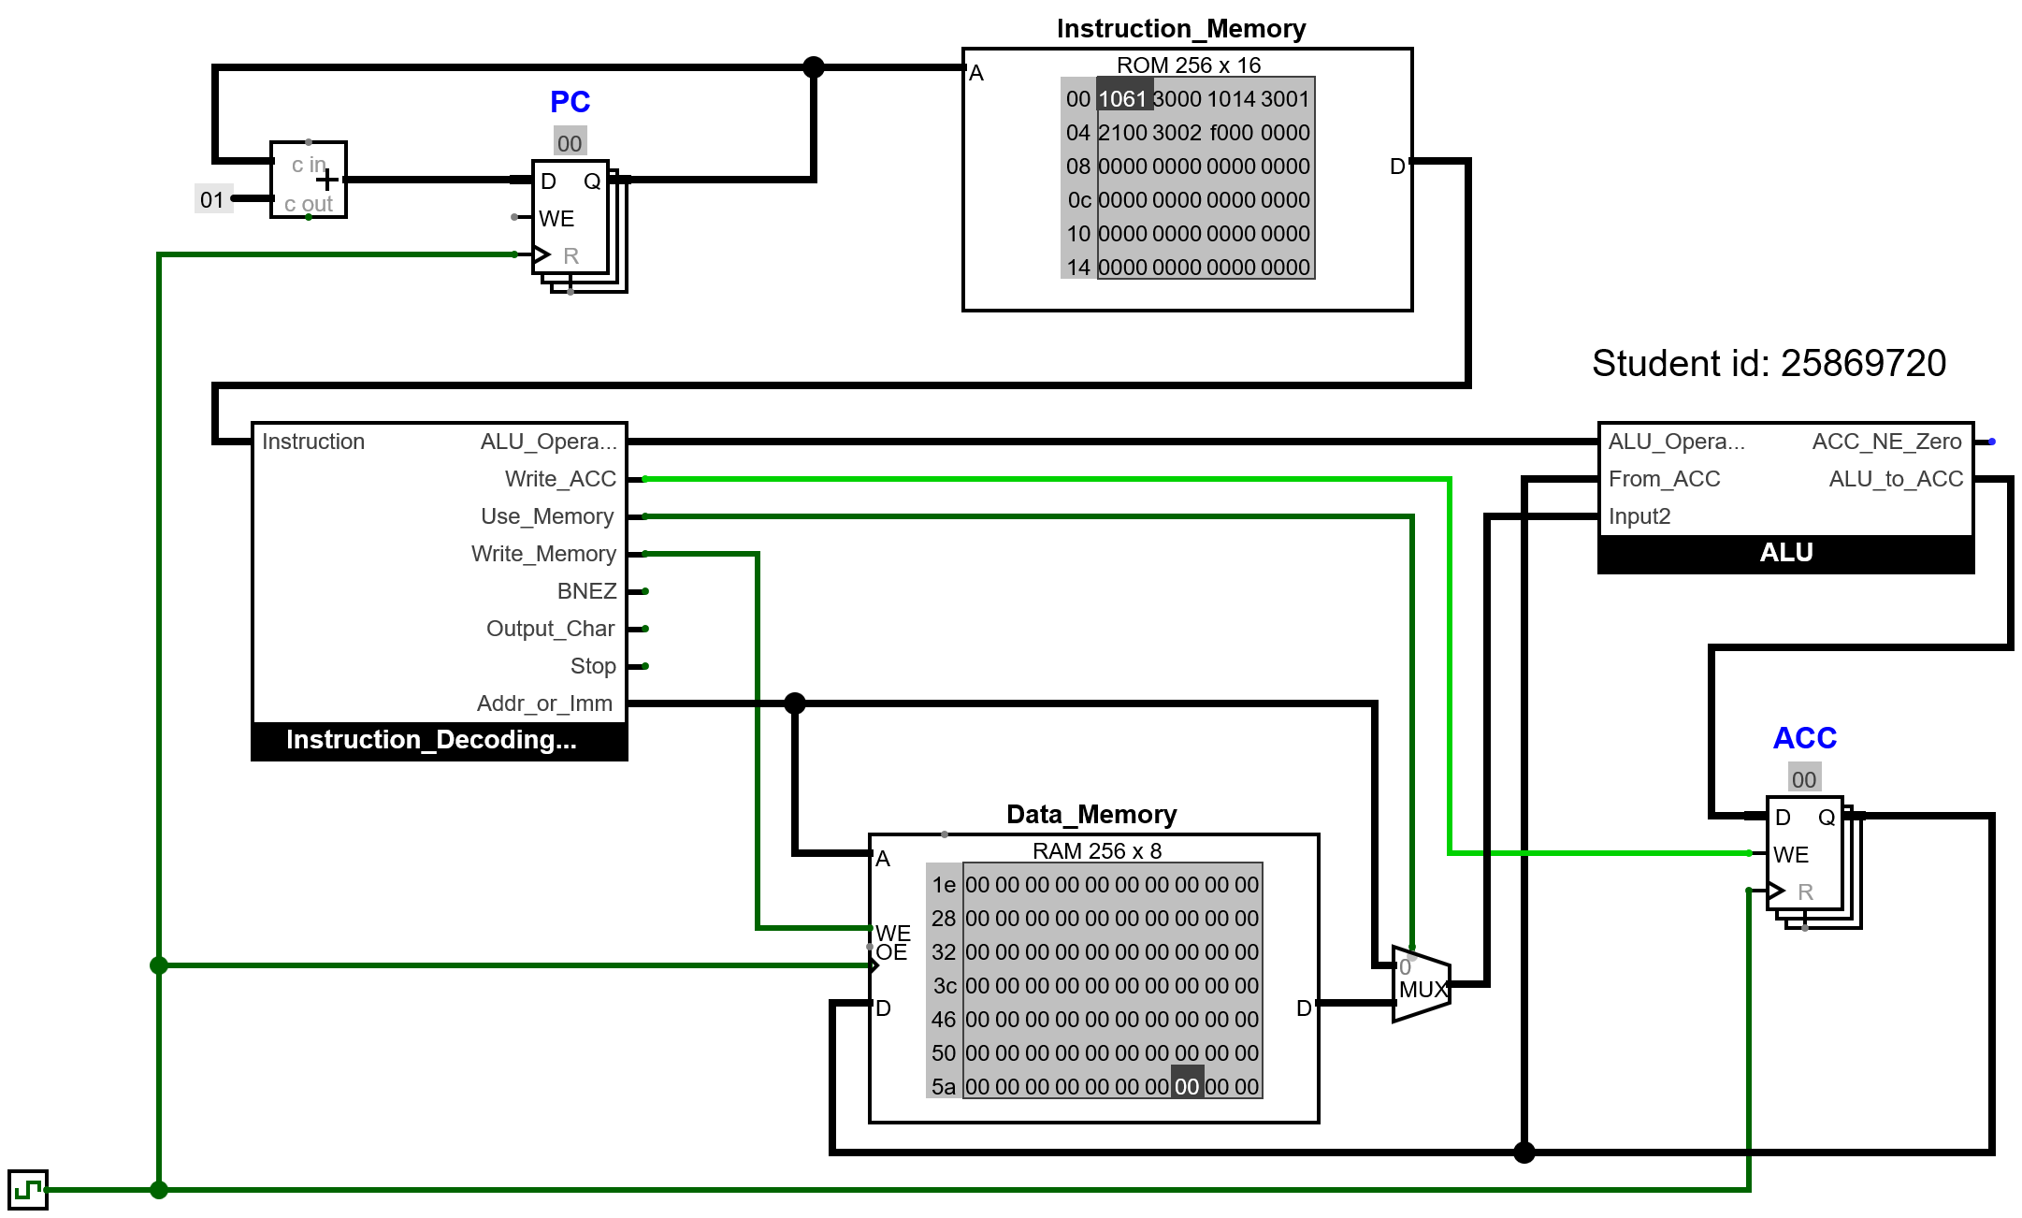

Circuit at end of program
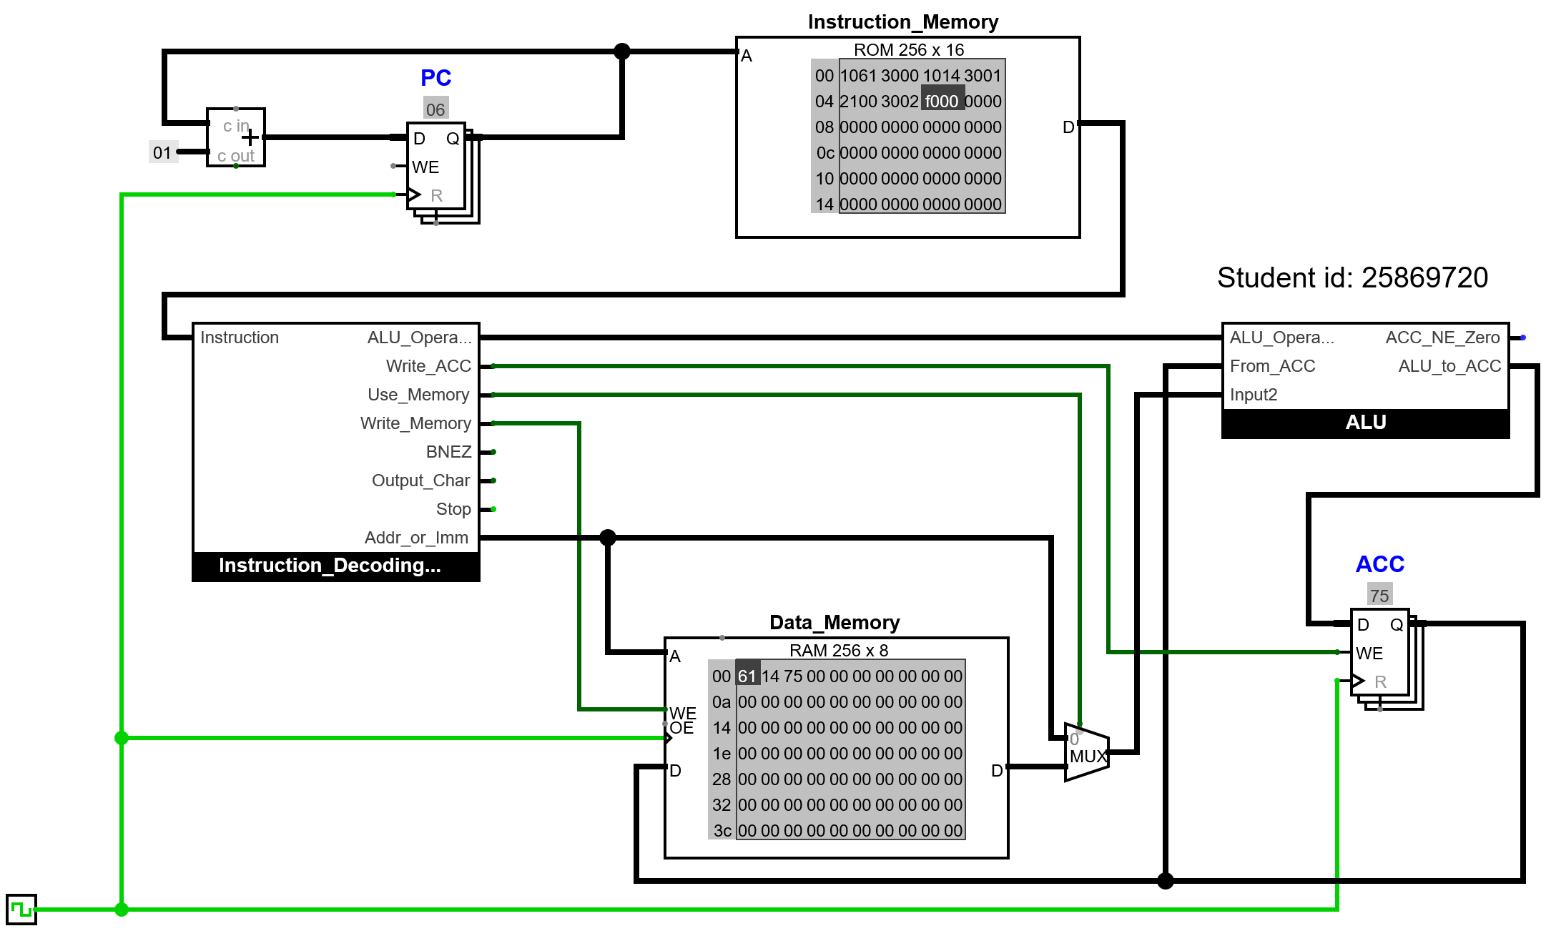

Result
The initial values and the total are in the first three addresses of the data memory.

Completing the stop instruction

Circuit at start of Test 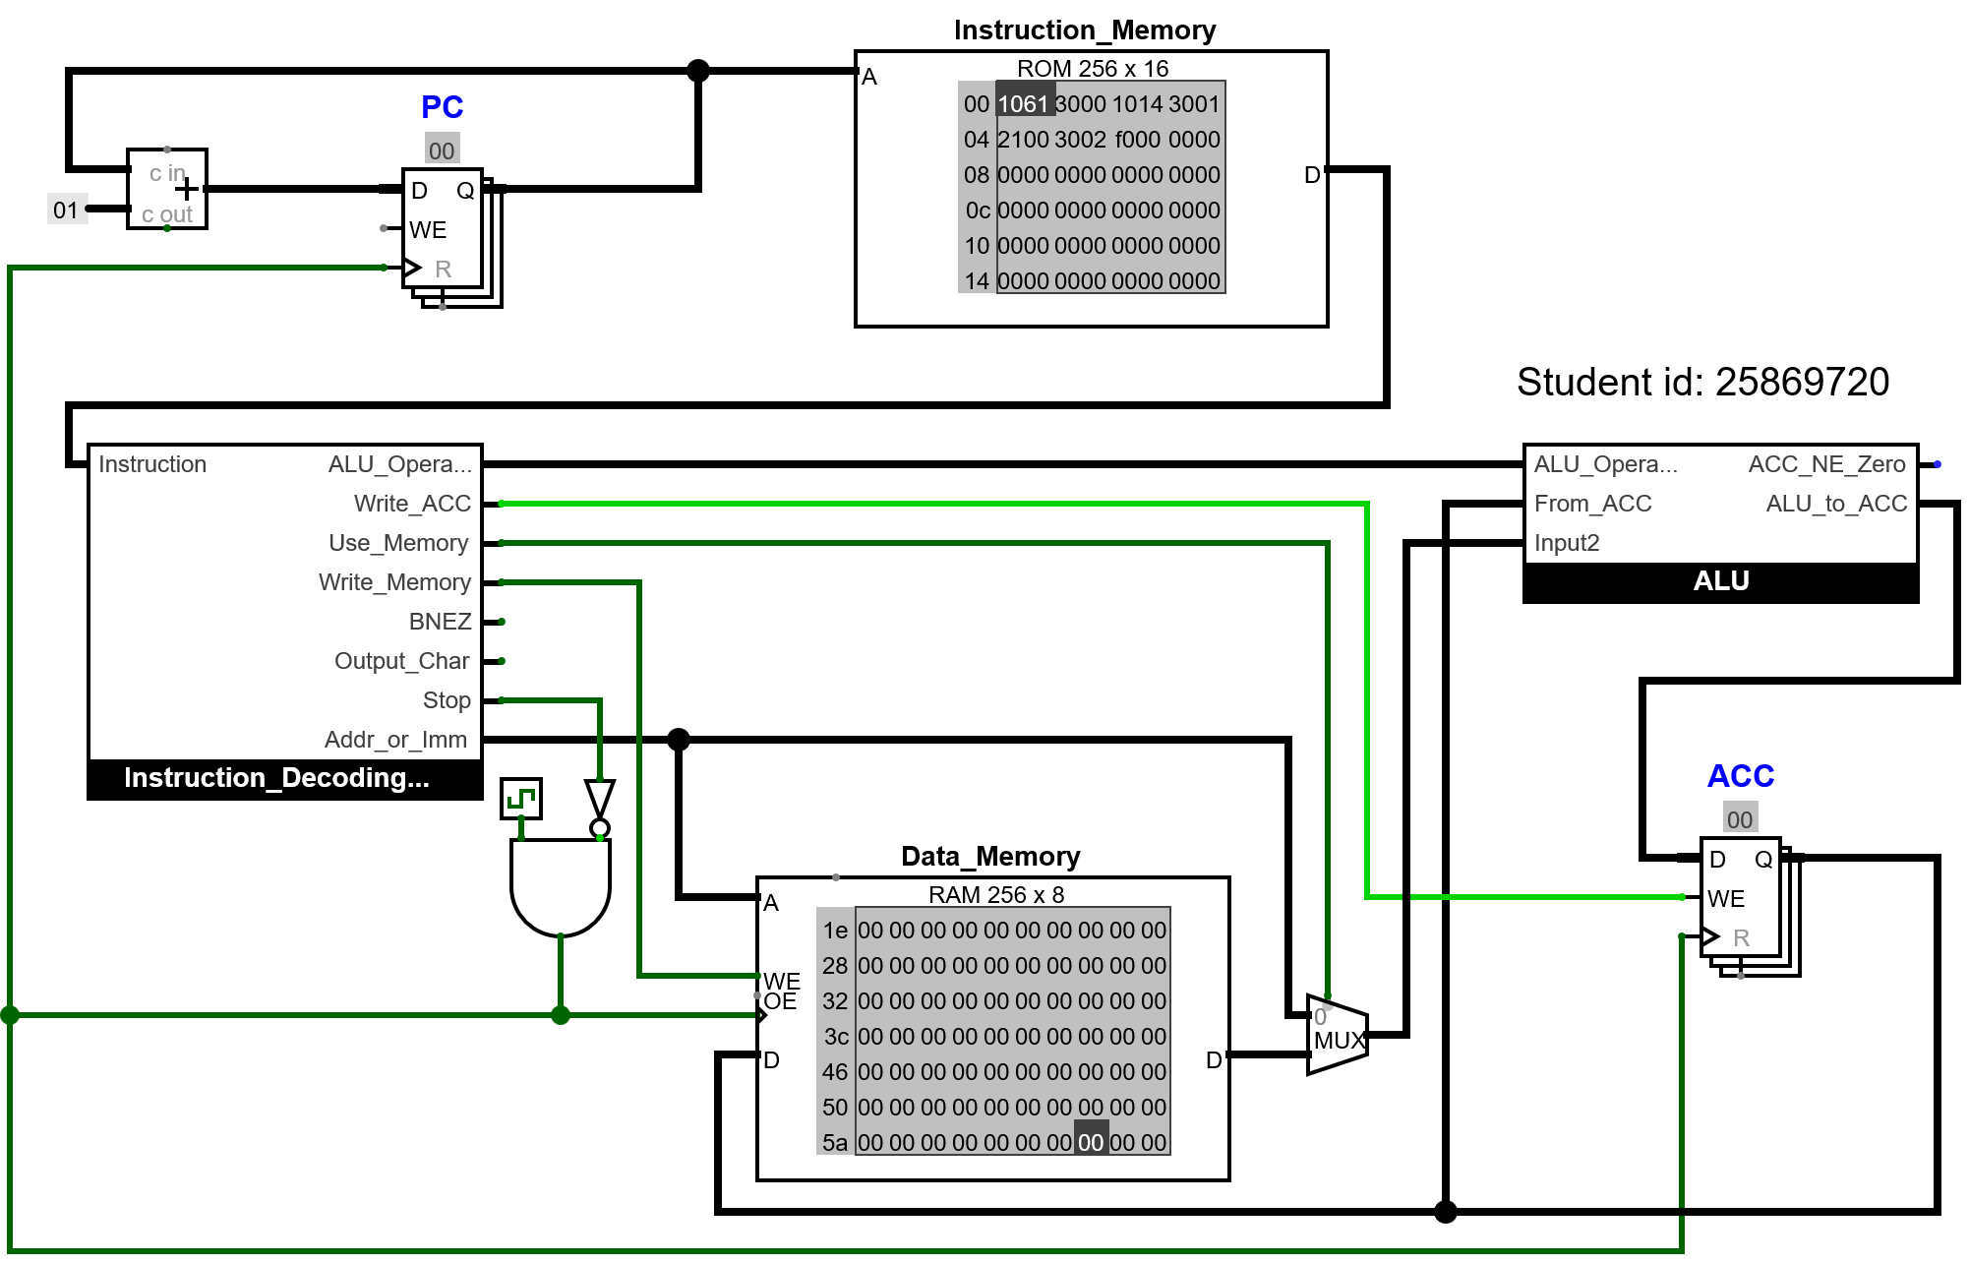

Circuit at end of Test
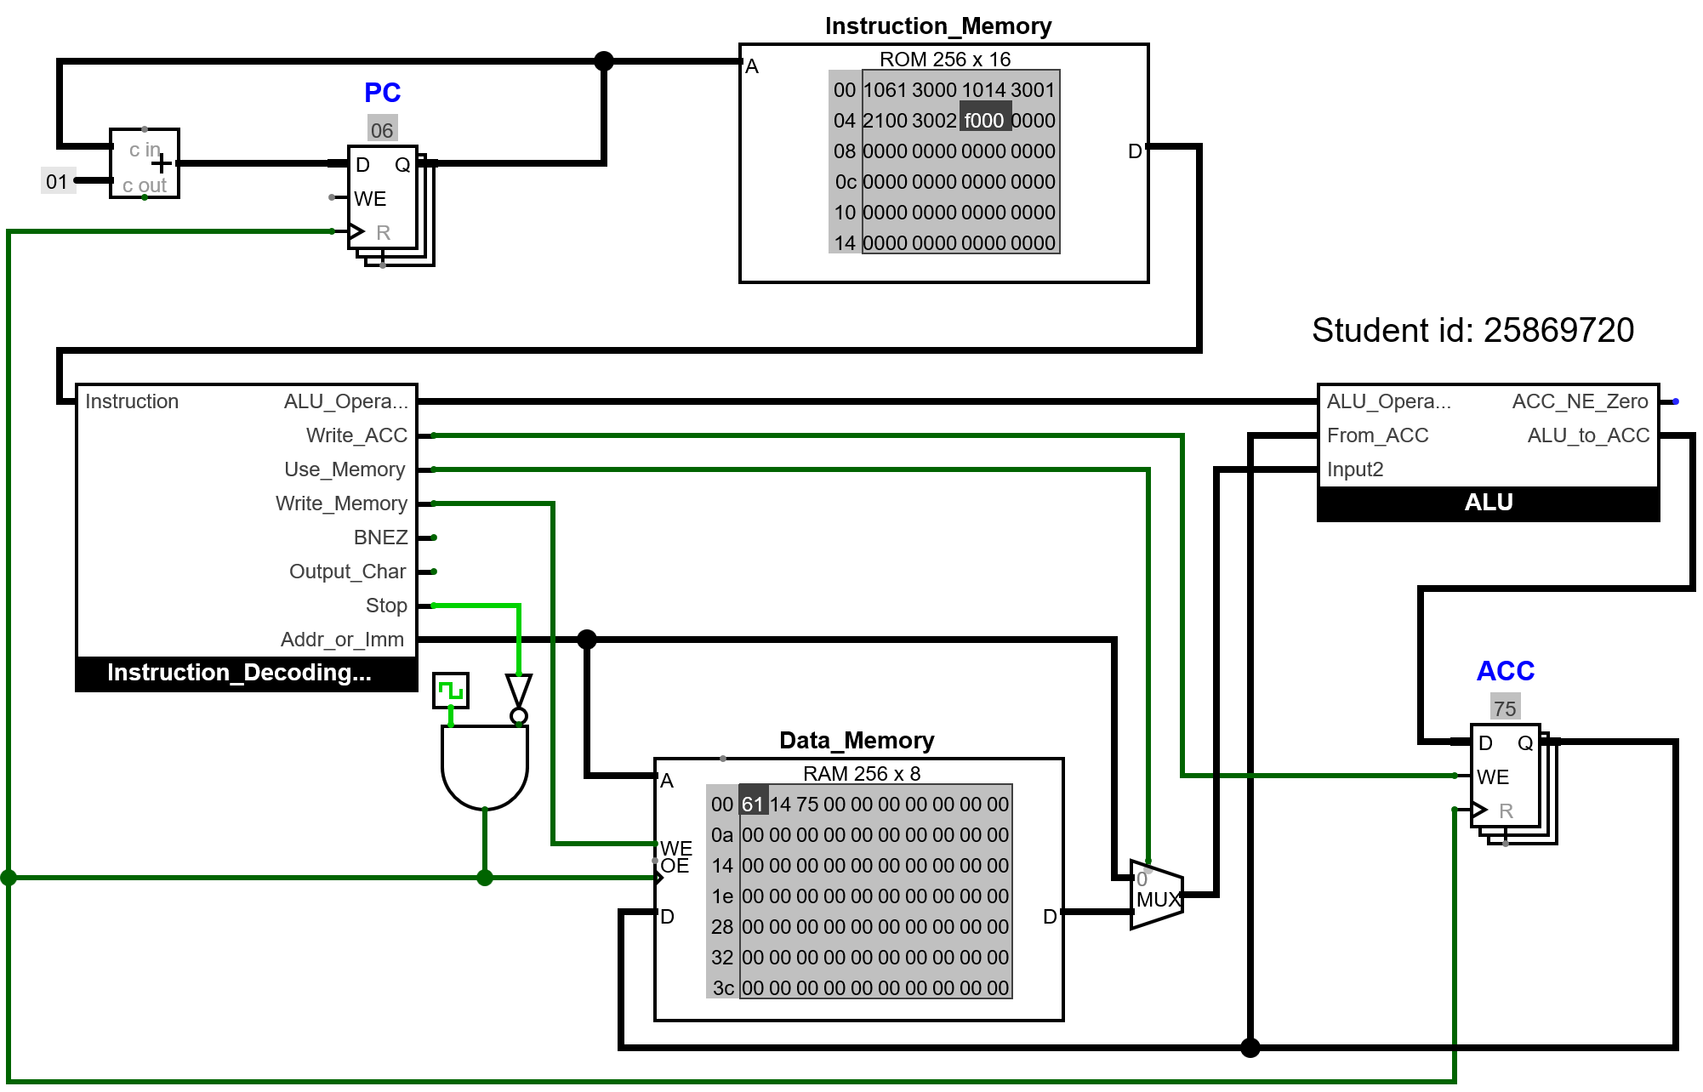

Explanation
The ACC, PC, and Data Memory require a clock signal because it enables them to store and update data in sync with each other.

Bitwise Operations

Test program
v2.0 raw
1061 3000 # 1. put first value to ACC and store to 00
1014 3001 # 2. put second value to ACC and store to 01
2100 # 3. add ACC value to value from address 00
3002 # 4. store ACC value to address 02
2000 2201 # 5. load from 00 to ACC, bitwise NAND with value from 01
3003 # 6. store ACC value to address 03
2000 2301 # 7. load from 00 to ACC, bitwise OR with value from 01
3004 # 8. store ACC value to address 04
f000

Expected result
 | Binary | Hex
First number | 0110 0001 | 61
Second number | 0001 0100 | 14
Bitwise AND of original numbers | 0000 0000 | -
Bitwise NOT of previous result (giving NAND) | 1111 1111 | ff
After bitwise OR of original numbers | 0111 0101 | 75

Circuit at end of program
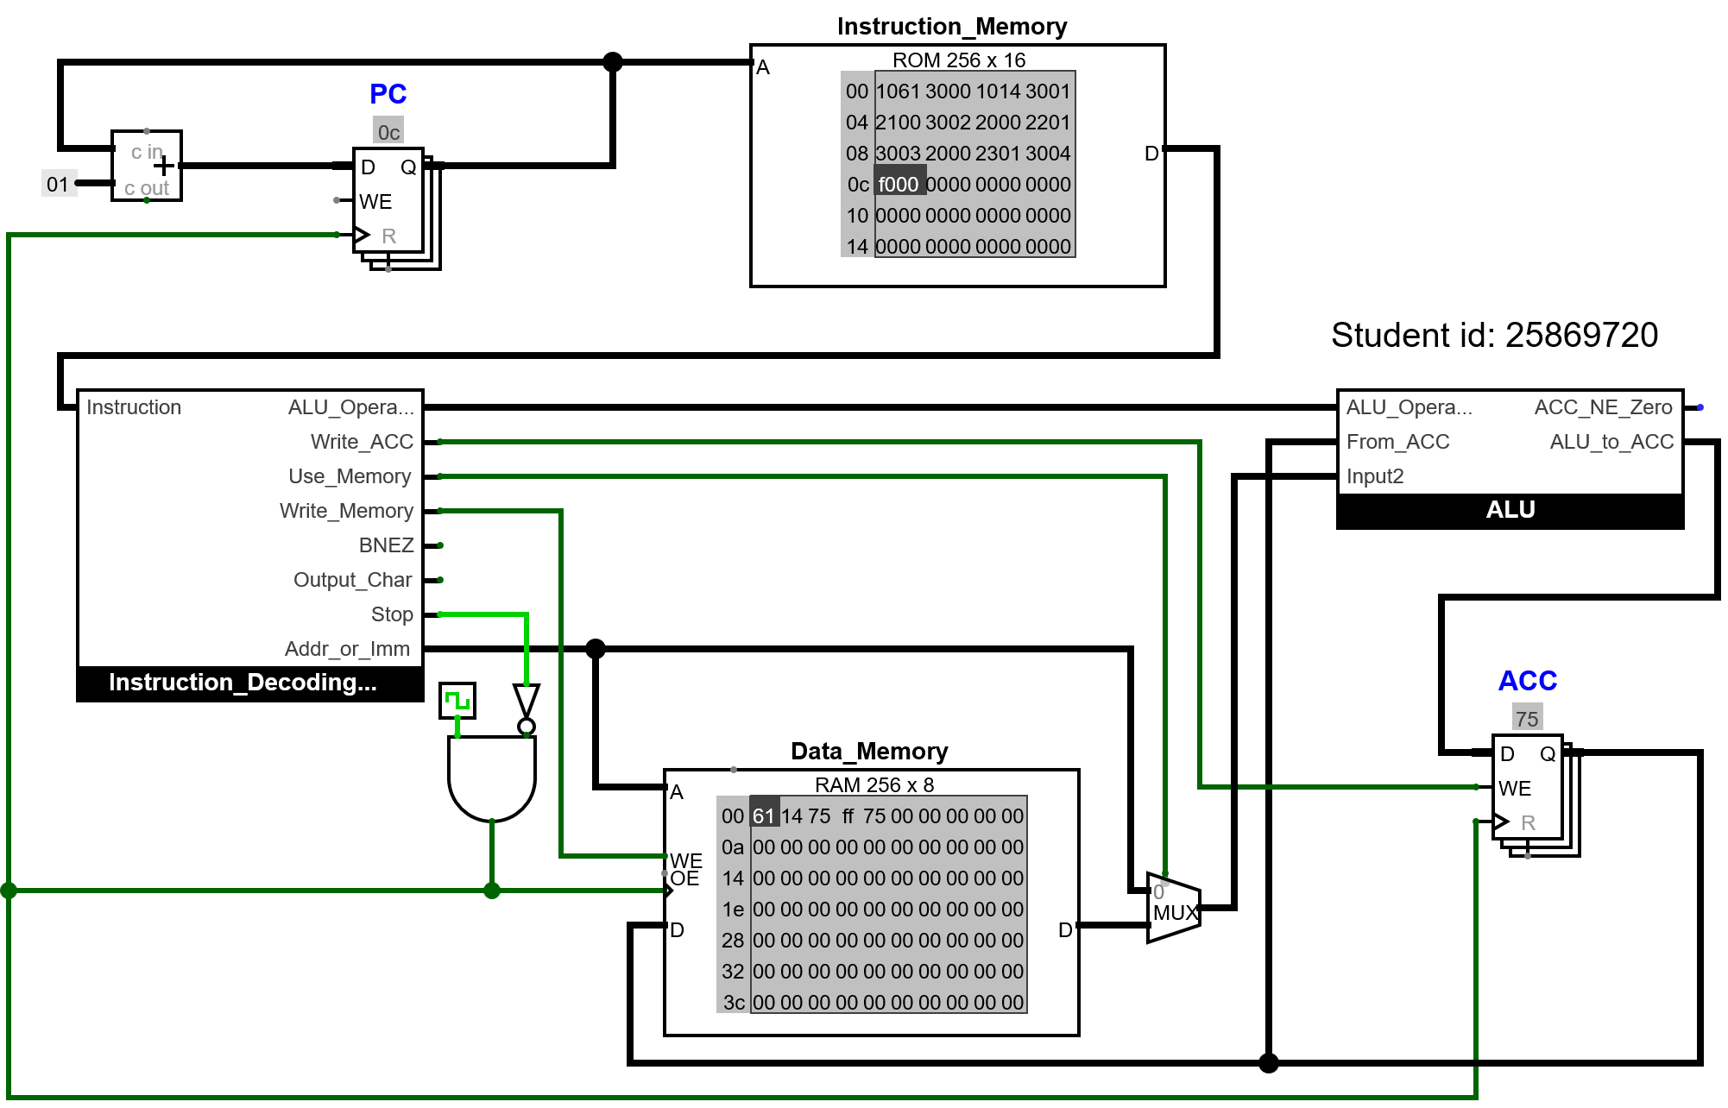

Result
In the data memory, the results stored were the same as the expected results.

Explanation
The instruction decoding unit will read the ALU opcode from the instruction and then pass it to the ALU. The ALU will perform an operation specified by the ALU opcode that was passed. Depending on the opcode, the ALU will perform different operations to output the NAND and the OR instruction.

Amending the ALU

ALU circuit
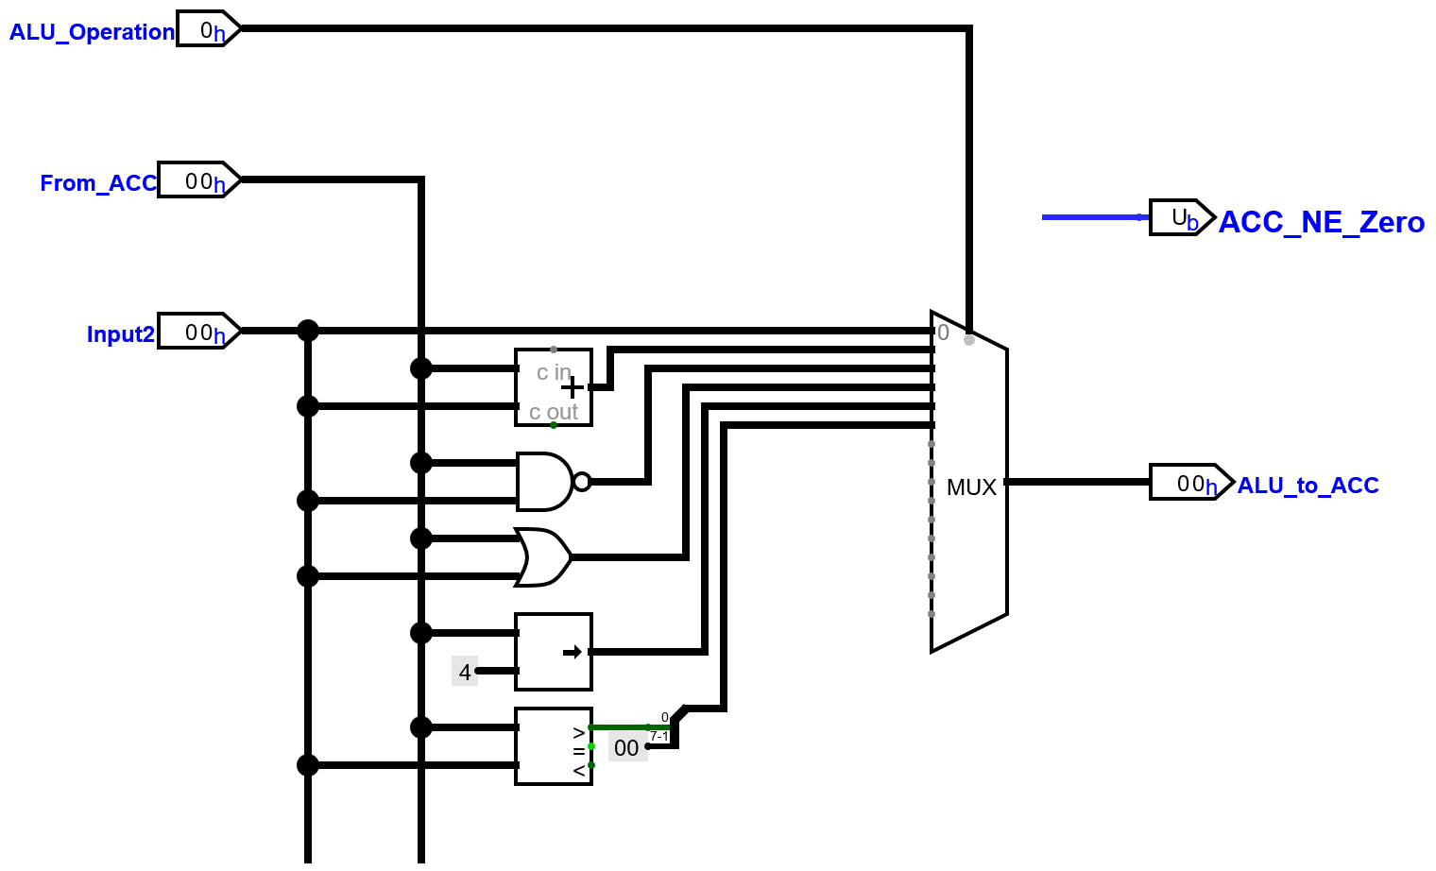

Test Program
v2.0 raw
1061 3000 # 1. put first value to ACC and store to 00
1014 3001 # 2. put second value to ACC and store to 01
2100 # 3. add ACC value to value from address 00
3002 # 4. store ACC value to address 02
2000 2201 # 5. load from 00 to ACC, bitwise NAND with value from 01
3003 # 6. store ACC value to address 03
2000 2301 # 7. load from 00 to ACC, bitwise OR with value from 01
3004 # 8. store ACC value to address 04
2000 2400 # 9. load from 00 to ACC, bitwise right-shift by 4 bits
3005 # 10. store ACC value to address 05
2000 2501 # 11. load from 00 to ACC, and checks if it's greater than the value from 01
3006 # 12. store ACC value to address 06
f000

Expected result
Test description | Value at 00 | Value at 01 | Right shift of first value | Set greater than value
First number smaller | 14 | 61 | 01 | 00
First number bigger | 61 | 14 | 06 | 01
Both numbers the same | 61 | 61 | 06 | 00

The images below are shown in the order they appear in the table above.

Circuit at end of program
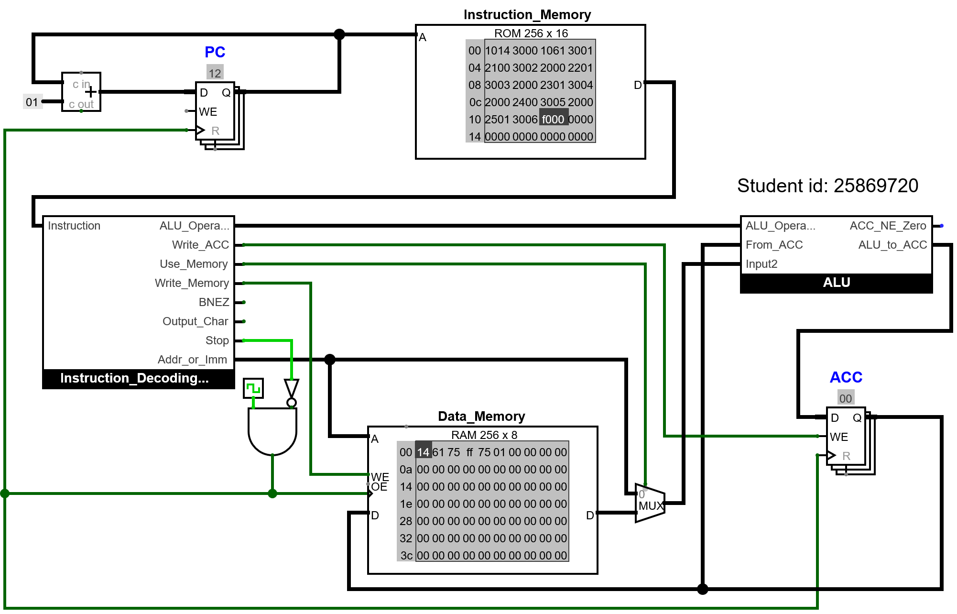

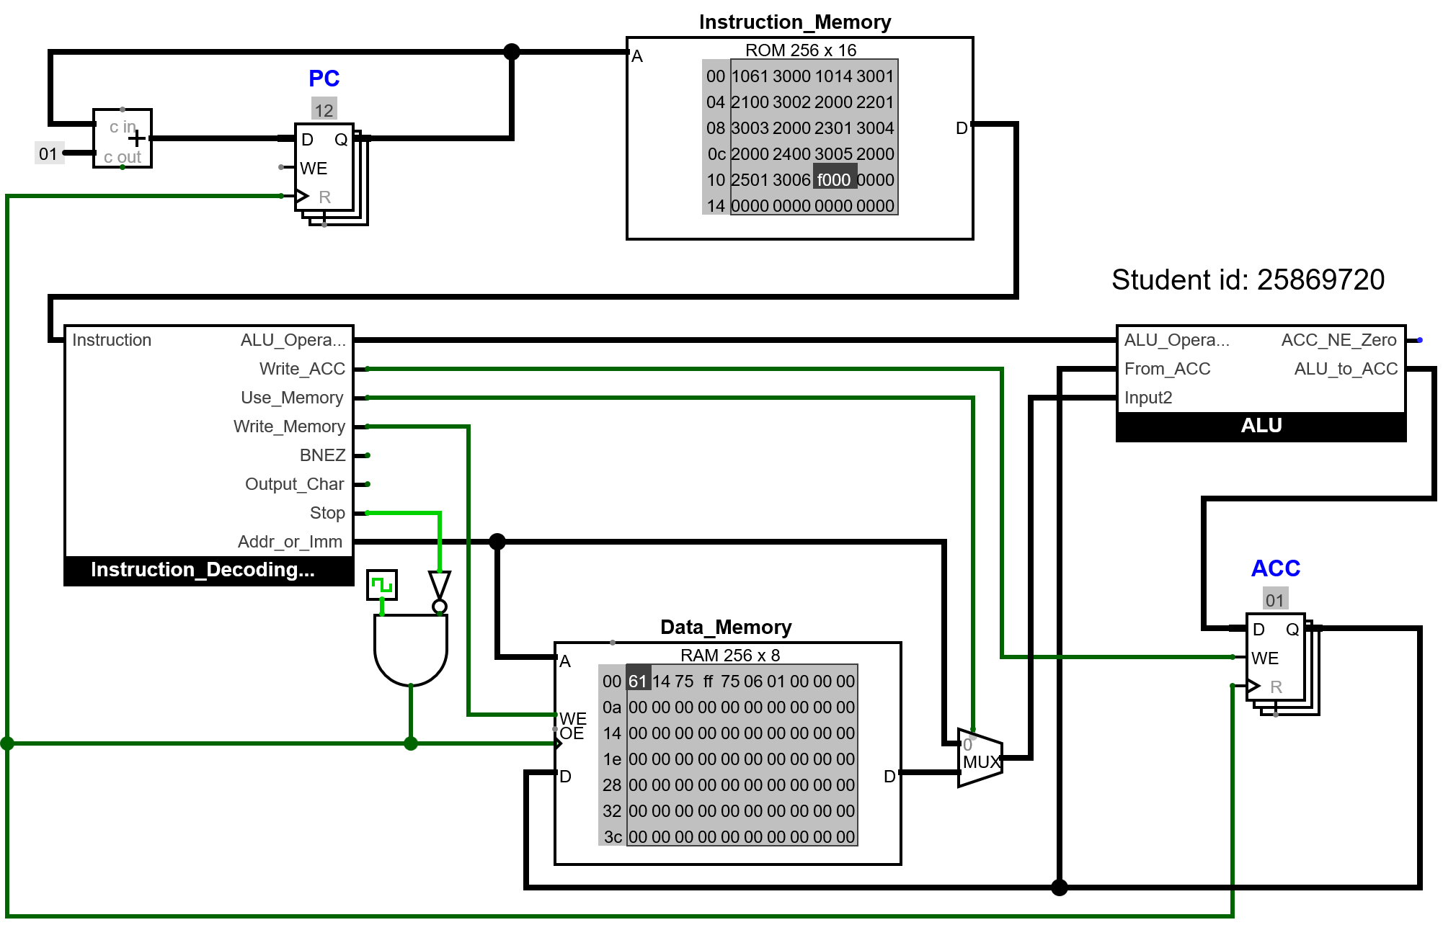

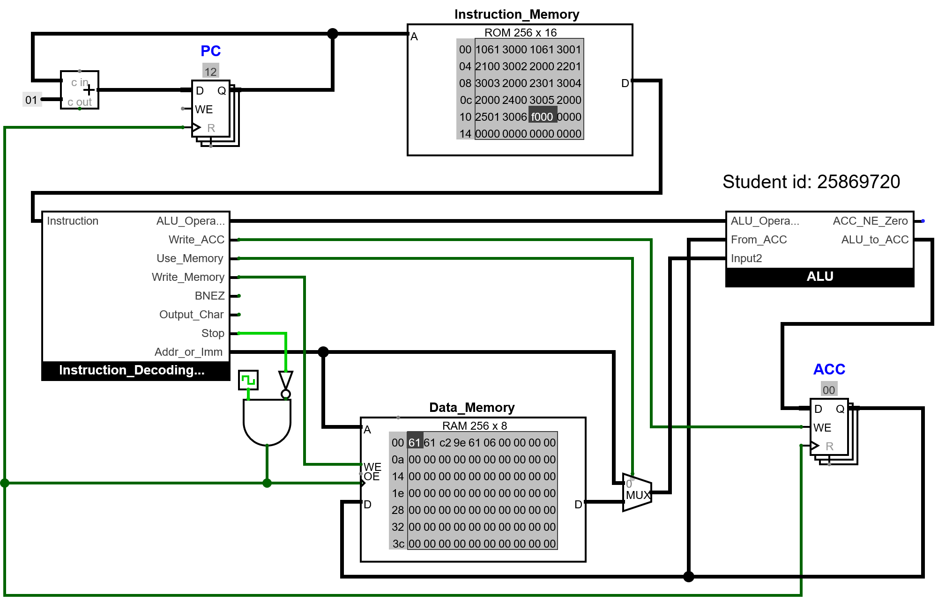

Result
For all three tests, the values stored in the data memory were the same as the values expected in the table.

Explanation
To convert the output from the comparator to 8 bits, a splitter was used to make a new 8-bit value from 1 value by setting the least significant bit to the output of the comparator and then the rest of the values to be a constant 0. This will result in the output always being either 00 or 01. This Solution will not require any research.

Output Device

Test Data and Expected Result
The test data will be 3e 47 72 65 65 74 69 6e 67 73 20 66 72 6f 6d 20 57 6f 6a 63 69 65 63 68 20 31 34 in hexadecimal, and the expected result is that in the TTY, the output should be >Greetings from Wojciech 14.

Test Program
v2.0 raw

#Load all values into memory
103E # loads (>) and store at 00
3000

1047 # loads (G) and store at 01
3001

1072 # loads (r) and store at 02
3002

1065 # loads (e) and store at 03
3003

1065 # loads (e) and store at 04
3004

1074 # loads (t) and store at 05
3005

1069 # loads (i) and store at 06
3006

106E # loads (n) and store at 07
3007

1067 # loads (g) and store at 08
3008

1073 # loads (s) and store at 09
3009

1020 # loads ( ) and store at 0A
300a

1066 # loads (f) and store at 0B
300b

1072 # loads (r) and store at 0C
300c

106F # loads (o) and store at 0D
300d

106D # loads (m) and store at 0E
300e

1020 # loads ( ) and store at 0F
300f

1057 # loads (W) and store at 10
3010

106F # loads (o) and store at 11
3011

106A # loads (j) and store at 12
3012

1063 # loads (c) and store at 13
3013

1069 # loads (i) and store at 14
3014

1065 # loads (e) and store at 15
3015

1063 # loads (c) and store at 16
3016

1068 # loads (h) and store at 17
3017

1020 # loads ( ) and store at 18
3018

1031 # loads (1) and store at 19
3019

1034 # loads (4) and store at 1A
301a

#Read from memory and output to TTY
2000 # loads from 00 and output (>)
5000

2001 # loads from 01 and output (G)
5000

2002 # loads from 02 and output (r)
5000

2003 # loads from 03 and output (e)
5000

2004 # loads from 04 and output (e)
5000

2005 # loads from 05 and output (t)
5000

2006 # loads from 06 and output (i)
5000

2007 # loads from 07 and output (n)
5000

2008 # loads from 08 and output (g)
5000

2009 # loads from 09 and output (s)
5000

200a # loads from 0A and output (space)
5000

200b # loads from 0B and output (f)
5000

200c # loads from 0C and output (r)
5000

200d # loads from 0D and output (o)
5000

200e # loads from 0E and output (m)
5000

200f # loads from 0F and output (space)
5000

2010 # loads from 10 and output (W)
5000

2011 # loads from 11 and output (o)
5000

2012 # loads from 12 and output (j)
5000

2013 # loads from 13 and output (c)
5000

2014 # loads from 14 and output (i)
5000

2015 # loads from 15 and output (e)
5000

2016 # loads from 16 and output (c)
5000

2017 # loads from 17 and output (h)
5000

2018 # loads from 18 and output (space)
5000

2019 # loads from 19 and output (1)
5000

201a # loads from 1A and output (4)
5000

f000 # stop

Circuit at end of program
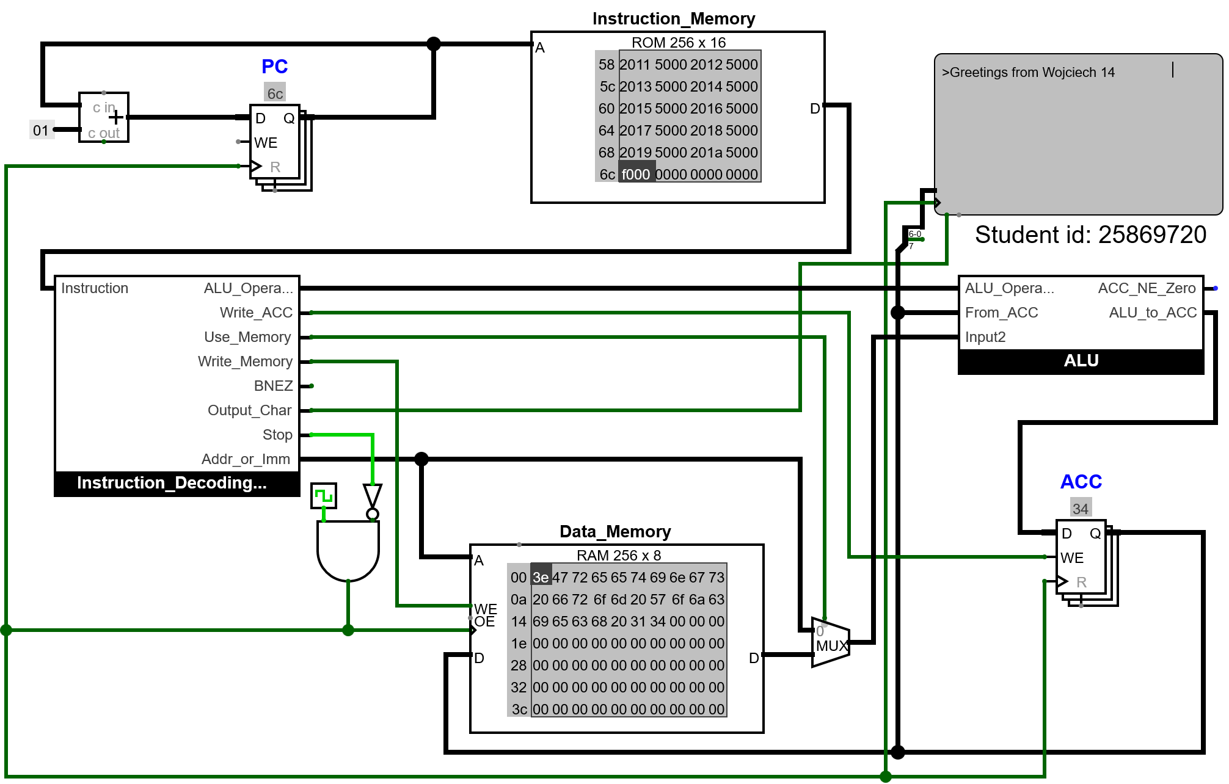

Result
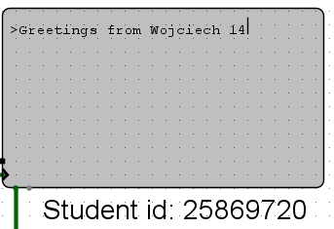
The output as seen in the TTY is the same as my expected result.

Explanation
A limitation of ASCII is that its 7 bits, which means that it can only ever store 128 unique characters, which is not enough to cover all the possible characters, such as symbols or non-English letters. This is why extended ASCII can be used, which uses 8 bits to store characters. This allows for more combinations and allows for a large number of characters to be represented. Research has shown that ASCII is not enough for storing many symbols and letters, and that extended ASCII allows for there to be more characters that can be stored(Webopedia Staff,2021).

Branch instruction

ALU circuit and testing
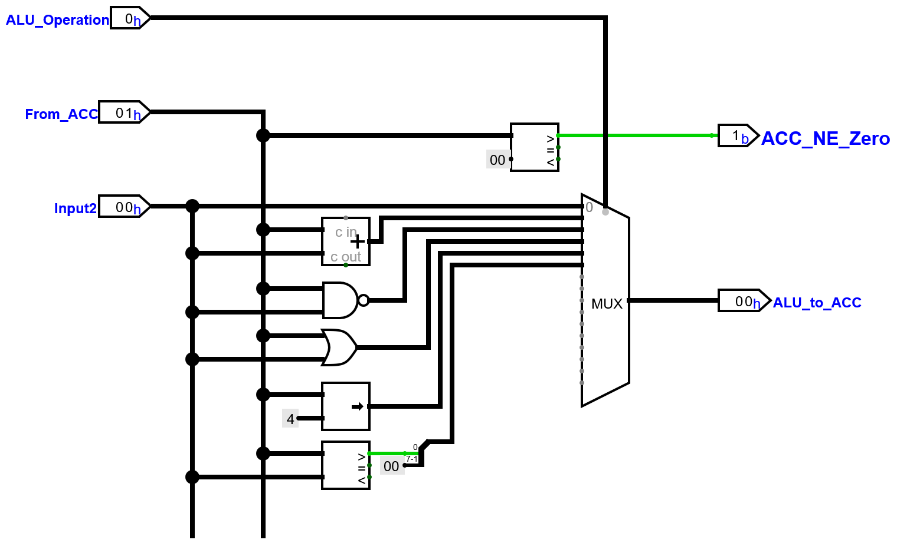
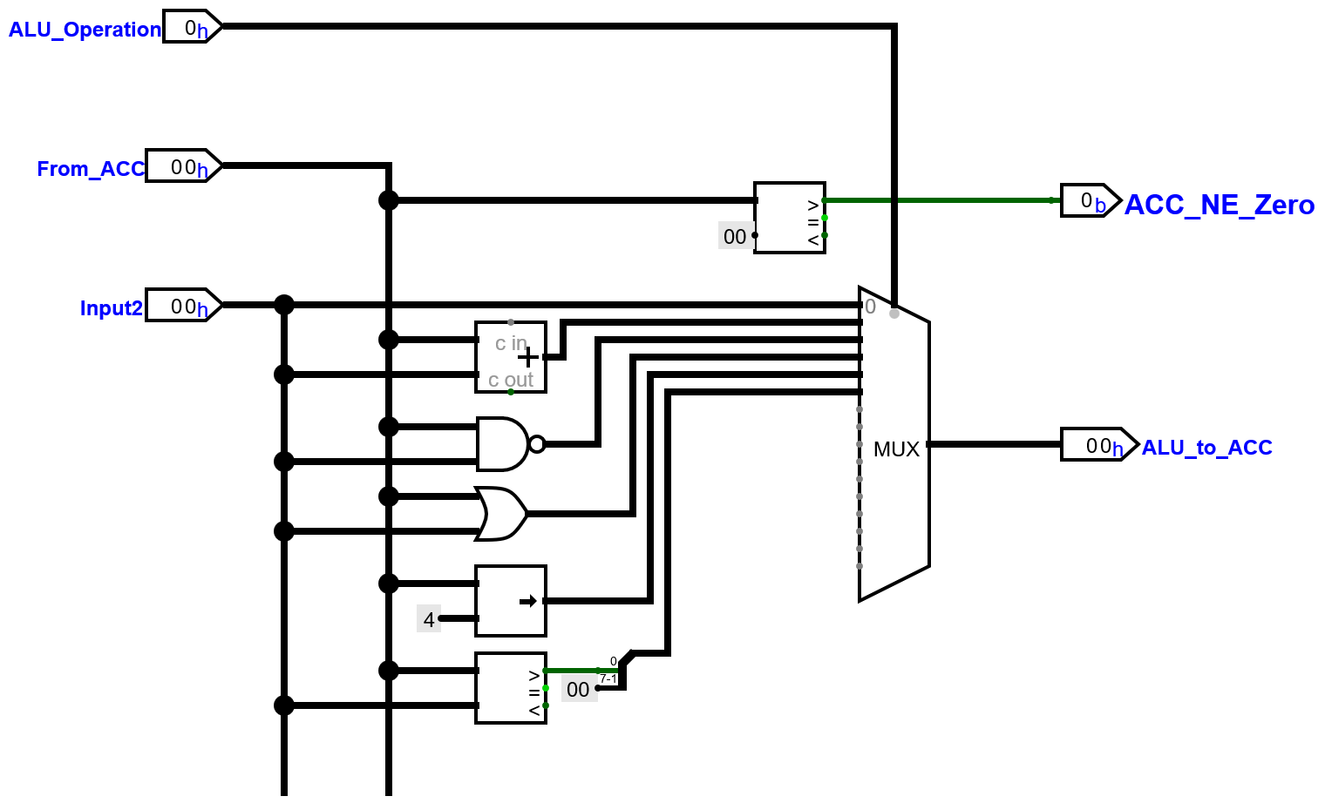
A comparator is used to check if the value from the ACC is greater than the constant 00 value.

Test program
v2.0 raw

1061 3000 # store 14
1014 3001 # store 61

2000 2501 # check if value in the acc is greater than input 2
400f #if so branch to stop condition

2000 3002 # else they will be swapped around
2001 3000
2002 3001
1000 3002

f000 # stop

Expected Results
Test description | Value at 00 | Value at 01 | branched | Address 00 at the end | Address 01 at the end
First number smaller | 14 | 61 | False | 61 | 14
First number bigger | 61 | 14 | True | 61 | 14
Both numbers the same | 61 | 61 | False | 61 | 14

Only when the value in the ACC is greater than the value in input 2 can the CPU branch to the end of the program. If the CPU doesn’t branch, then it will switch around the values in 00 and 01 by using 02 as a temporary address to store one of the values, then move the other.

The images below are shown in the order they appear in the table above.

Results
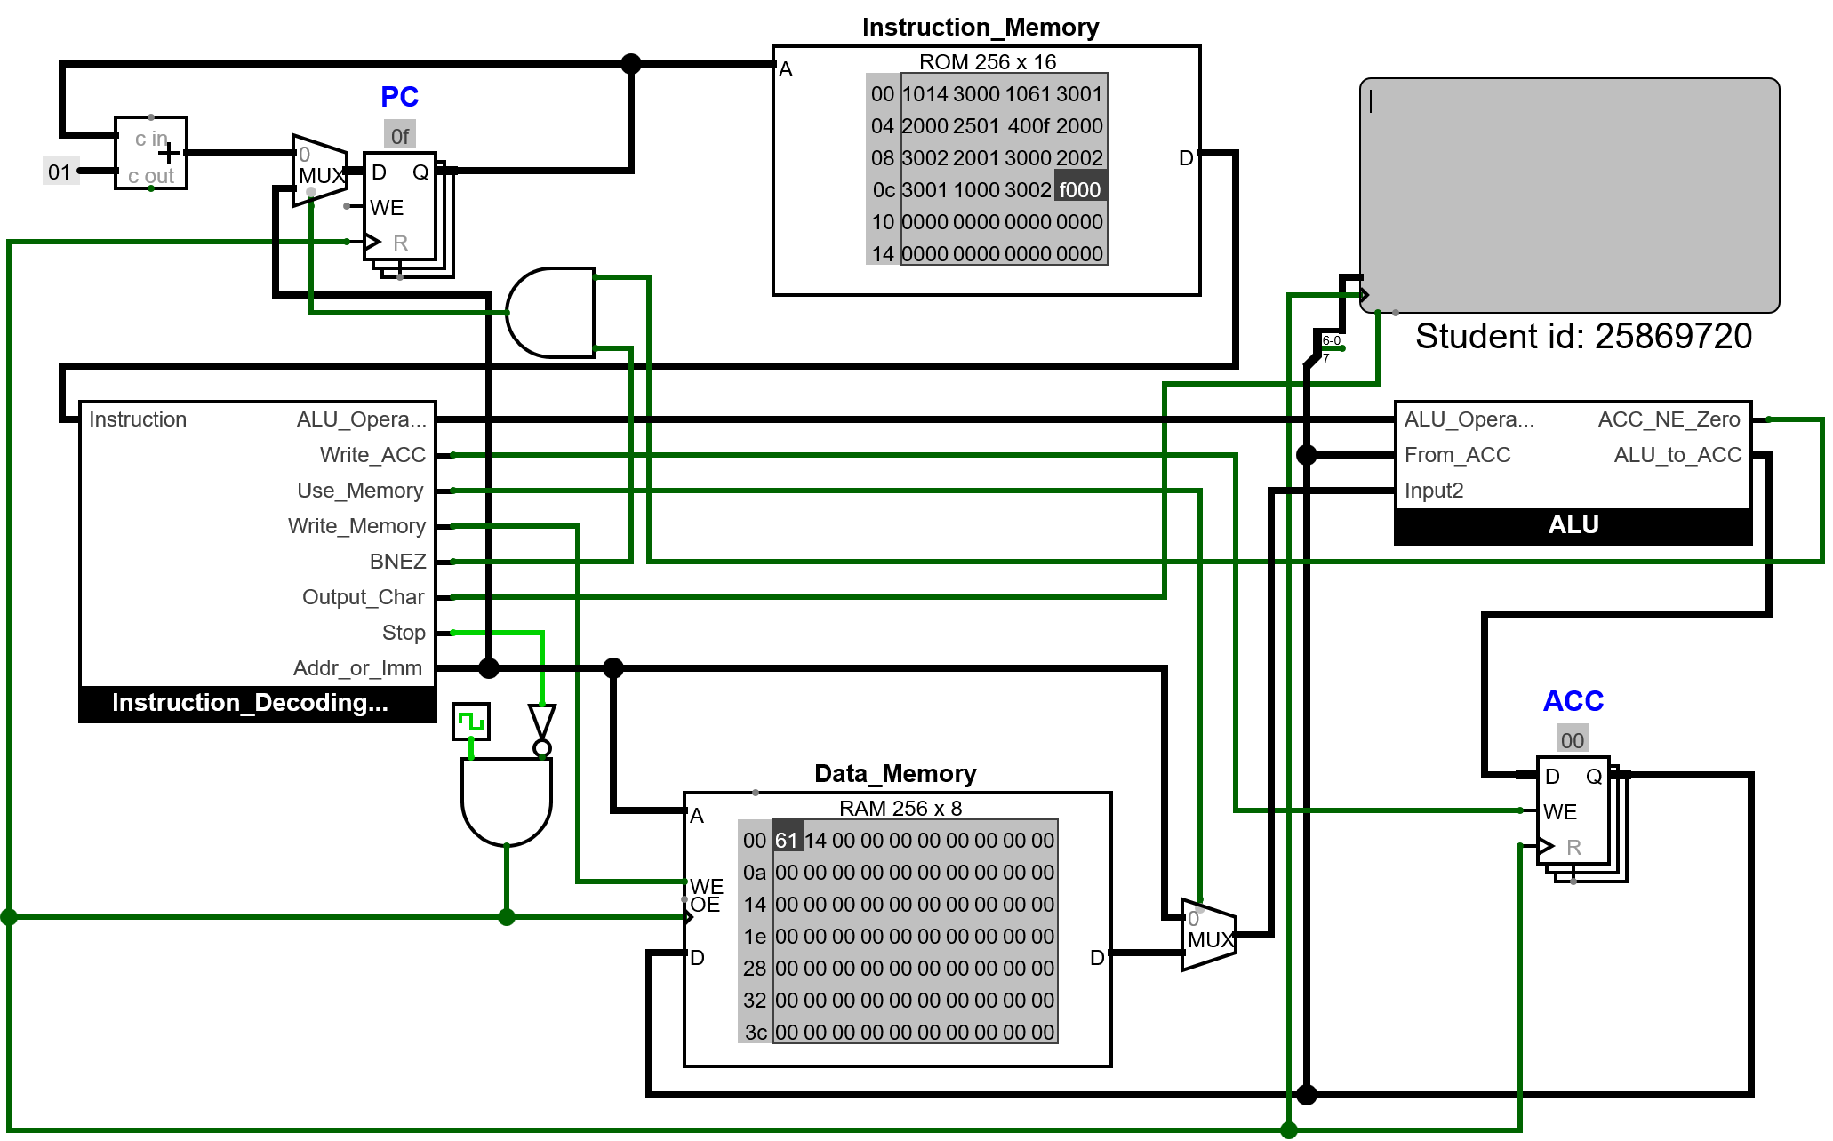
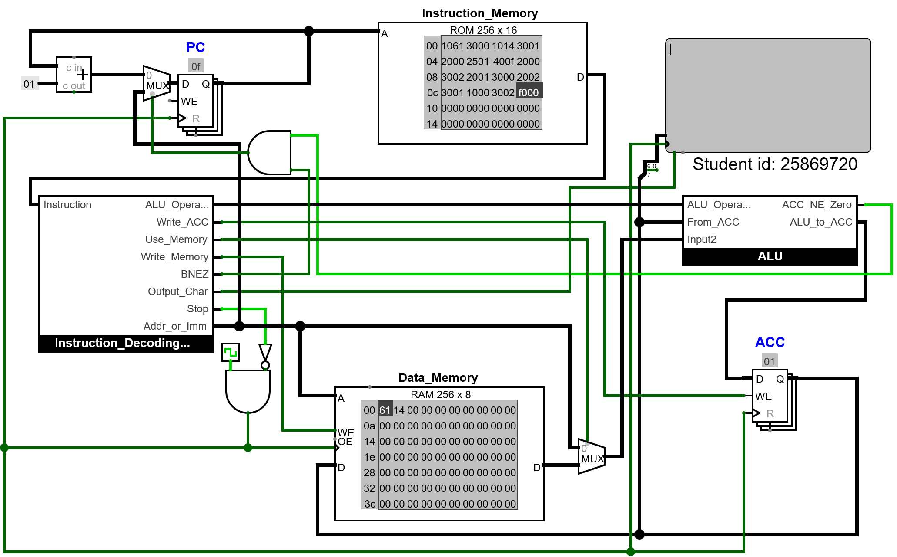
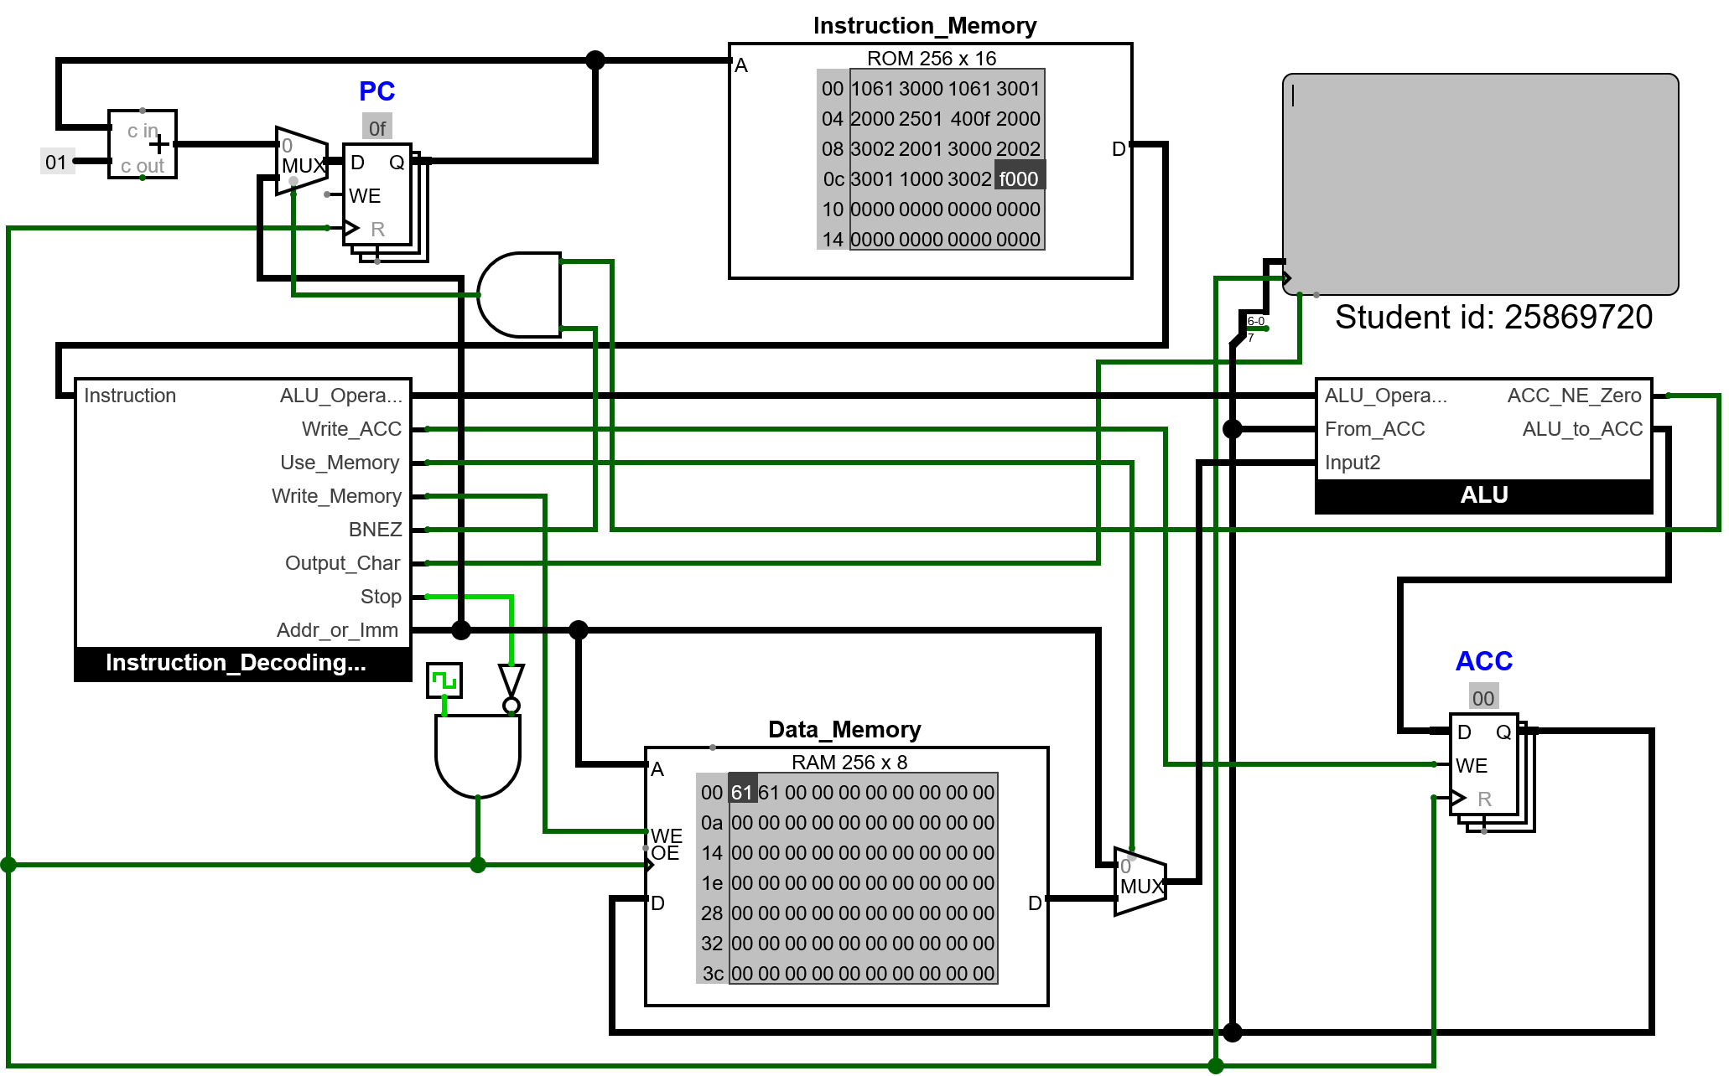

Explanation
To make the branching possible the pc will now receive a multiplexer to the data pin and if the input is 0 program will just make the data the previous value and +1 however if the program branch it will first check with an AND gate to see if it should branch it will happen when BNEZ is the CPU operation and when the ACC is not equal to zero if both of these are true then the program will set the value of the multiplexer to 1 and it will now set the value of the pc to be the immediate value in the branch instruction to allow the program to branch to that address. Another possible way of branching would be BRA. This would always branch, no matter what the value in the ACC. This can be achieved by having another output pin from the ALU that would be a constant 1, as it would always branch, and then that constant would go into an AND gate with the BRA pin from the instruction decoding unit. Research has helped me understand that there are different possible ways to branch other than just when the value in the ACC is not equal to zero (CSNewbs, 2025).
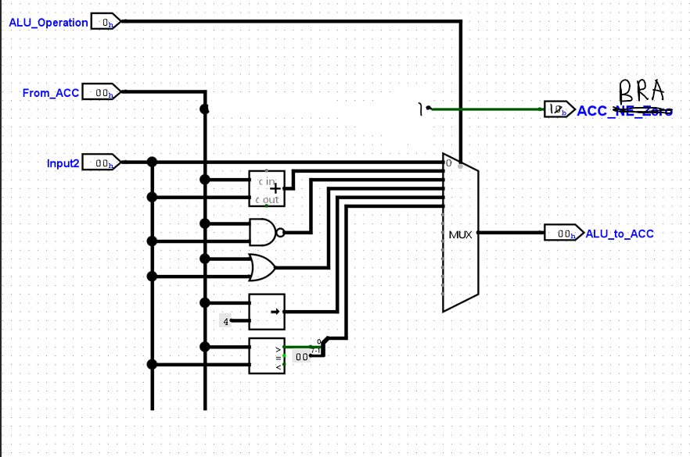

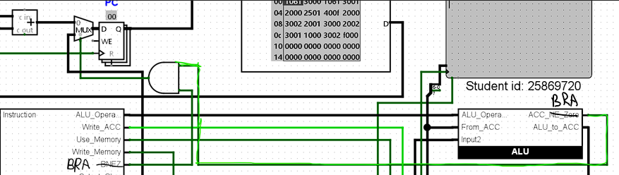

Loop

Displaying Hex Output
In my research, I found that if a hex digit is 0-9, to get the ASCII equivalent of that digit, you add 0x30, but if it's equal to a or a-f, then you add 0x37 to get the ASCII equivalent (Rollins, 2009). The research helped me understand how I can simply convert a digit into ASCII, as this is something that I was unable to do, as I did not know how to do it. I did not explore alternative approaches, as this method was the most direct and could be implemented easily.

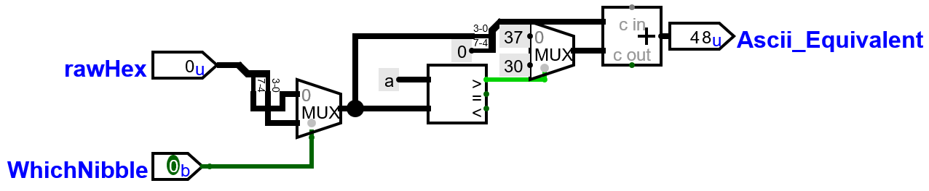

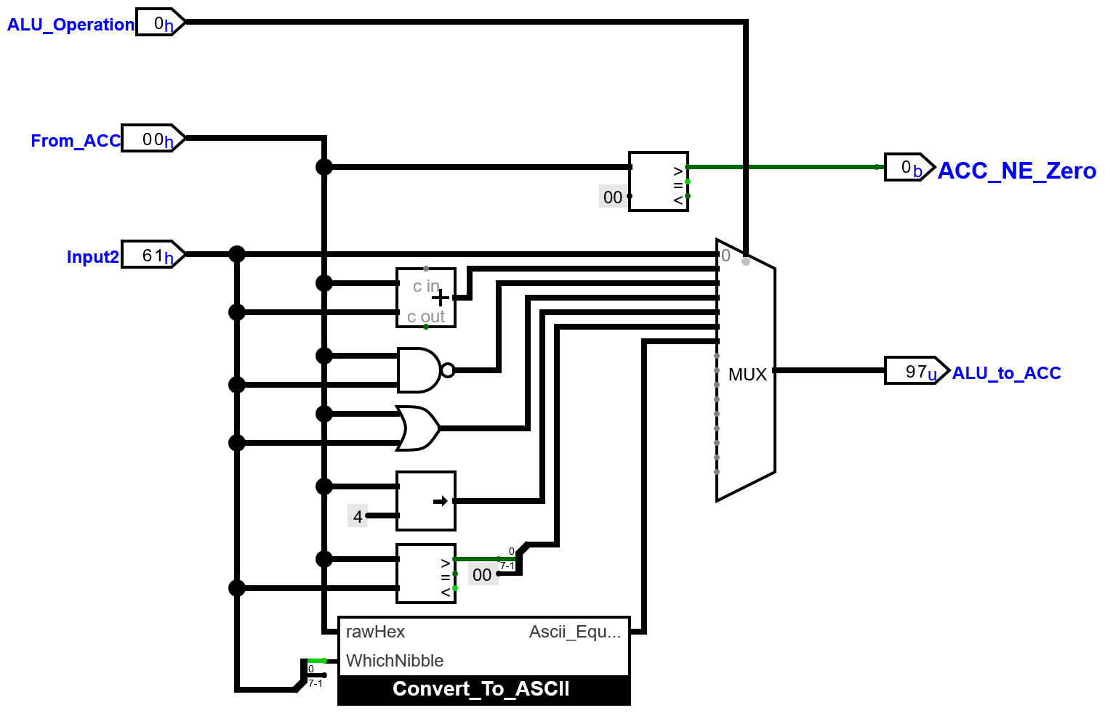

Test program

v2.0 raw

1061 1600 5000 # load 61 get the ascci value of 6 and output it to tty
1061 1601 5000 # load 61 get the ascci value of 1 and output it to tty

1014 1600 5000 # load 14 get the ascci value of 1 and output it to tty
1014 1601 5000 # load 14 get the ascci value of 4 and output it to tty

f000 # stop

Expected results
output to TTY:6114

Outcome

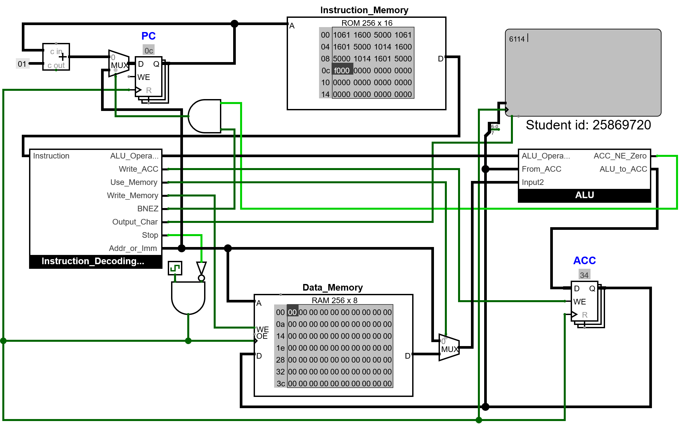
Result

the value outputted to the TTY was the same as the expected value, and therefore it works.

Running Loop
Code

v2.0 raw
1061 3000 # store 14
1014 3001 # store 61
2000 2501 # check if value in the acc is greater than input 2
400f #if so branch to loop

2000 3002 # else they will be swapped around so that they are in order in memory
2001 3000
2002 3001
1000 3002

# start loop

2000 1600 5000 #load 00 to acc convert the last nibbles to ascii and output to tty 0f
2000 1601 5000 #load 00 to acc convert the first nibbles to ascii and output to tty

1020 5000 #add a space to tty X020 = " "

2000 11ff #load 00 to acc add -1 and store to address 00
3000

2000 2501 #load 00 then load 01 and check if 00 is greater than 01
400f # end of loop if the value is not equal 0 it branches back to the beginning and loop again

2000 1600 5000 #add a space load 00 and output it to tty
2000 1601 5000 #add a space load 00 and output it to tty
1020 5000

f000 # stop

Test description | Value at 00 | Value at 01 | Swapped | Address 00 at the end | Address 01 at the end
First number smaller | 14 | 61 | True | 14 | 14
First number bigger | 61 | 14 | False | 14 | 14
Both numbers the same | 61 | 61 | True | 60 | 61

The images below are shown in the order they appear in the table above.

The appearance of instruction memory was changed to Logisim-Evolution to allow the instructions at the start of the program to be visible.

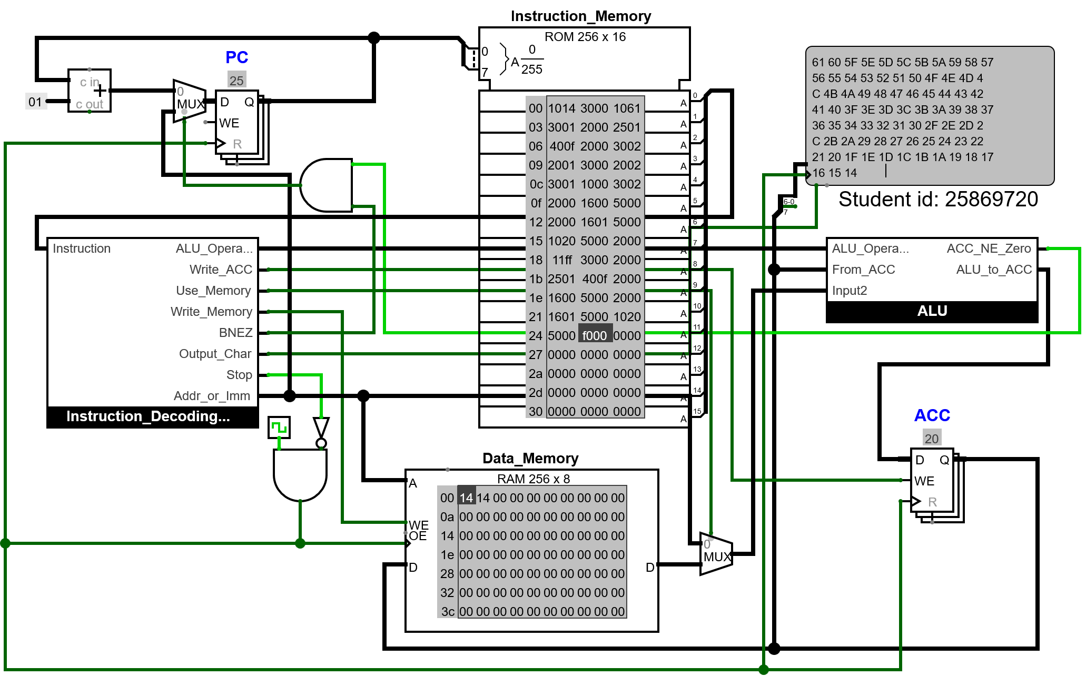

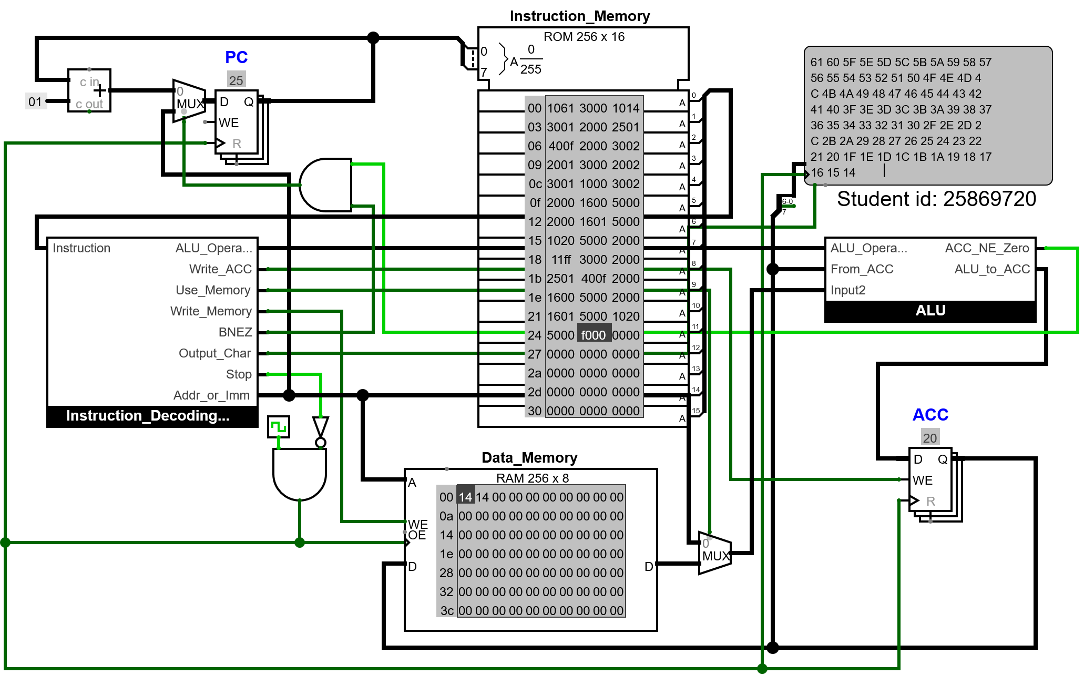

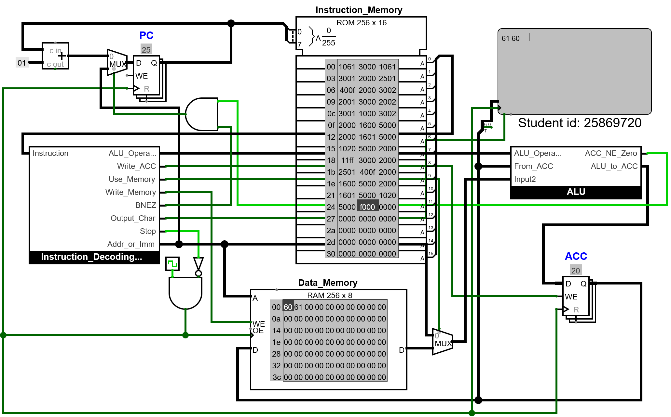

The result is the same as expected.

Explanation
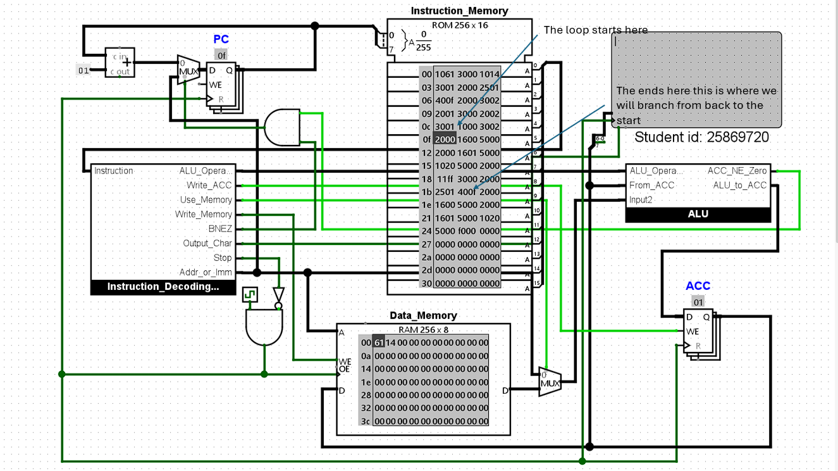
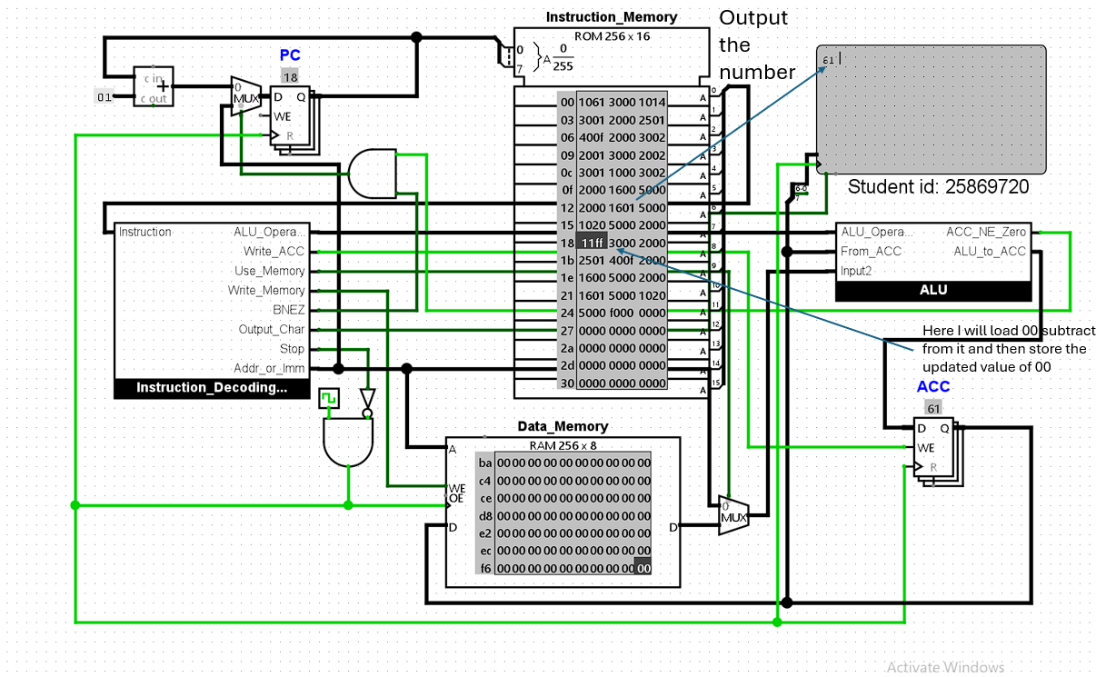
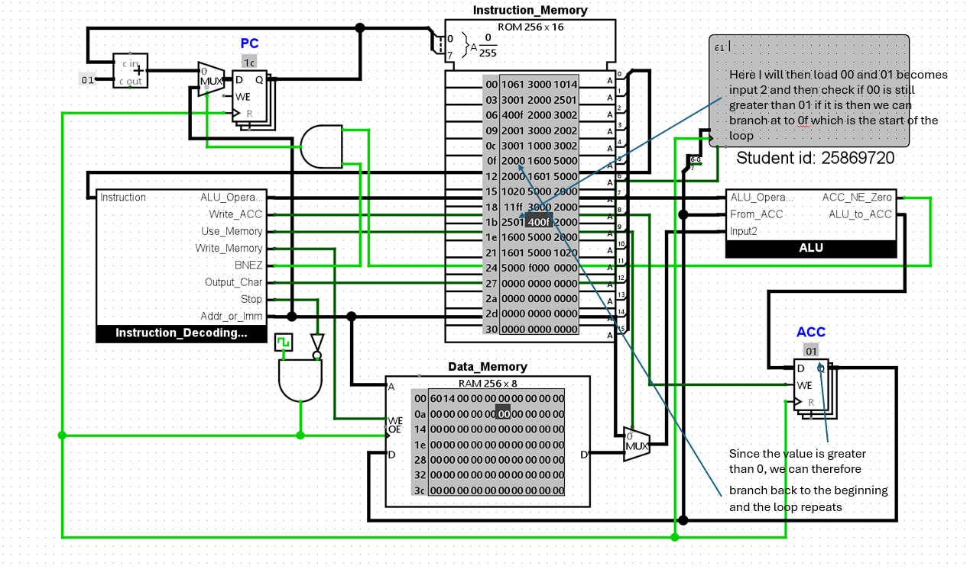

When the numbers are the same, the loop is only entered once, as at the end, when the program does the check to see if 00 is greater than 01, that will be false, therefore the program will not branch and just move along to the next instruction. When this happens, an error occurs. This is because the loop will never loop. After all, the numbers are the same, so 1 can't be bigger than the other, and therefore it will just move onto the next line. I did not do any additional research to get to this conclusion.

Game

The game I will be making is higher or lower. At the start of the game, two random values are generated. One of the values is shown to the player via the TTY. The player has inputs if the value shown is lower than or equal to the value not shown or higher than it, using a button. If the player guesses correctly, they move on, and the value hidden will now be shown, and a new value will be generated, and the game continues until the player guesses incorrectly.

The first thing that needs to be done is to allow the ALU to generate a random number by adding more circuitry to it.
the program will be using the random generator in Logisim to generate the random numbers. I was unsure how to use it, so I used a YouTube tutorial to help me understand how I can generate the random numbers using the random generator (Nelson Darwin Pak Tech 2021).

The ALU was adjusted to allow it to generate random numbers by adding a random generator from wiring components to the multiplexer. This component also requires the clock, which is why the ALU will now also take in a clock pin.

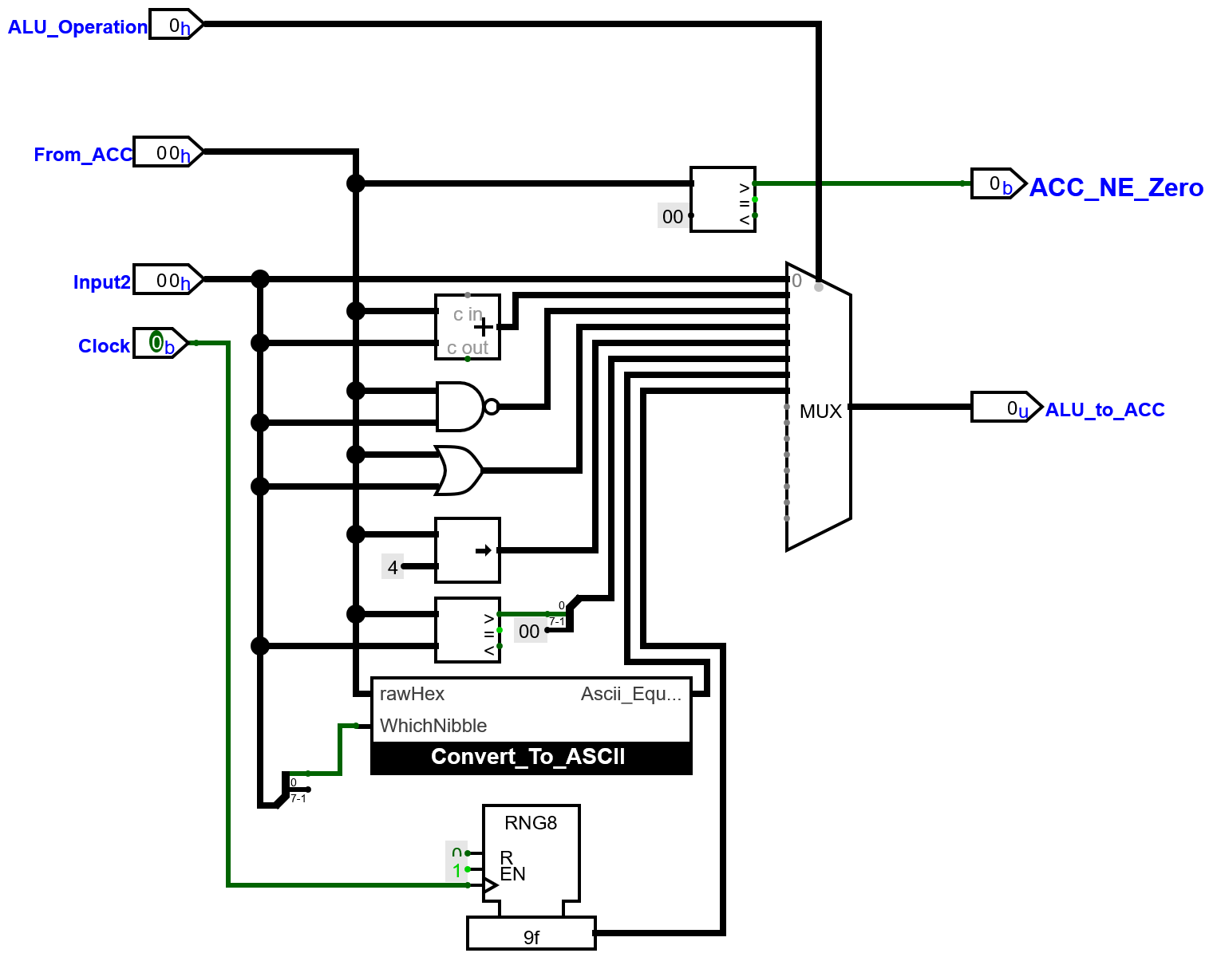

A test will be done to see if it works by writing a simple program that will generate three random numbers and store them in memory.

v2.0 raw
1700 3000 # generate a random number and store it at 00
1700 3001 # generate a random number and store it at 01
1700 3002 # generate a random number and store it at 02
f000 # stop

two images will be added to show that the numbers generated are random and not predetermined in the instructions.

Expected result: all 3 generated numbers should be random.

Result:

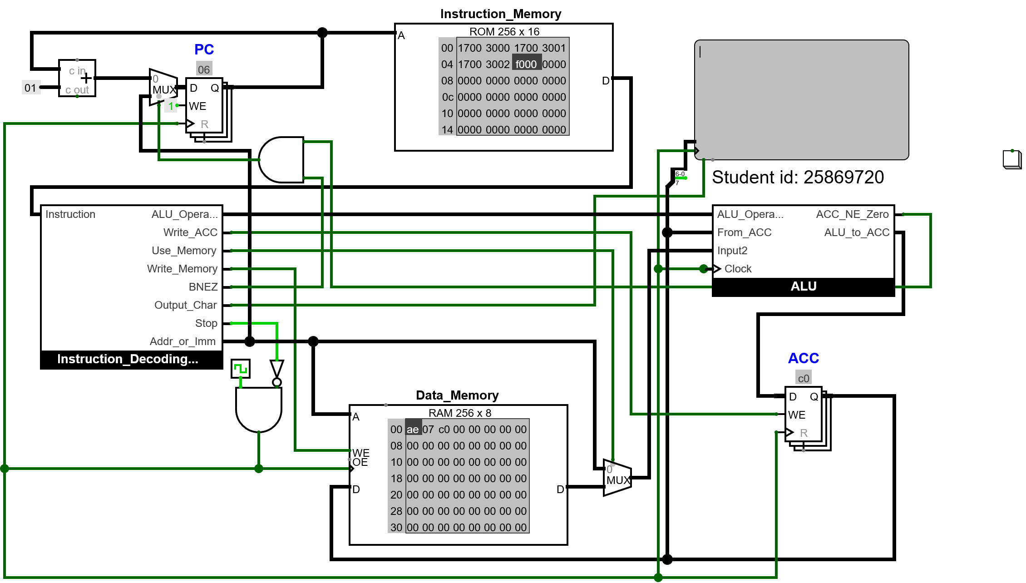

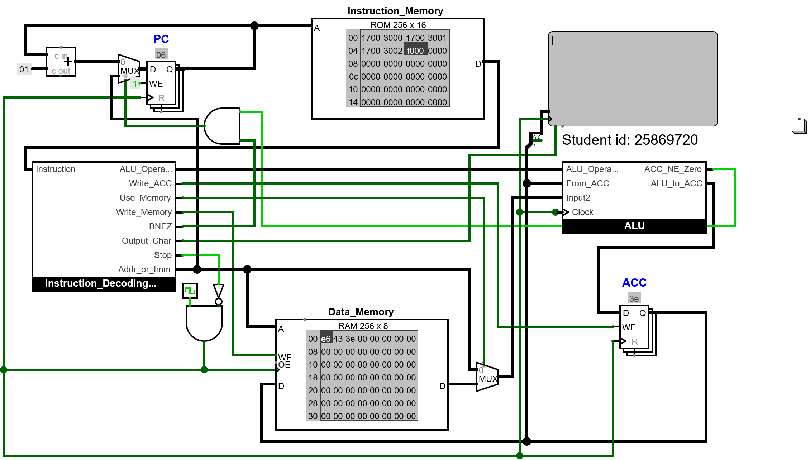

All the random numbers generated were random; therefore, it works.

For the game, there needs to be an option to clear the TTY, which is why an instruction was added to the instruction decoding unit decoder to do this.
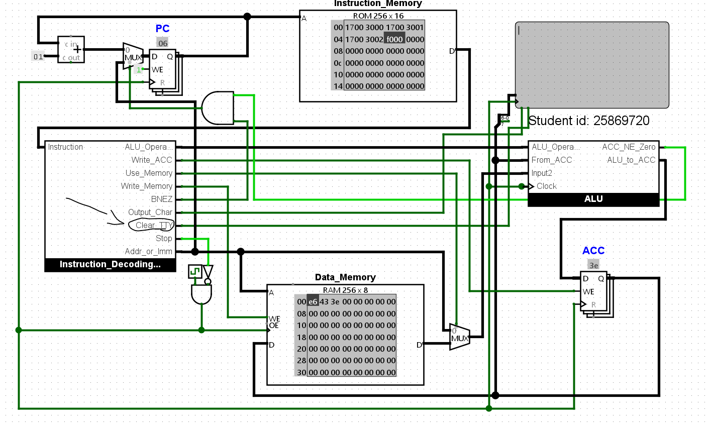

A test can be done to show that the clear instruction works by writing a simple program to output characters to the TTY, then clearing it.

v2.0 raw
1068 5000 #output h
1069 5000 #output i
1021 5000 #output !
6000 #clear
f000 # stop

Expected Outcome: The TTY should be empty at the end of the program.
Result:

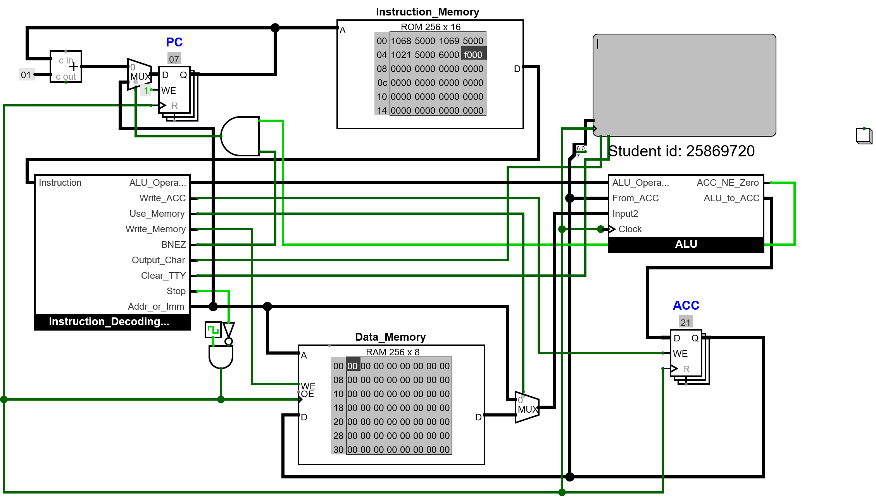

Even though three characters were outputted at the end of the program, the TTY was clear, therefore it works.

Now the CPU needs to take in inputs from the buttons.

extra circuitry was added to the CPU.
The CPU waits for an input before continuing the next instruction by stopping when either Stop is decoded or an input is needed. A new output from the decoder was added that will be 1 when an input is needed. Buttons have also been added; now there are two, and when they are pressed, the ALU can output them to the ACC, where 01 is button 1, Greater Than, and 00 is button 2 Less Than or equal. This way, the program can then check which button has been pressed and then use these values to check if the player guessed correctly.

NOTE: The button presses will not be detected correctly if the Auto Tick Frequency is set to lower than 32.0 Hz, and due to the buttons, it cannot run correctly any higher than 512.00 Hz.

To test that this works, a simple program that will wait for a button input and then store it at memory address 00 can be made.

v2.0 raw
7000 1800# wait for an input, then output it to the acc
3000 #store the button pressed
f000 # stop

Expected result: 01 will be stored when the greater than button is pressed, and 00 will be stored when the less than button is pressed.

Result:

4
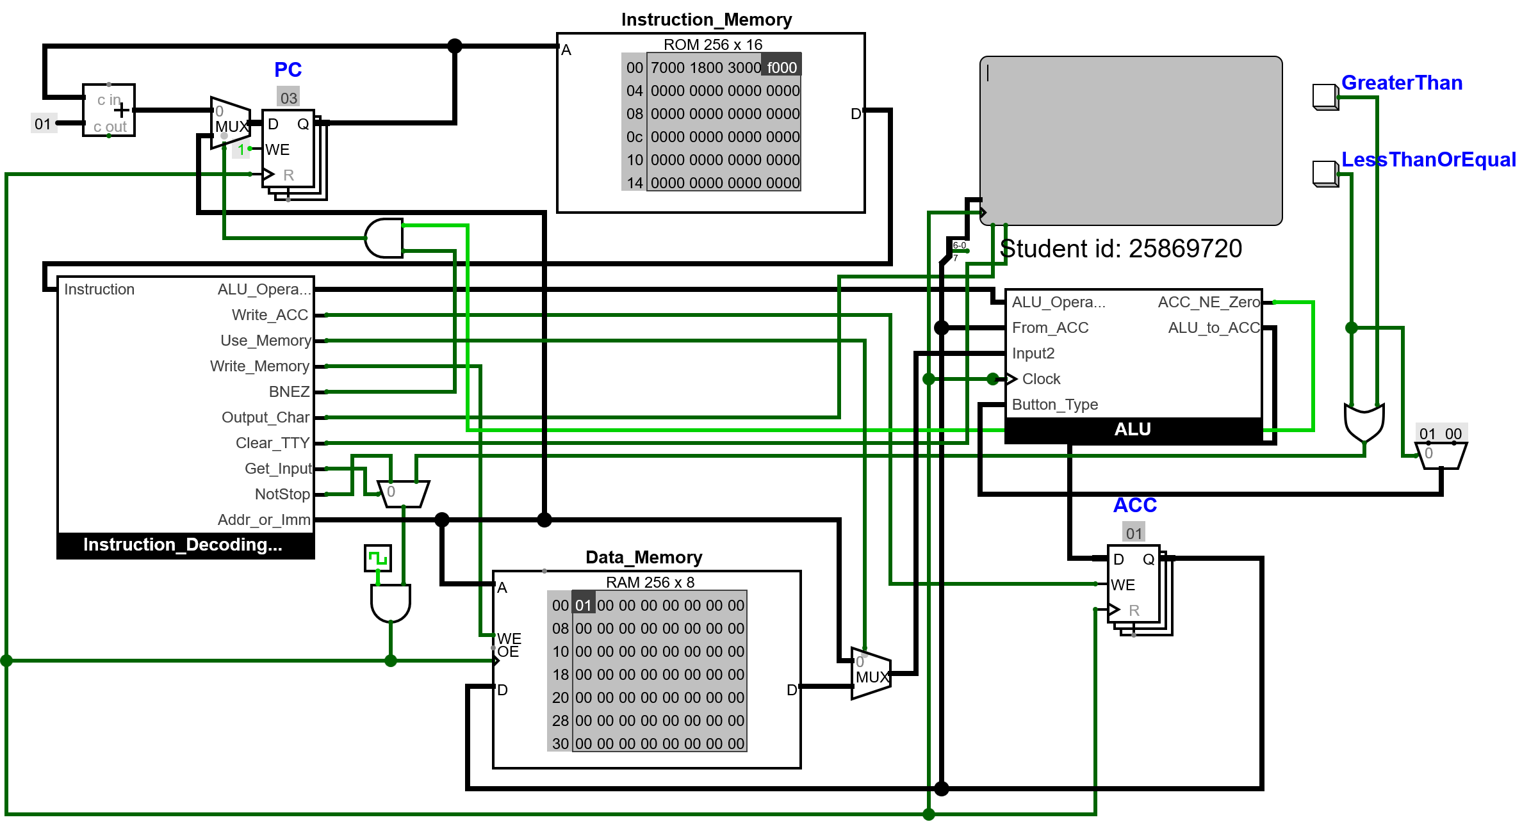

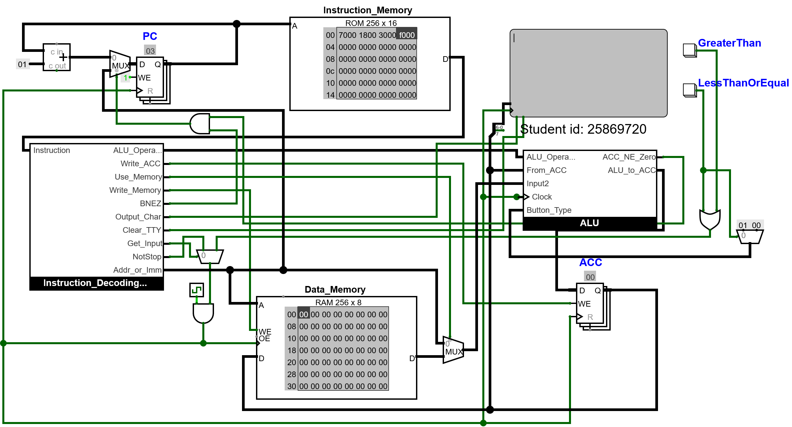

As you can see, the values stored were correct depending on the button pressed, therefore it works.

Another feature that is needed is to add is the ability to check if two numbers are the same by adding a comparator to the ALU.
This is important as it would allow checks to see if the button pressed will correspond to the greater than checks, and if they do, then the player can proceed to the next level.

The ALU multiplexer will take in the result of a comparator that checks if the values are equal. The comparator that is already in the alu can be reused.

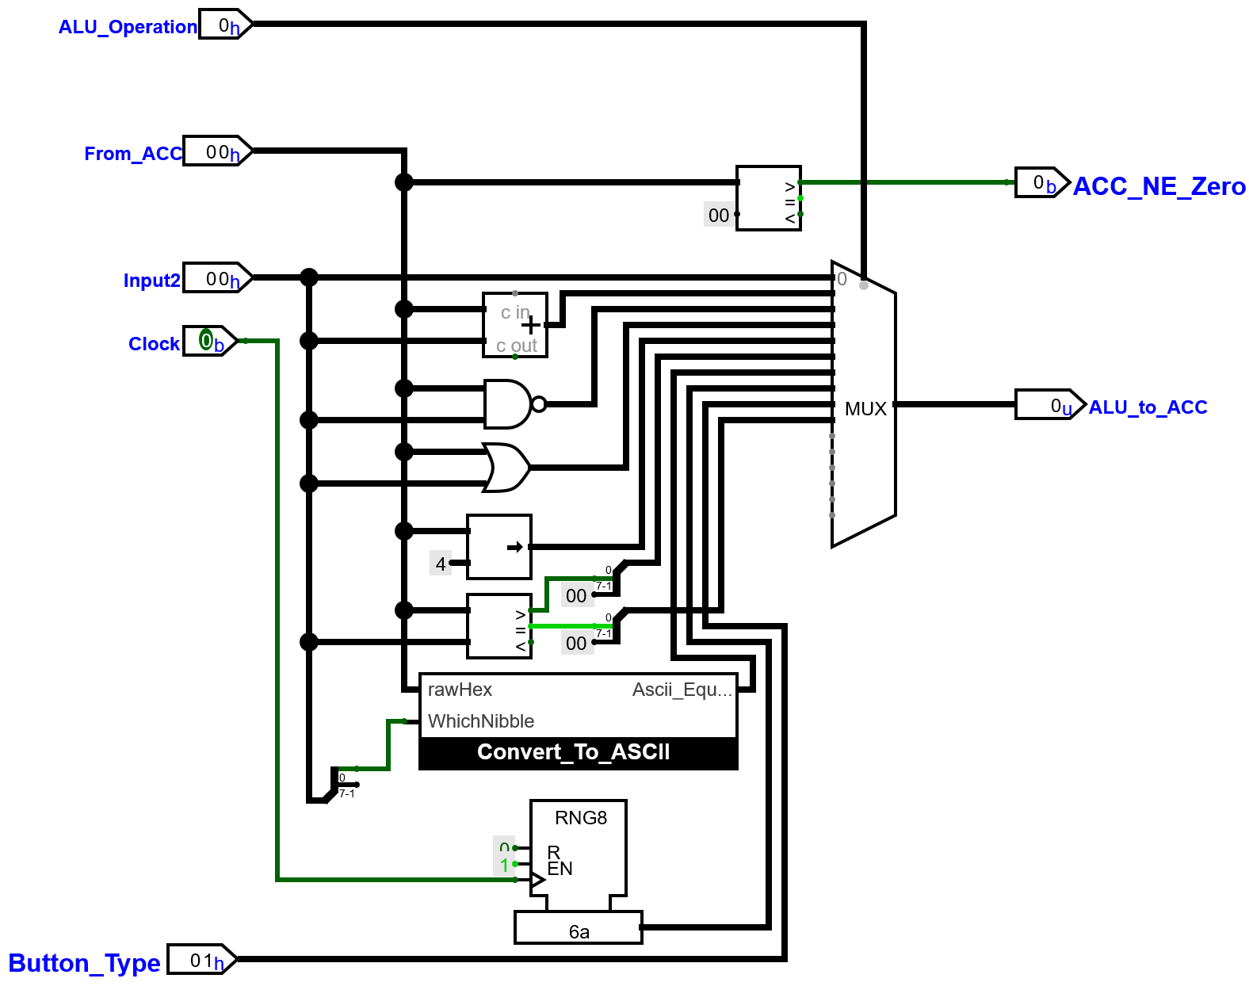

A test can be done to show that this works with a simple program that will load two values that are the same and different, then store the result at 00.

v2.0 raw
1061 1961 # load 2 same values then check if they are the same
3000 #store the output
f000 # stop

Expected Result: when the values are the same, 01 is stored, but if they are different, 00 is stored.

Result:

In the first image, the values are the same, whilst in the second one, the values are different.

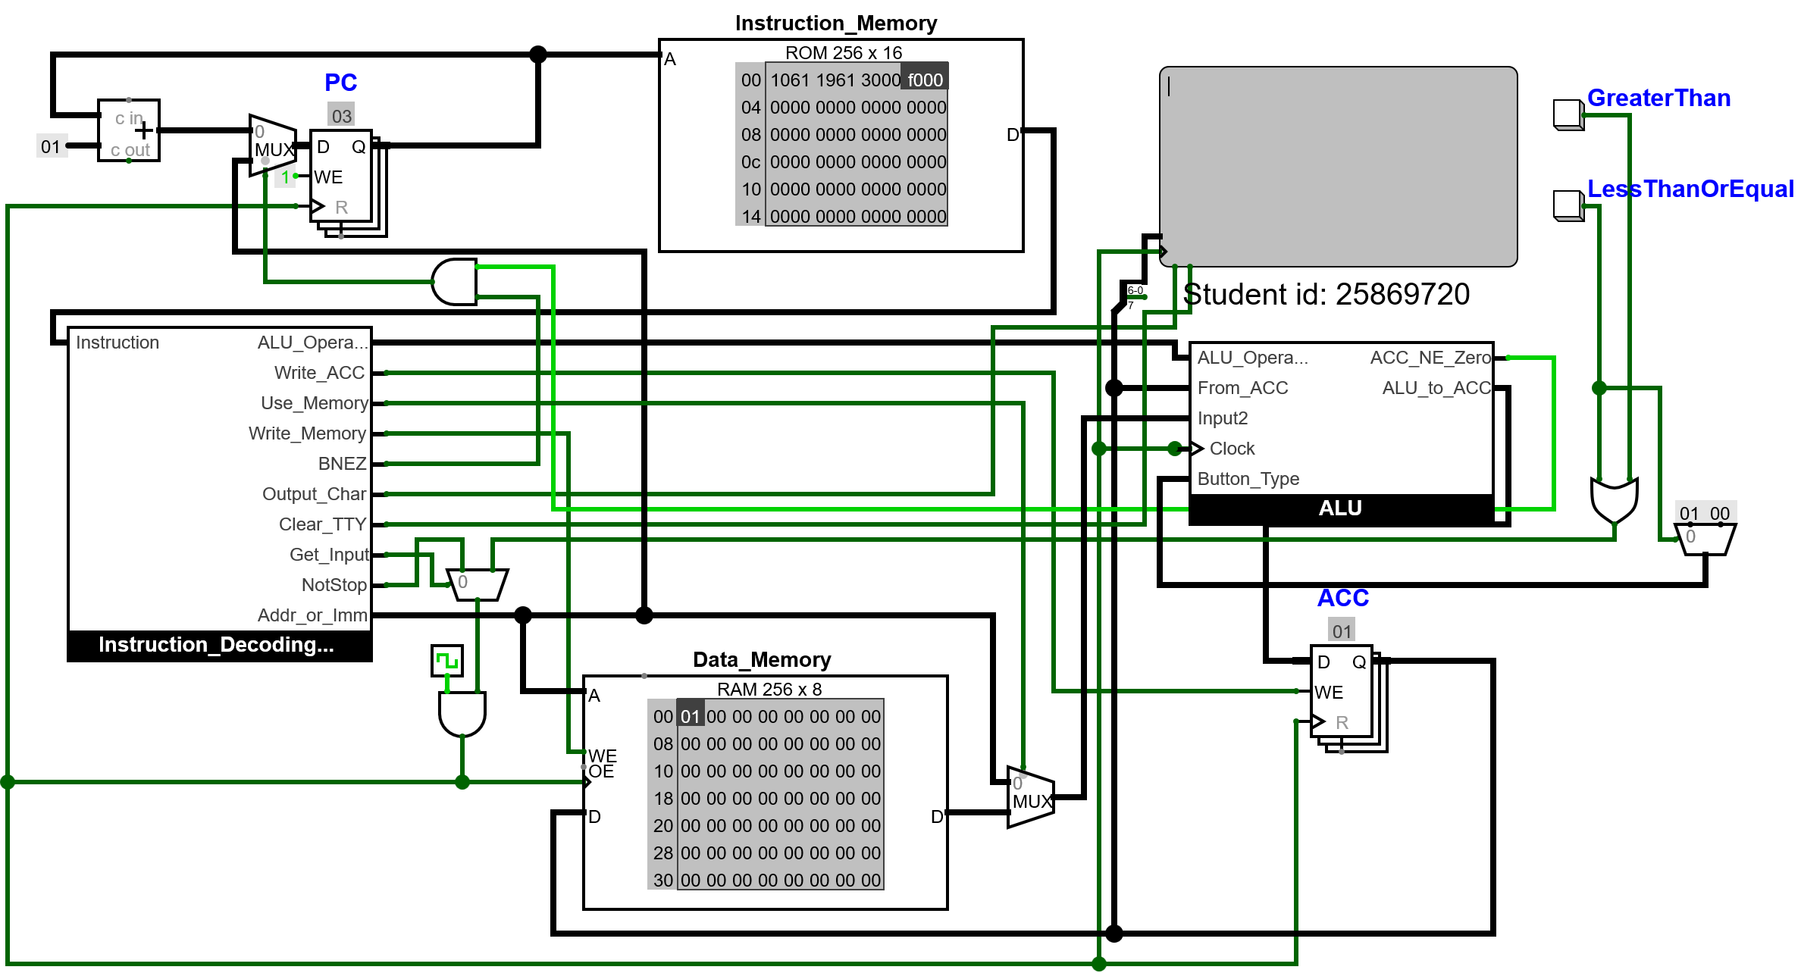

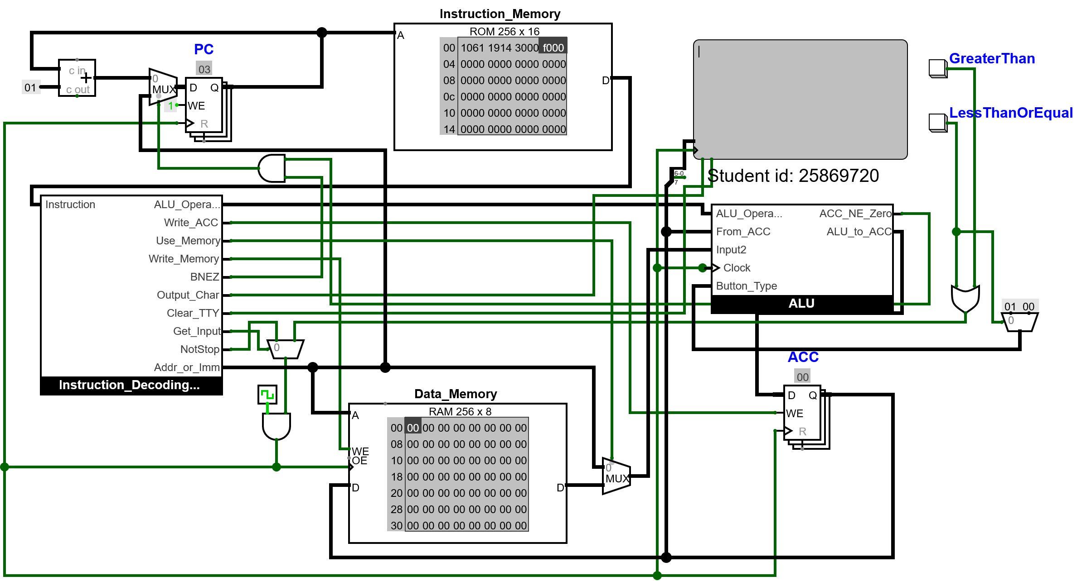

As you can see, when the values are the same, the value stored is 01, and when they’re not, it's 00; therefore, it works.

Another issue that needs fixing is that when the program writes to the TTY firstly it would need to do 10(ascii in hex value) then do 5000 output to the TTY this means It will have a lot of redundant 5000 especially in long words which would unnecessarily increase the number of instructions to fix this the CPU just need to allow instruction 5 to allow writing to the ACC this way It won’t need to don’t need 10 and can just do it all in one go so it would be 50(hex of ascii value).

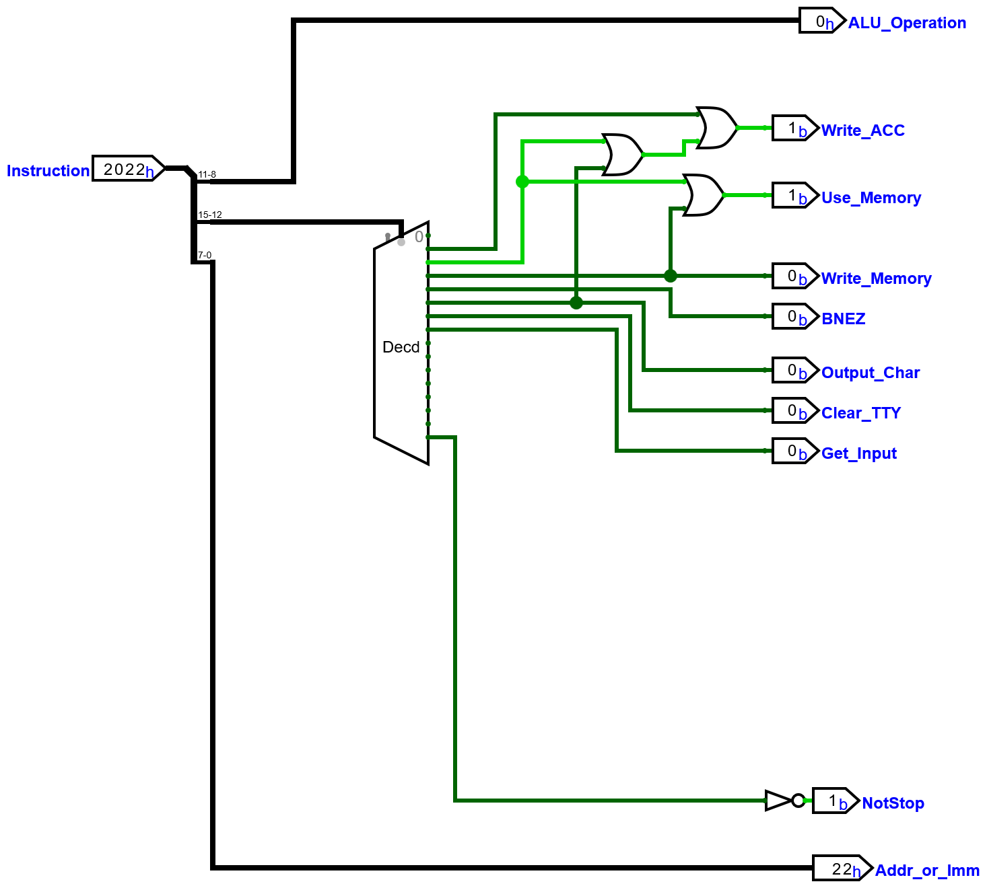

The CPU is altered so that I can write the game code now.

v2.0 raw

2022
10ff
3002 #set the score to -1 as it is adding in a loop, so if it added at the start of #the loop, starting at 0, it
#would be off by 1

1700 3000 # loop begins here
1700 3001 #generate two random numbers and store them

2002
1101
3002 # loads the score adds 1 to the score and stores it

2000
2501
3003 # here it will load both random numbers and check if 00 > 01 and store the result

6000 #Clears the TTY from previous characters before writing on it

1069
5000

1073
5000 # writes the words "is"

1020
5000

2000
1600
5000

2000
1601
5000 #outputs the random number to the TTY

5020

5048

5069

5067

5068

5065

5072

5020

506f

5072

5020

504c

506f

5077

5065

5072

5020 # all of this from the last comment writes the words " is Higher or Lower" to the TTY

7000 # waits for a player's input

1800
2903 #checks if the button pressed equals the result of the greater than calculation of the two random numbers
#if its correct then it will output 01
4003 # branch back to the beginning as the game continues

6000 # if the values are not equal that means the player answered incorrectly and therefore exit the loop

5047

5061

506D

5065

5020

504F

5076

5065

5072

5021

500A

5053

5063

506F

5072

5065

503A

5020

2002
1600
5000

2002
1601
5000 # all of this writes the words "Game Over!
Score:(outputs score)" to the TTY

f000 # stop

This game code works, and I will now show it working.

Outcome:

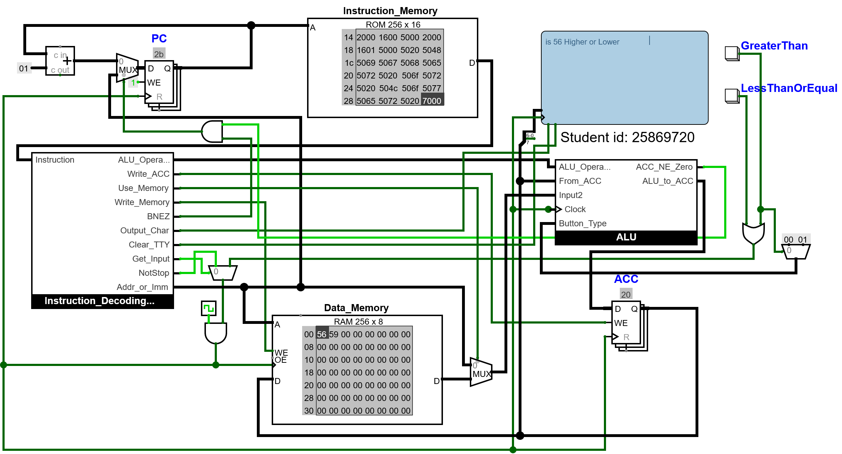

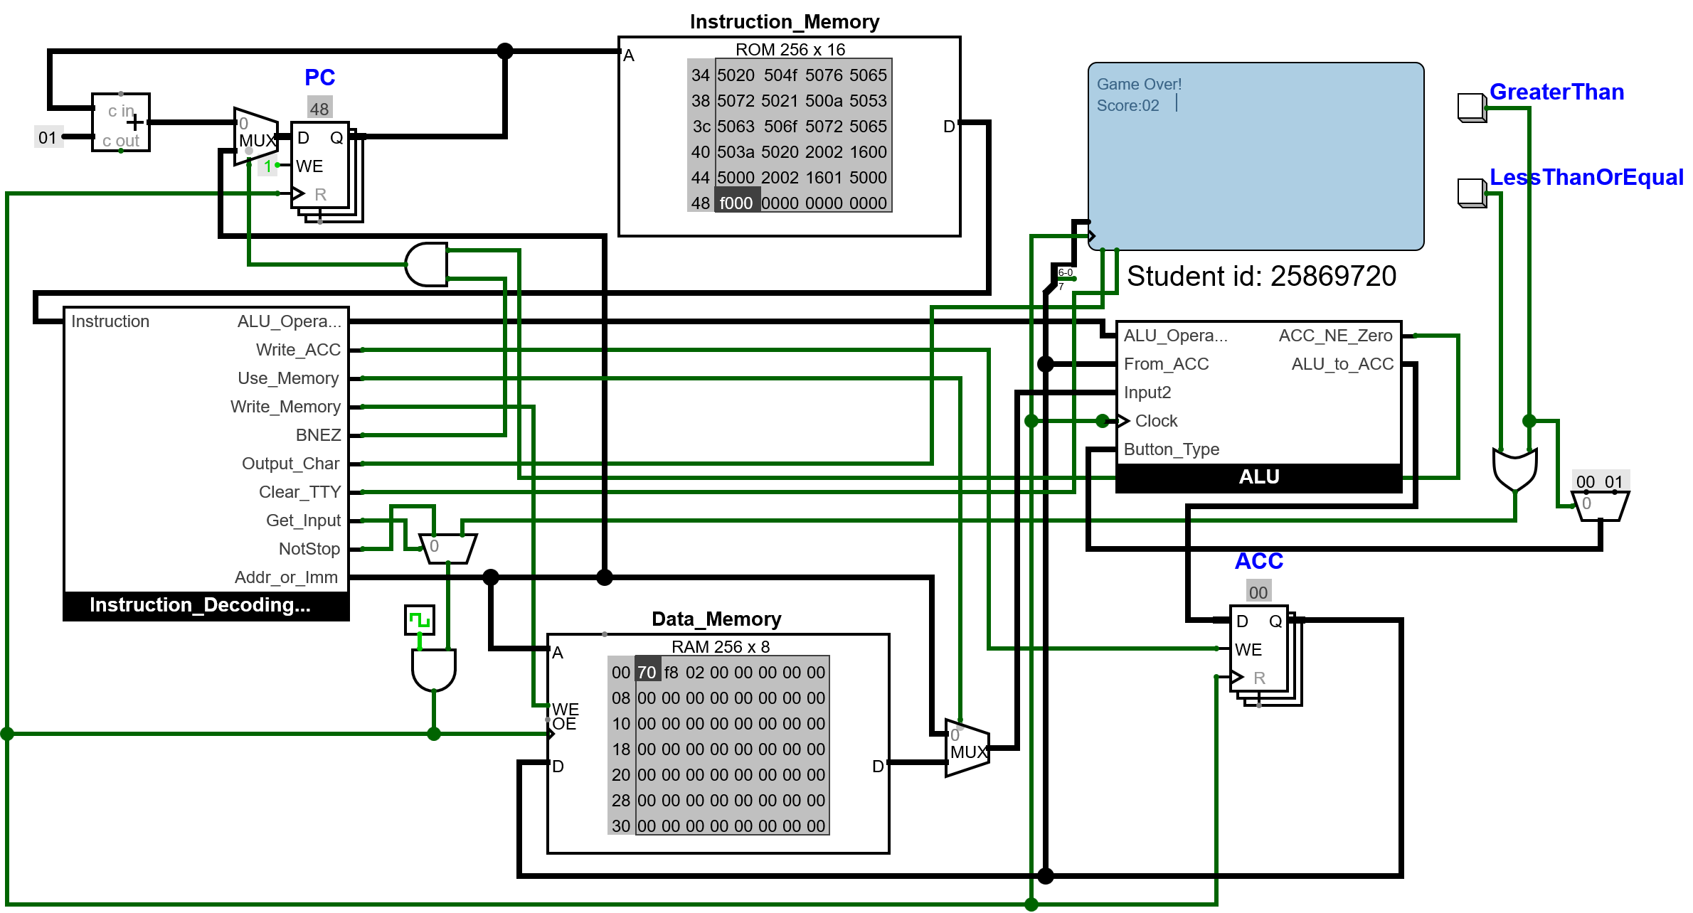
This game fully works now; however, there is an issue where the numbers are being outputted to the TTY in their Hexadecimal form, which makes it harder for the player to read them, as some players may not understand hexadecimal.

To fix this, a method is needed to convert a number into its individual digits, which can then be converted into ASCII and output to the TTY.

To do this, a way is needed to extract the individual digits from a number. I was unsure on how to do this, so I asked AI to help me, and I found out to get the ones digit I do n MOD 10 the tens digit I do (n DIV 10) MOD 10
And the hundreds digit is n DIV 100. Once I get all the individual digits, they can just be converted to ASCII and outputted to the TTY. (ChatGPT,2025)

To do these two more functions are need to the ALU needs the mod and the div. This can be achieved by using the divider component, and the mod will just be the reminder.
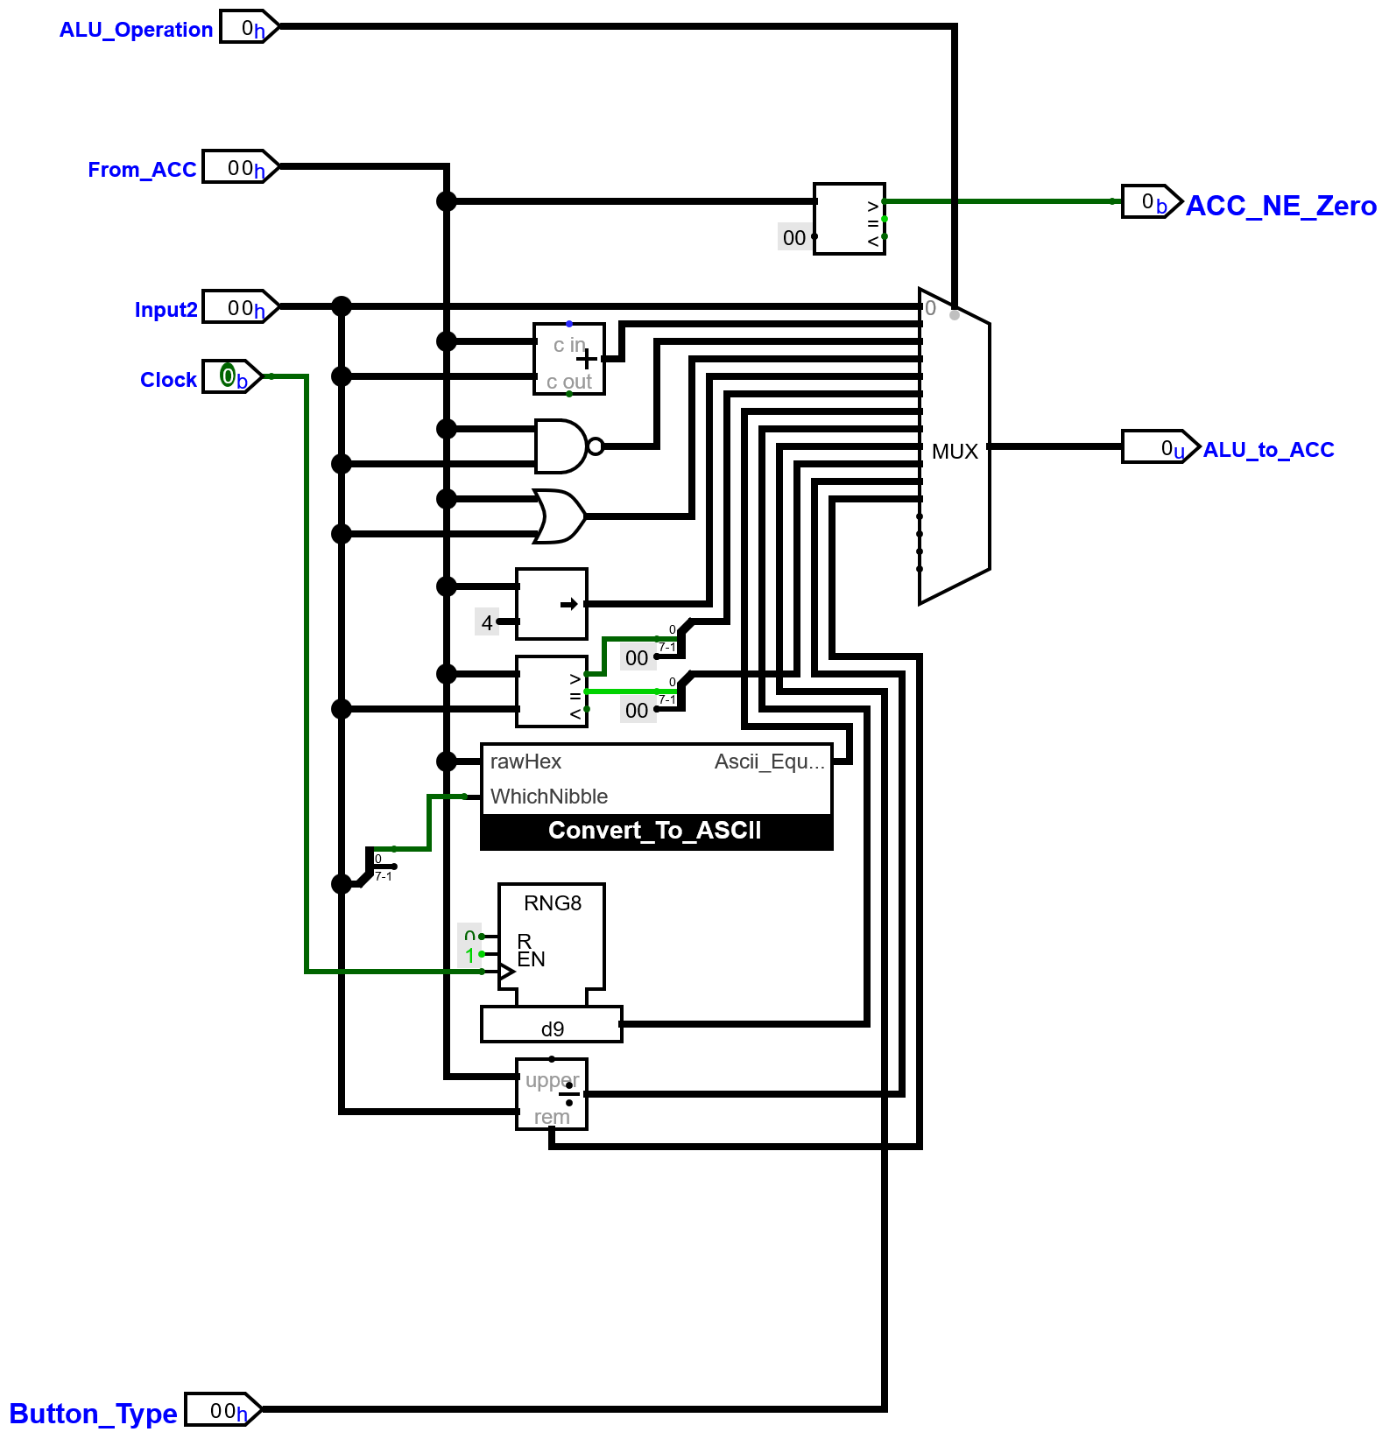

This can be tested by writing a simple program that stores a value at 00, then outputs the three digits of that number to the TTY.

Program

v2.0 raw

1014 # it will swap out the 14 for the other values to test them so 61 and 9d and show #this in the results
3000 # store it

#hundreds
1a64
1601
5000 # does n DIV 100 converts it to ascii and outputs it

2000 #tens
1a0a
1b0a
1601
5000 # does (n DIV 10) MOD 10 converts it to ascii and outputs it

2000 #ones
1b0a
1601
5000 # does n MOD 10 converts it to ascii and outputs it

f000 # stop

expected result
Hex Value stored at 00 | Output to TTY
14 | 020
61 | 097
9d | 157

Result

The images are shown in the order they appear in the table.
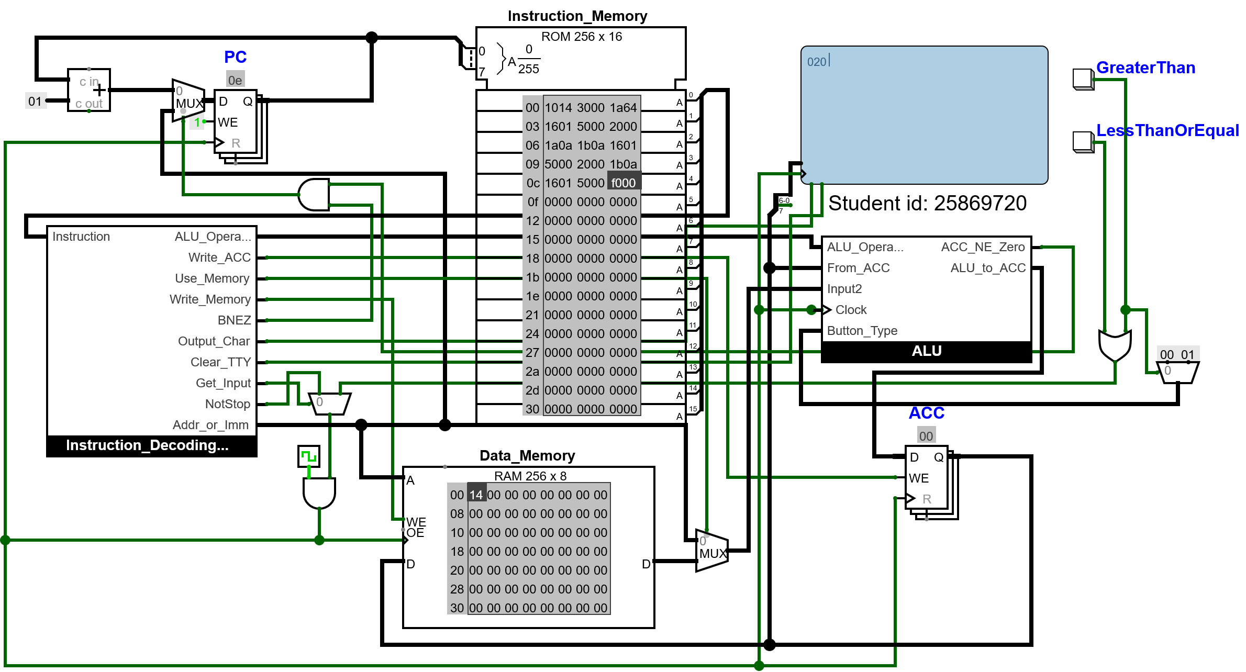

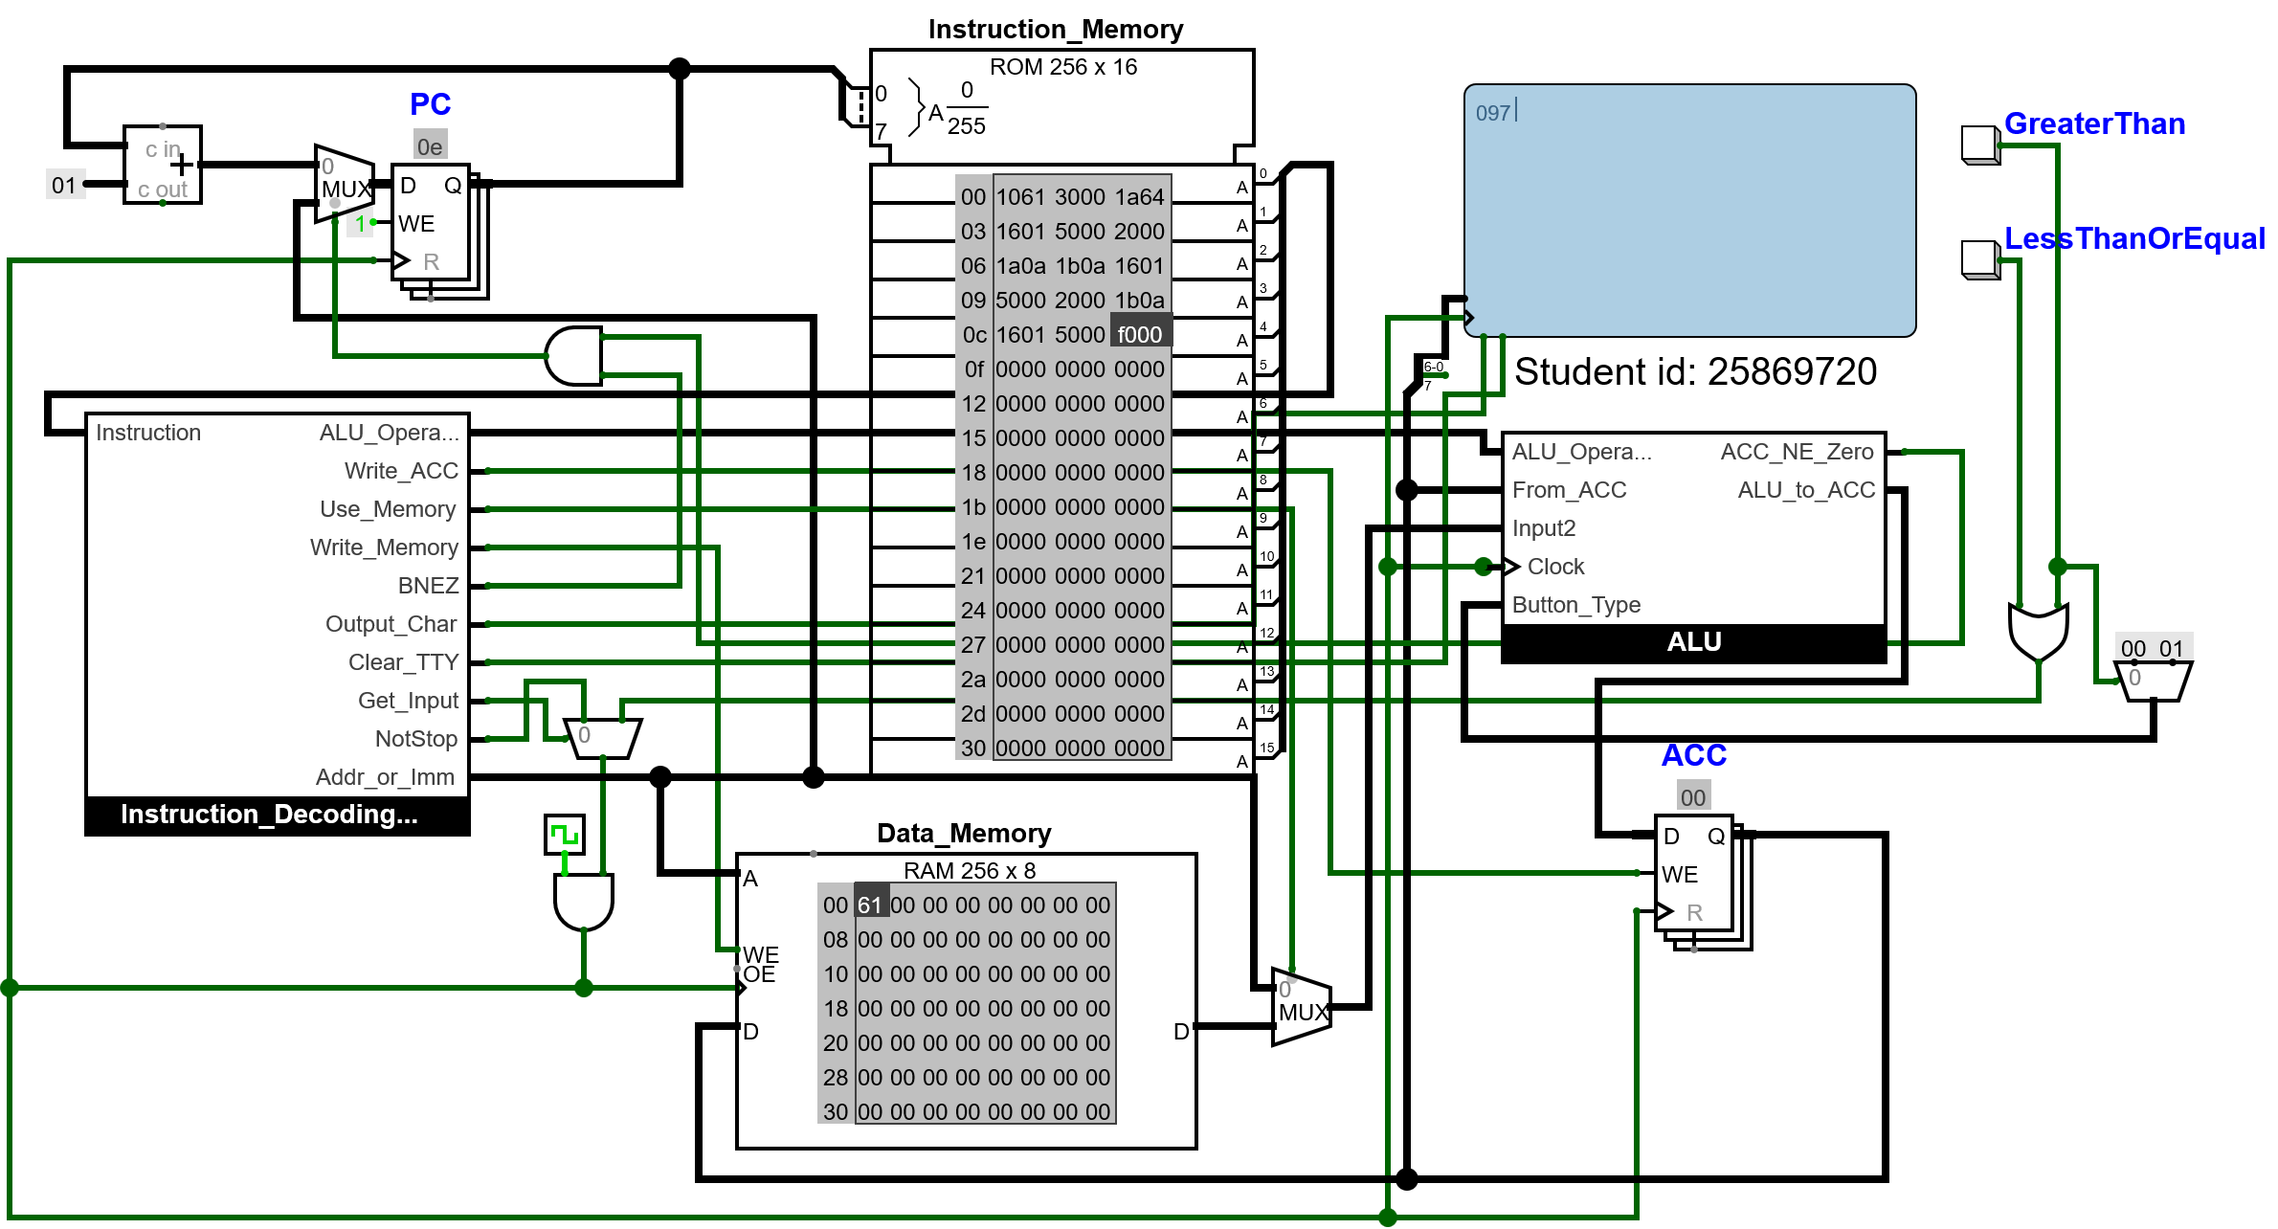

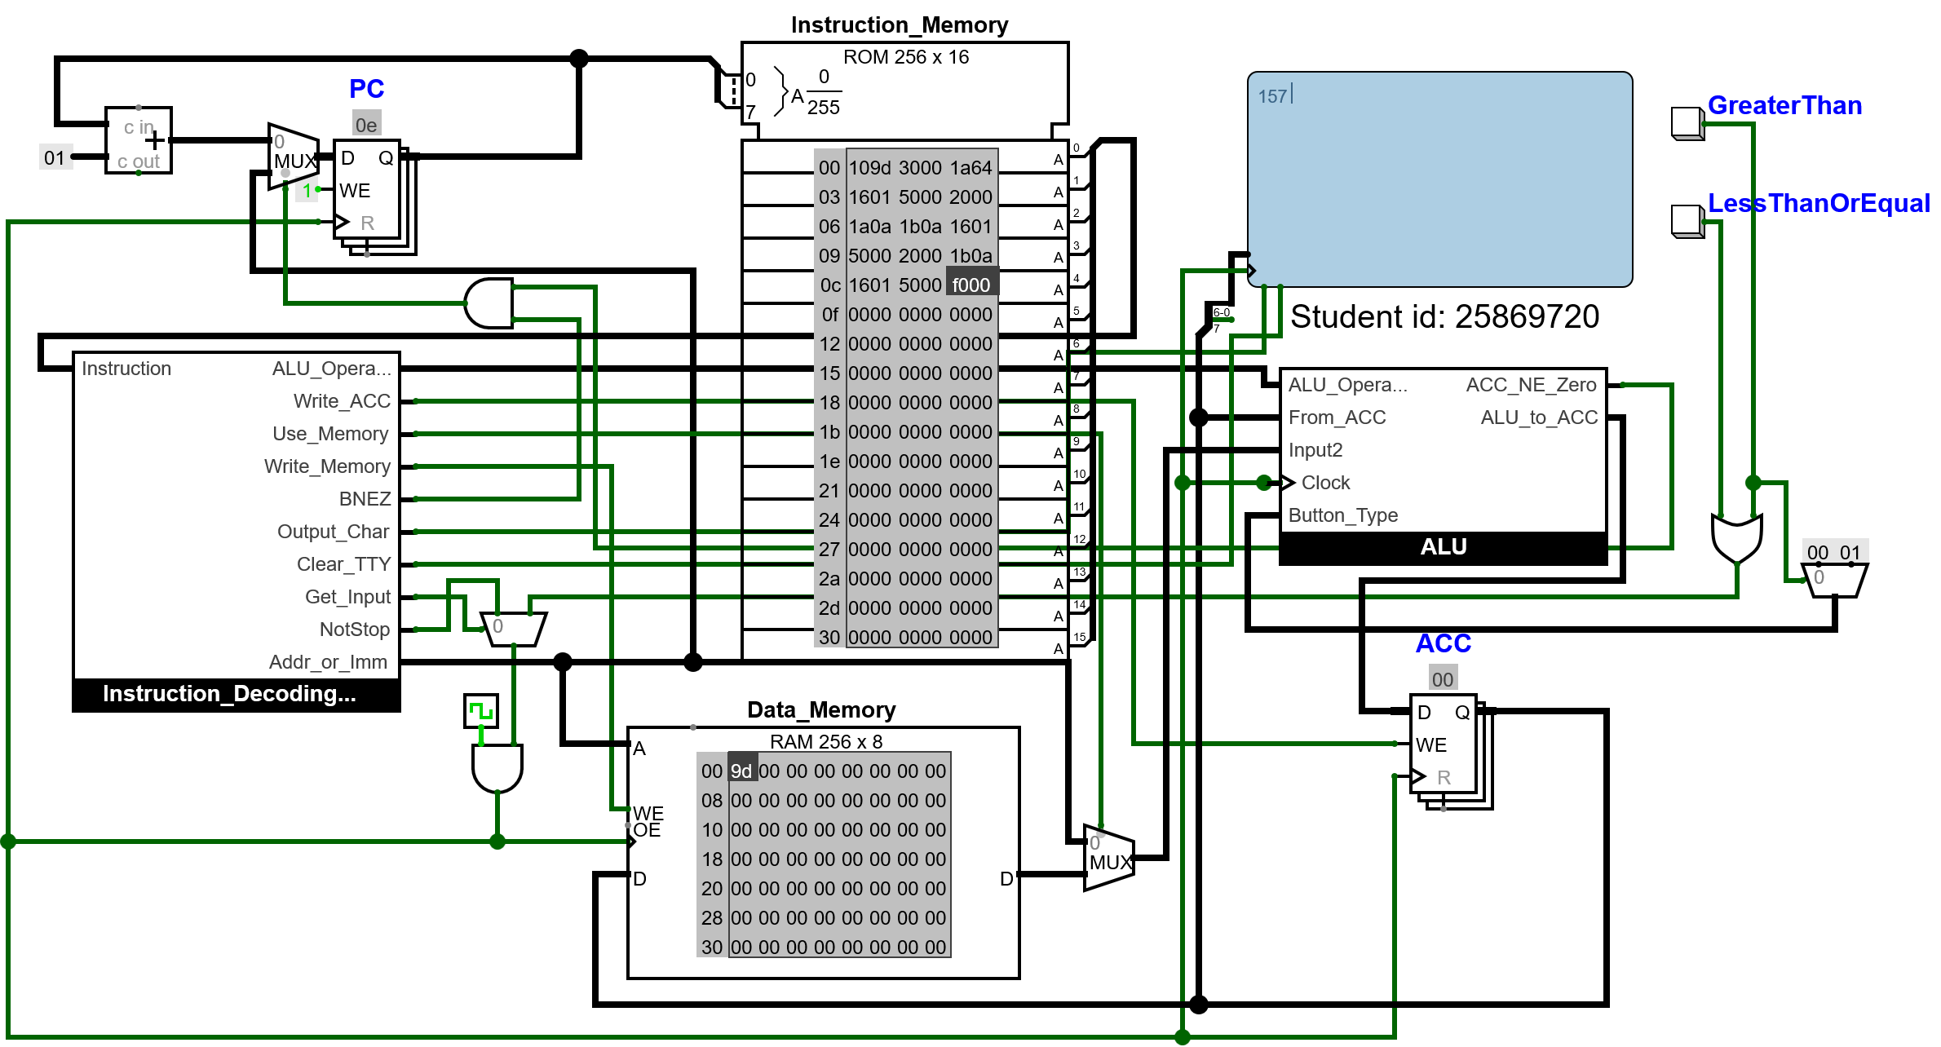
As you can see, the decimal values were outputted correctly.

Now the game code needs to be altered to take advantage of this feature.

New game code:
v2.0 raw
2022
10ff
3002 #set the score to -1 as it are adding in a loop, so if we added at the start of the loop starting at 0, it #would be off by 1
1700 3000 # loop begins here

1700 3001 #generate two random numbers and store them
2002
1101
3002 # loads the score adds 1 to the score and stores it
2000
2501
3003 # here it will load both random numbers and check if 00 > 01 and store the result
6000 #Clears the TTY from previous characters before writing on it
1069
5000
1073
5000 # writes the words "is"
1020
5000

2000 #loads 00 hundreds
1a64
1601
5000 # does n DIV 100 converts it to ascii and outputs it

2000 #tens
1a0a
1b0a
1601
5000 # does (n DIV 10) MOD 10 converts it to ascii and outputs it

2000 #ones
1b0a
1601
5000 # does n MOD 10 converts it to ascii and outputs it

5020

5048

5069

5067

5068

5065

5072

5020

506f

5072

5020

504c

506f

5077

5065

5072

5020 # all of this from the last comment writes the words " is Higher or Lower" to the TTY

7000 # waits for a player's input

1800
2903 #checks if the button pressed equals the result of the greater than calculation of the two random numbers
#if its correct then it will output 01
4003 # branch back to the beginning as the game continues

6000 # if the values are not equal that means the player answered incorrectly and therefore exit the loop

5047

5061

506D

5065

5020

504F

5076

5065

5072

5021

500A

5053

5063

506F

5072

5065

503A

5020

2002
1a64
1601
5000 # does n DIV 100 converts it to ascii and outputs it

2002
1a0a
1b0a
1601
5000 # does (n DIV 10) MOD 10 converts it to ascii and outputs it

2002
1b0a
1601
5000 # does n MOD 10 converts it to ascii and outputs it

# all of this writes the words "Game Over!
# Score:(outputs score)" to the TTY

f000 # stop

As shown in the game code, the hex value will now be converted before being outputted; therefore, this works.
Result:

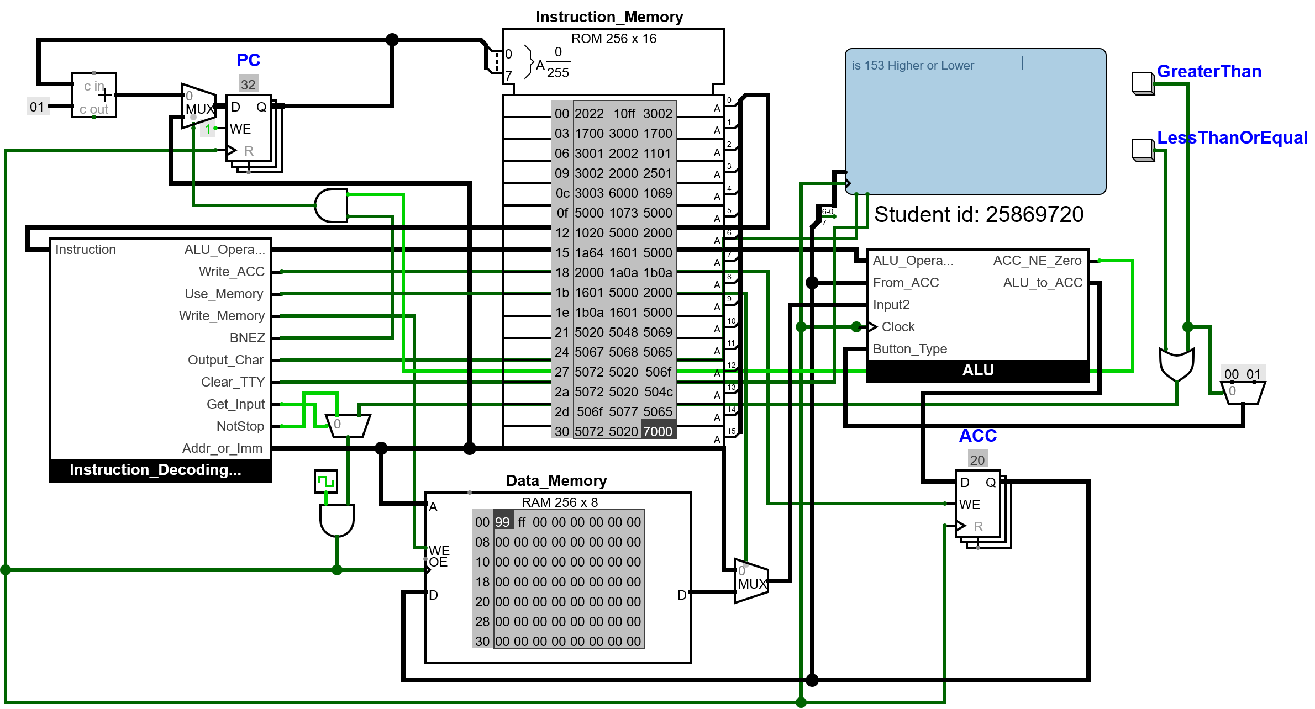

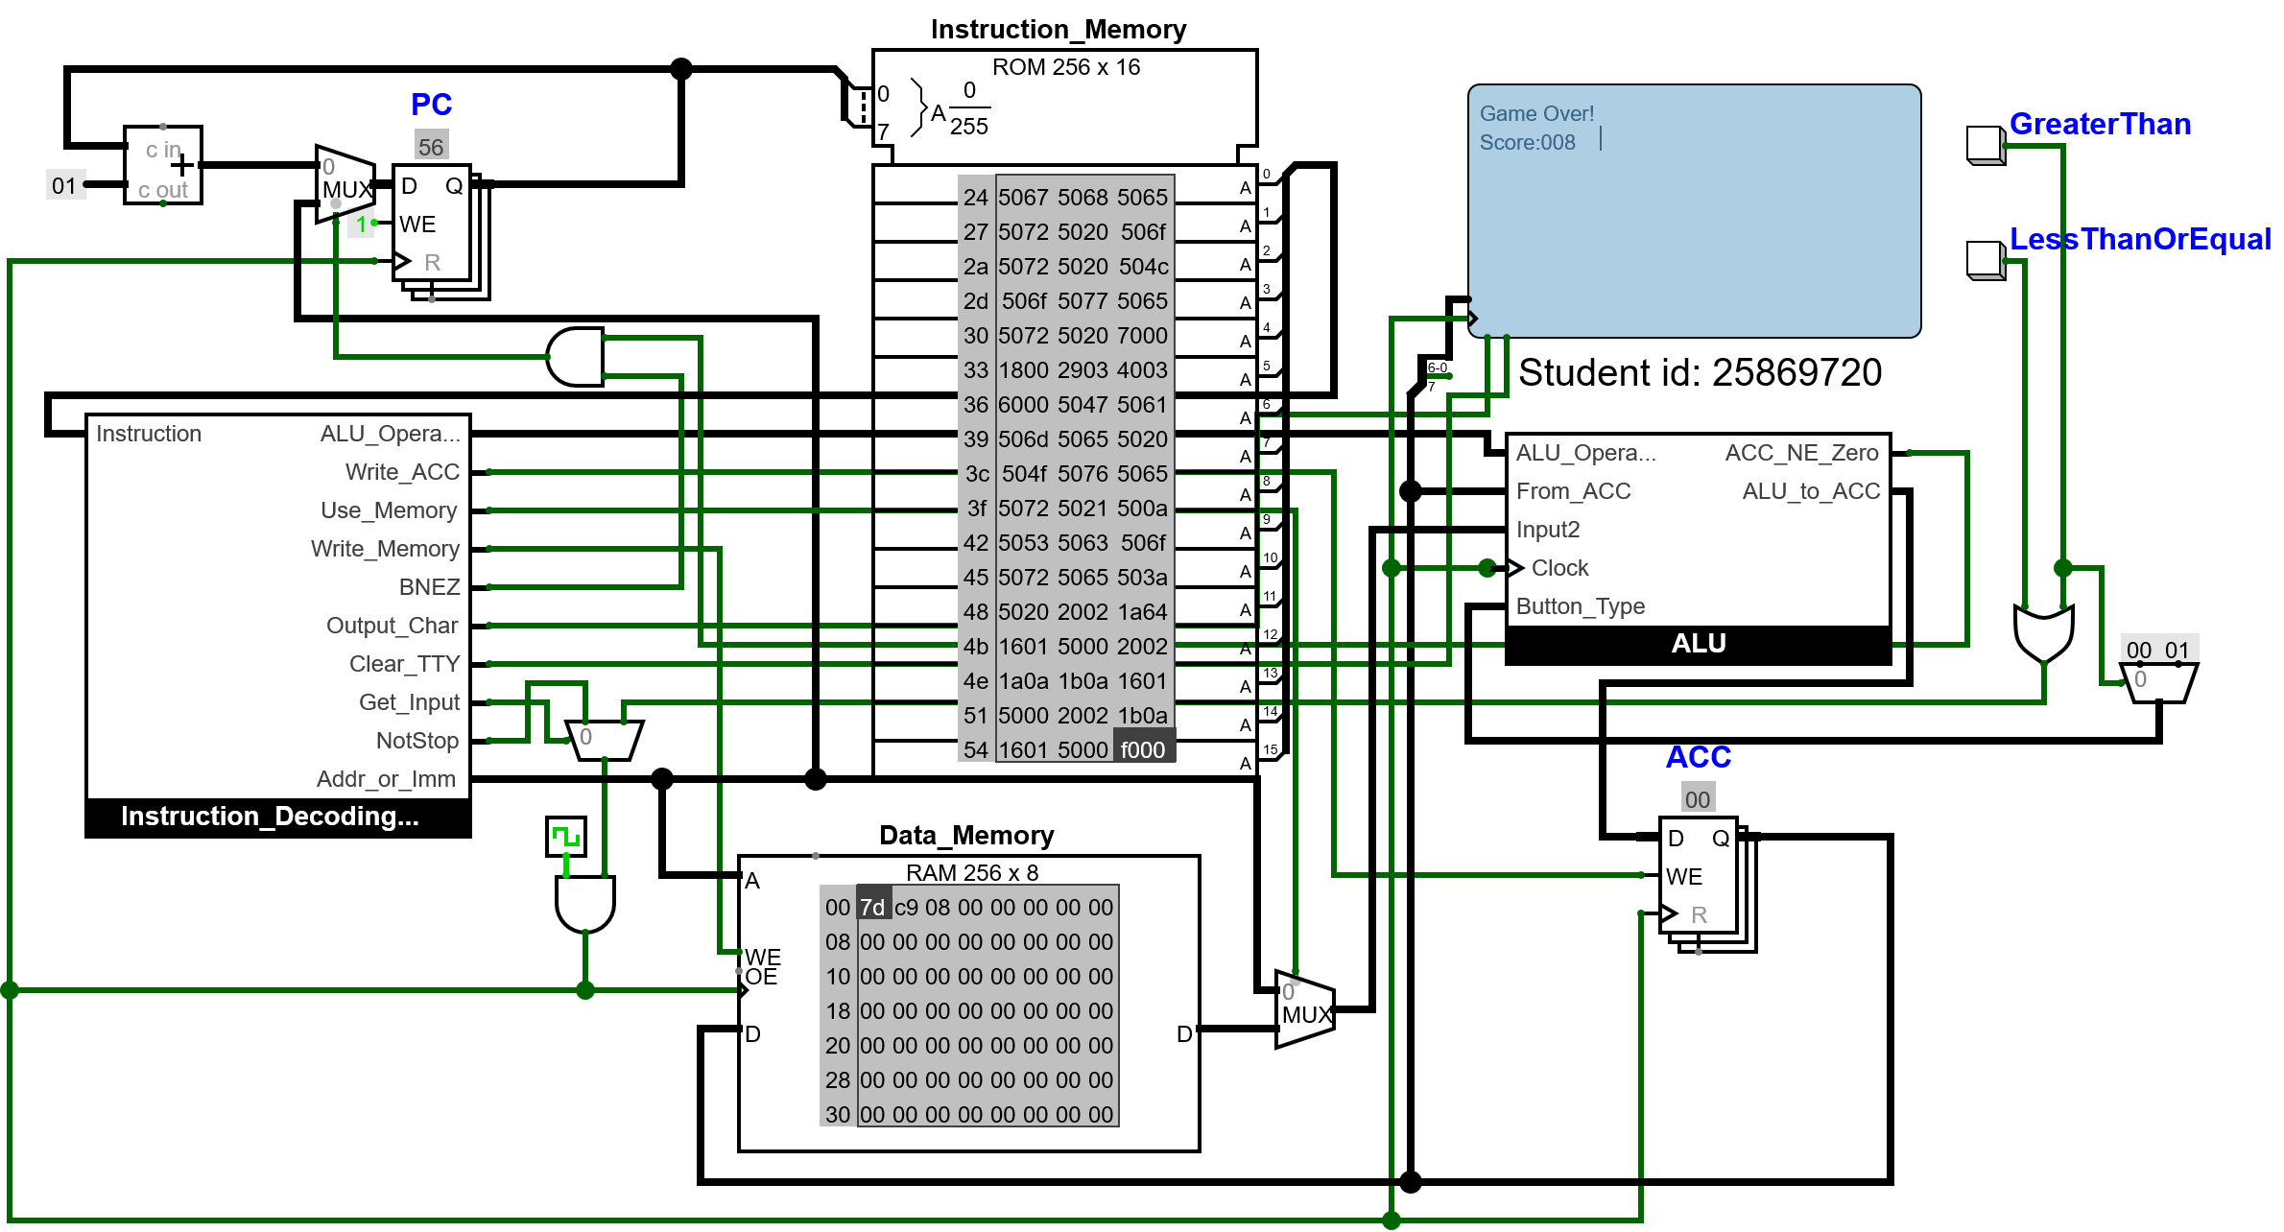

The hex values are now being correctly converted before being outputted.

The another thing that is needed to be done is making a sub circuit for the CPU that will take in the buttons as input and output all the circuitry the TTY will need this is needed as right now the TTY is in the same place as the circuit meaning that the player can look at what is stored in the data memory and therefore never lose by making a sub circuit that will not be possible. Additionally, by making the CPU a subcircuit, it will allow it to have multiple different programs loaded into other copies of the CPU at the same time.

This is now what it looks like as a subcircuit.

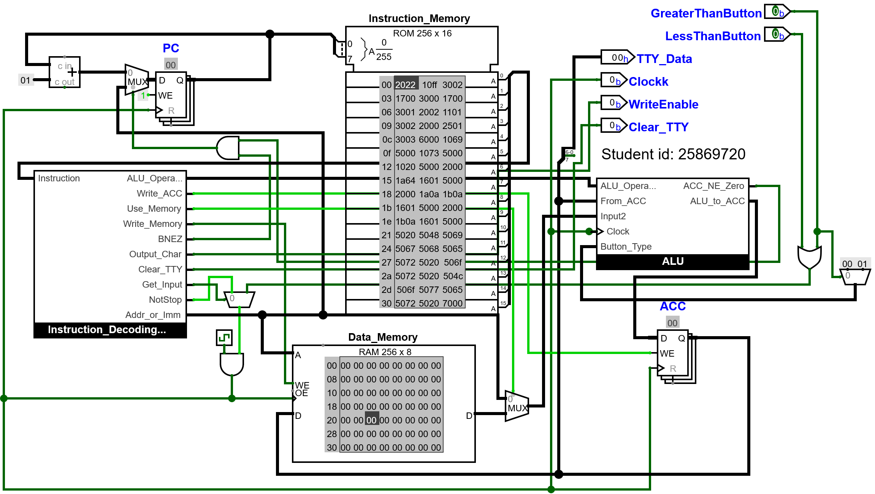

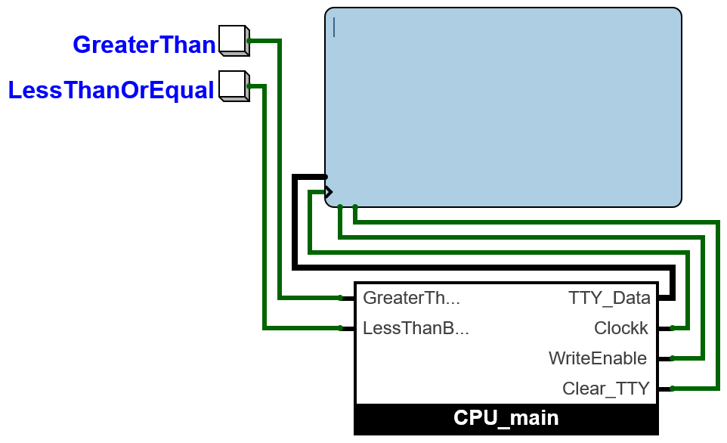

As you can see now, the CPU is in a subcircuit and takes in inputs and gives outputs to the TTY. Now, when the game is played, it is not possible to know what the value stored is, so the player can't cheat and will have to guess.

This is proof that the game still works even with new circuitry:

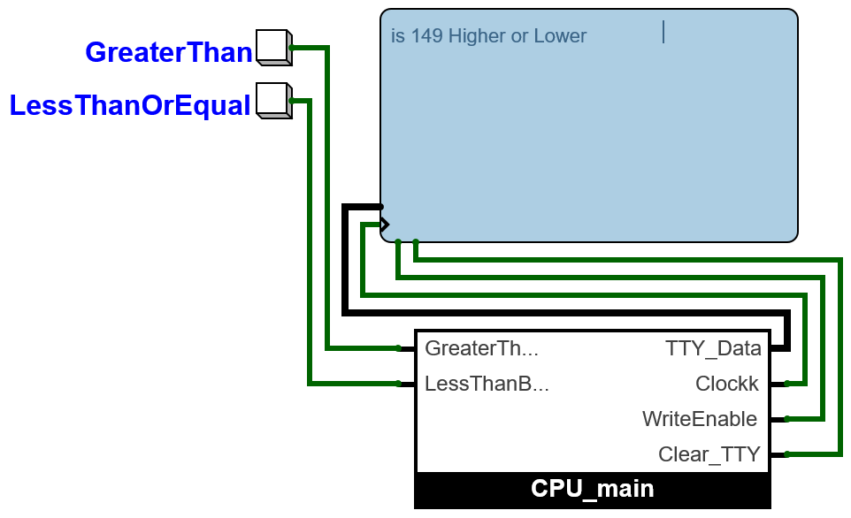

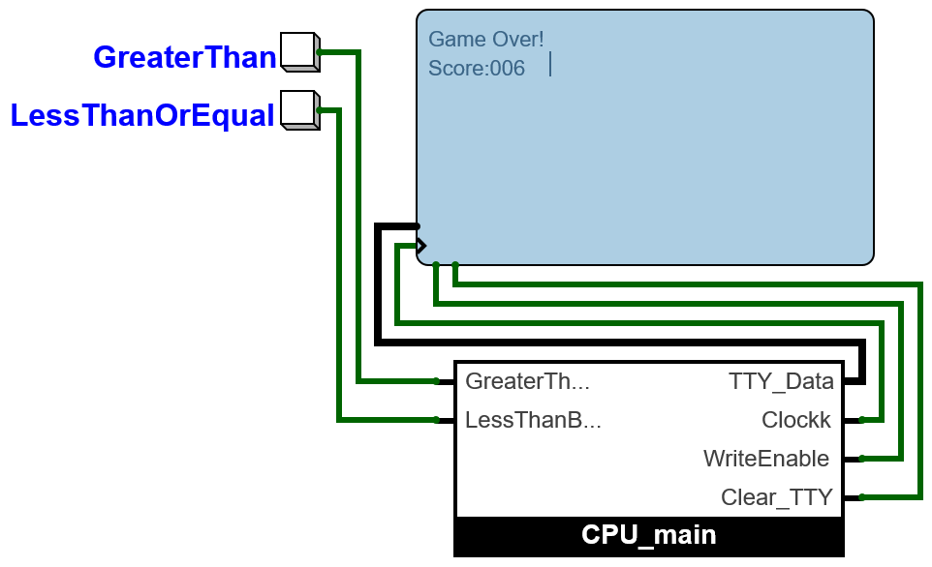

Something else that needs to be changed now is the game code. Firstly, the messages outputted are very vague and the player who doesn’t know the rules would not know how to play. Secondly, the game reaches a stopping condition and does not give the player an option to play again.

The code will be changed so that, in the beginning, the rules are explained to the player. This is what will be shown

Higher or Lower
-Two numbers generated
-You see one, guess if hidden is higher
/lower
-Right = continue, Wrong = lose
-Press any key

And in the end, this is what will be shown
Game Over!
Score:(outputs score)
Press any key to play again

For the player to be able to play again, the program will just wait for a button input, and when it does detect one, it will just branch back to the beginning of the game.

This is the updated code. I was limited to how well I could explain the game by the storage space I had; therefore, the English isn’t perfect. However, I now have 253 out of 256 instructions

Here is the updated game code:
v2.0 raw

2022
10ff
3002 #set the score to -1 as it are adding in a loop, so if it is added at the start of the loop starting at 0, it #would be off by 1
#253/256
5048 5069 5067 5068 5065 5072 5020 506F 5072 5020 504C 506F 5077 5065 5072 500A 502D 5054 5077 506F 5020 506E 5075 506D 5062 5065 5072 5073 5020 5067 5065 506E 5065 5072 5061 5074 5065 5064 500A 502D 5059 506F 5075 5020 5073 5065 5065 5020 506F 506E 5065 502C 5020 5067 5075 5065 5073 5073 5020 5069
5066 5020 5068 5069 5064 5064 5065 506E 5020 5069 5073 5020 5068 5069 5067 5068 5065 5072 502F 506C 506F 5077 5065 5072 500A 502D 5052 5069 5067 5068 5074 5020 503D 5020 5063 506F 506E 5074 5069 506E 5075 5065 502C 5020 5057 5072 506F 506E 5067 5020 503D 5020 506C 506F 5073 5065 500A 502D 5050 5072 5065 5073 5073 5020 5061 506E 5079 5020 506B 5065 5079
5000
7000

#outputs the message
#Higher or Lower
#-Two numbers generated
#-See one, guess if hidden is higher/lower
#-Right = continue, Wrong = lose
#-Press any key

1700 3000 # loop begins here

1700 3001 #generate two random numbers and store them
2002
1101
3002 # loads the score adds 1 to the score and stores it
2000
2501
3003 # here it will load both random numbers and check if 00 > 01 and store the result
6000 #Clears the TTY from previous characters before writing on it
1069
5000
1073
5000 # writes the words "is"
1020
5000

2000 #loads 00 hundreds
1a64
1601
5000 # does n DIV 100 converts it to ascii and outputs it

2000 #tens
1a0a
1b0a
1601
5000 # does (n DIV 10) MOD 10 converts it to ascii and outputs it

2000 #ones
1b0a
1601
5000 # does n MOD 10 converts it to ascii and outputs it

5020

5048

5069

5067

5068

5065

5072

5020

506f

5072

5020

504c

506f

5077

5065

5072

5020 # all of this from the last comment writes the words " is Higher or Lower" to the TTY

7000 # waits for a player's input

1800
2903 #checks if the button pressed equals the result of the greater than calculation of the two random numbers
#if its correct then it will output 01
4088 # branch back to the beginning as the game continues

6000 # if the values are not equal that means the player answered incorrectly and therefore exit the loop

5047

5061

506D

5065

5020

504F

5076

5065

5072

5021

500A

5053

5063

506F

5072

5065

503A

5020

2002
1a64
1601
5000 # does n DIV 100 converts it to ascii and outputs it

2002
1a0a
1b0a
1601
5000 # does (n DIV 10) MOD 10 converts it to ascii and outputs it

2002
1b0a
1601
5000 # does n MOD 10 converts it to ascii and outputs it

500A 5050 5072 5065 5073 5073 5020 5061 506E 5079 5020 506B 5065 5079 5020 5074 506F 5020 5070 506C 5061 5079 5020 5061 5067 5061 5069 506E 5000
7000
1001
6000
4000

# all of this writes the words "Game Over!
# Score:(outputs score)" to the TTY
# Press any key to play again

f000 # stop put here as a precaution in case it somehow breaks

this is how it looks in the game, and the loop is fully made now, so at the end of the program, the player can play again.

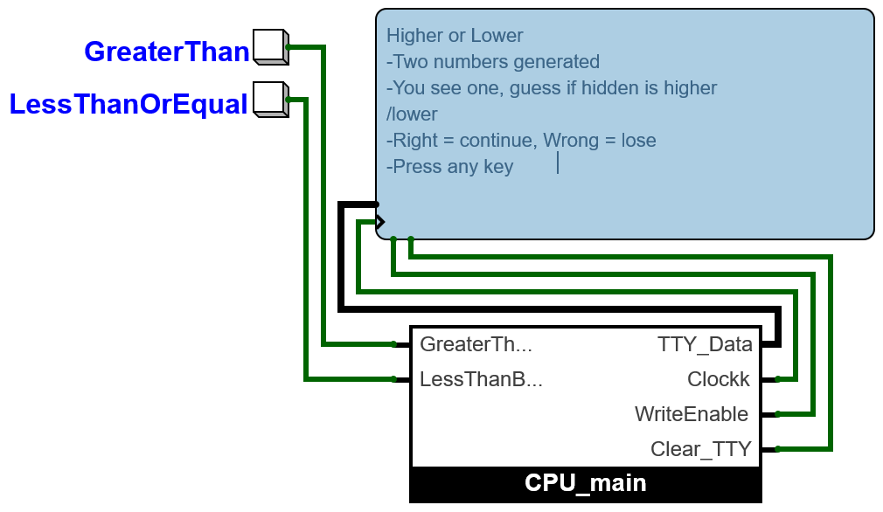

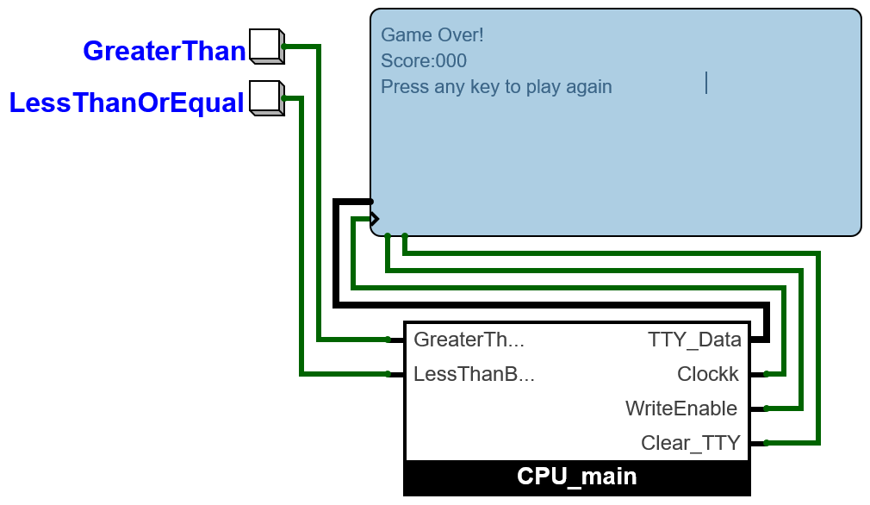

The game is now fully finished as all the features I wanted have now been implemented.

RISC-V Assembly Language Programming

Test the existing program with minor adjustments

Starter Program
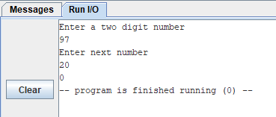

Expected Result
The total should be 117.

Program code
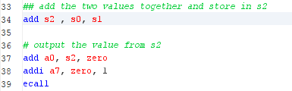
New code is on line 34.

Result
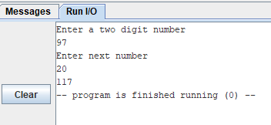
The total 117 is shown as expected.

Improve the messages that the program outputs

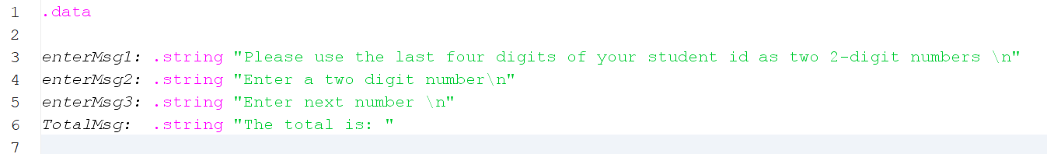
Program Code

The new message is the TotalMsg.

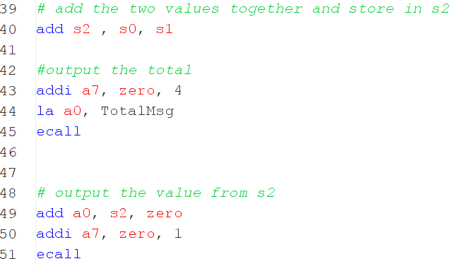

Lines 43-45 output the Total message.

Results

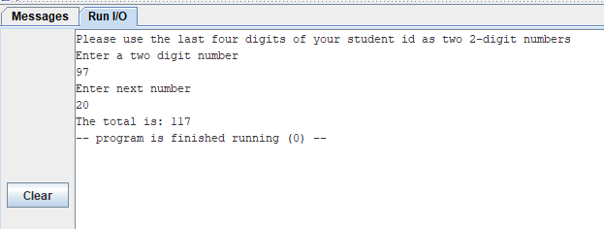

Explanation
Clear messages help the user to know what they need to input and how they need to interact with the program, for example, enter a number, as well as what the output means.

Enhancing the functionality of the program

Program Code
New output message.

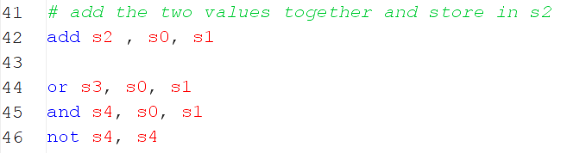
Calculate the value of the OR and NAND.

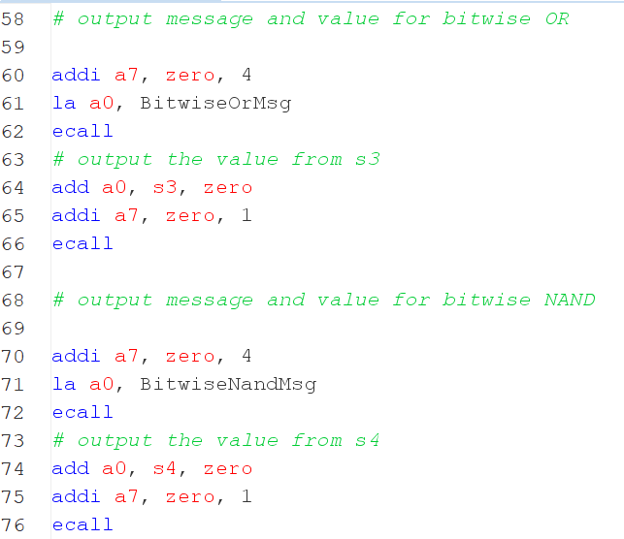
Outputs the message and the result of both bitwise or and NAND.

Expected Result
In the console, there should be
The Bitwise OR is: 117
The Bitwise Nand is: -1

Result
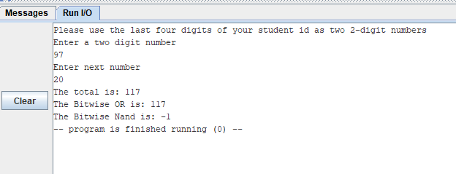
The result matches the expected result.

Explanation
The code for the bitwise OR does OR on the first and second number and stores the result in s3.
The code for the bitwise NAND does AND on the first and second numbers and stores the result in s4.
Then does a bitwise NOT on the contents of s4 and stores it back into s4.

Comparison
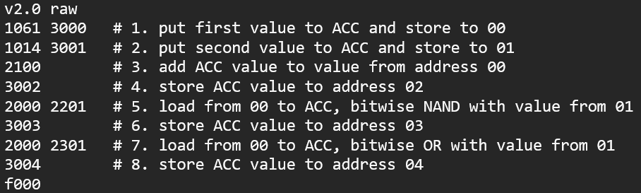

In the CPU simulation as seen here the values first need to be loaded one at a time and then the appropriate instruction to the alu needs to be completed and then the value needs to be stored for the result, on line 5 it loads the first value then the second value and complete a Nand which is then in the alu and needs to be stored back into memory same thing happens with OR bitwise and addition.
Whilst risc
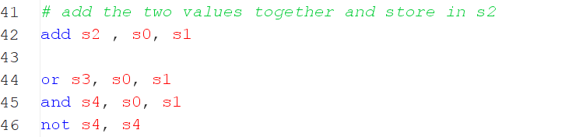

Can load both values, add them and store them into a specified register with 1 instruction, as shown on line 42, whilst the CPU simulation needs multiple instructions for this to happen.

To check if the values are correct in the CPU simulation, the values stored in the data memory after a calculation can be looked at to see if they match the expected value.

Whilst in risc, the values are outputted to the console with environment calls.
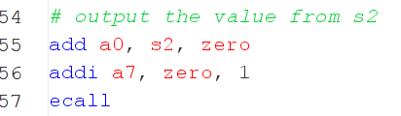
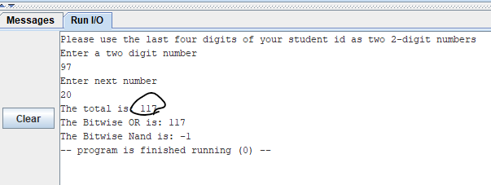

Adding a subroutine

Subroutine code
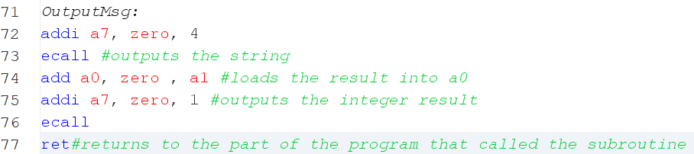
This is the Subroutine that was created to output text and a result.

This is how the values will be passed to the subroutine, which will then be called.

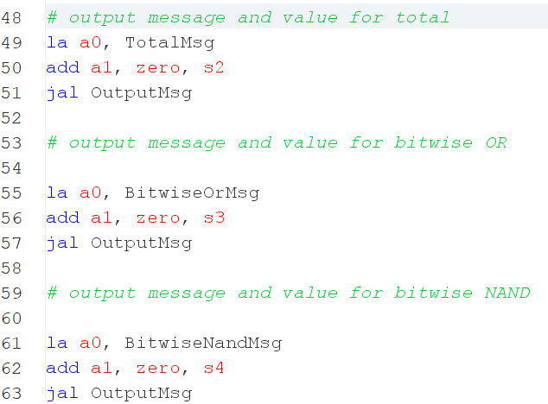

Result
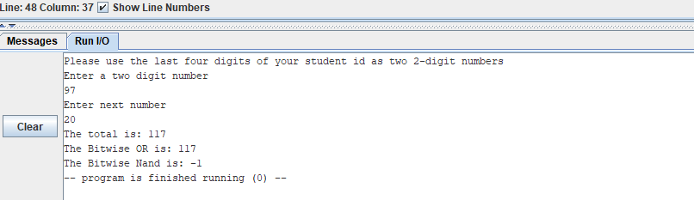
The code still runs as expected with the subroutine.

Explanation

Subroutines are important as they help to reduce code duplication and reduce the overall size of the code
As seen here before, 6 lines of code were needed to output a message and a result; now only 3 are required. This can make a huge difference in big projects in the file size.

Jal stands for jump and link because it jumps to a different part of the program and links to it as the lines in that part of the program execute. Jal is needed as it allows for there to be subroutines. To return to the part of the program that called the subroutine ret is needed which stands for return this will return to the next instruction to the one that called so that it is not called again return is needed as without it the program would go of the bottom and keep executing lines after the subroutine has finished with return it knows where in the program to return to. No research was used.

Swapping Numbers

Program Code

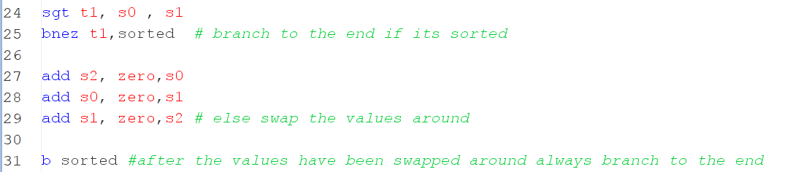
This code swaps the two numbers when they are out of order.

Expected Result

Test description | First number | Second number | Output at the end of the program
The values are not in descending order | 20 | 97 | Sorted: 97,20
The values are already in descending order | 97 | 20 | Sorted: 97,20
Both numbers the same | 97 | 97 | Sorted: 97, 97

Result
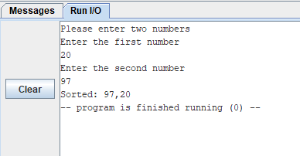
Because the input values were not in order, they were sorted and output correctly.

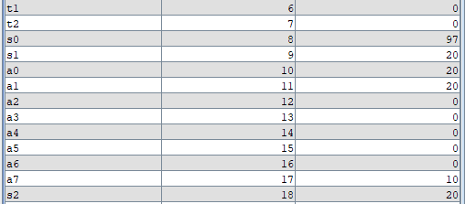
As visible in the registers, 97 and 20 were swapped around, as the s2 register was used to make a temporary copy of 20 whilst the values were swapped around.

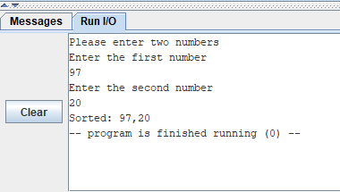
When the values are inputted in the correct order, they will be outputted in the correct order too.

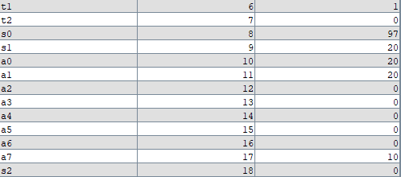

The values were not swapped around as the t1 stores 1, meaning the first input was greater than the second input, and the s2 register was not used.

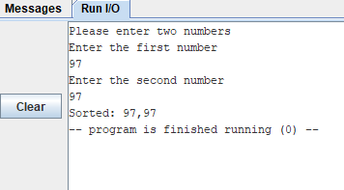

When the values are the same, the order in which they are outputted is the second input becomes the first output, as 97 is not greater than 97; therefore, they are swapped around, but the order does not matter.

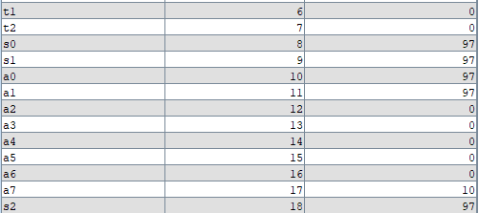
As shown here, t1 stays as 0, and the s2 register is used. Therefore, the values were swapped around unnecessarily, as 97 is not greater than 97; it's equivalent.

Alternative approach

Another method of swapping is the xor swap, which will swap the two values without requiring a temporary register like s2. It uses an xor bitwise to swap the two values around (BetterExplained, Swap two variables using XOR).

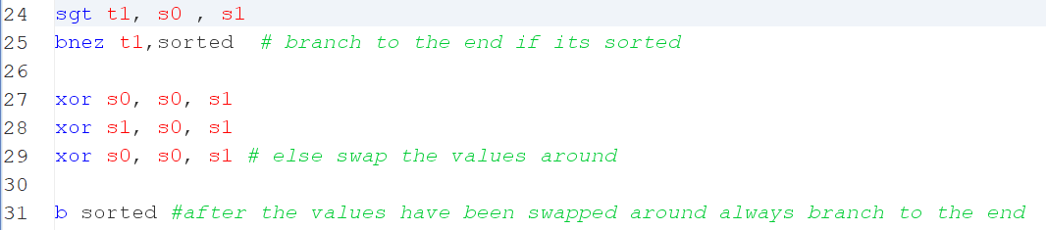
Test description | First number | Second number | Output at the end of the program
The values are not in descending order | 20 | 97 | Sorted: 97,20
The values are already in descending order | 97 | 20 | Sorted: 97,20
Both numbers the same | 97 | 97 | Sorted: 97, 97

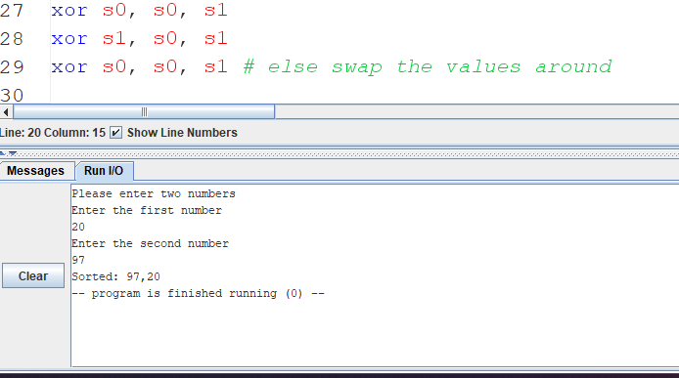
When the values are in the incorrect order.

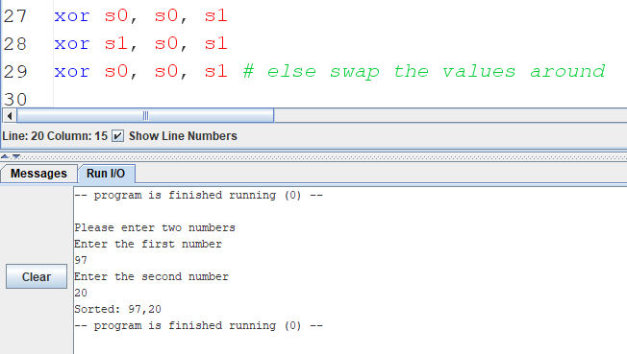

When the values are in the correct order.

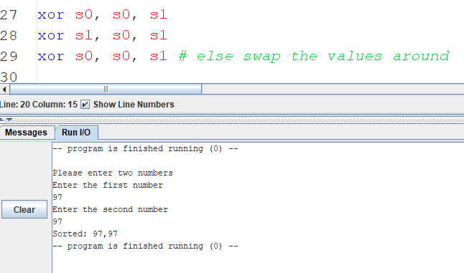
When the values are the same.

Explanation
The similarity between the two methods is that they both require 3 lines of code to complete the swap, which means that it has no impact on the instruction memory. However, a difference is that the xor method only uses two registers, whilst the other method uses 3. This means it has an impact on the data stored during the program's runtime and reduces it.

I prefer the xor method as it uses less memory, which may not seem insignificant; however, when the project gets bigger, like the game (2.8), and many registers are needed, it can have a big impact on what is possible.

My research has helped me understand that it is possible to swap two values without using a temporary variable, which I thought would not be possible.

Comparison

In RISC, the values are stored by using a temporary register to store one of the values, to move a value to a register, it needs to be added to that register using the zero register.

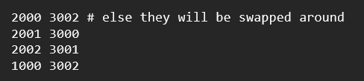
Whilst in the CPU simulation, it needs to load each value into the acc and then store it in another memory location, using and use a temporary memory location and keep loading into the acc and storing values in memory until it's in the correct order.

No additional research was used.

Counting down with a loop

Loop Code

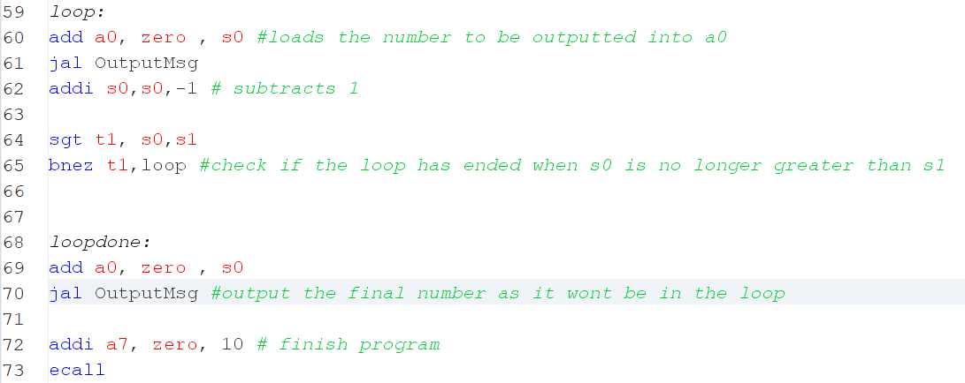

Results
Then scrolled right

Using student numbers

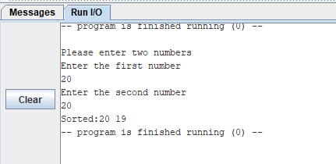
Using the same numbers

Alternative approach

The reason 19 was output was because bnez was used, which meant the lowest number at the end still had to be output. This was done after the loop to fix the issue, but it's a side effect of this approach.

In my research I have found out that there are other ways to set numbers other than set greater than when a>b c gets set to 1 else if it isn’t then it gets set to zero the however this doesn’t work well when the numbers are the same that is why another method to use is slt which is set less than when b>a c gets set to 1 else it gets set 0 this is useful as it allows us to only output integers inside the loop only which will prevent any errors and incorrect outputs however the output of this would be wrong that’s why it also needs the output to be inverted so that it is correct this can be achieved by doing an xor mask of an immediate value of 1 (xori)(Holy Cross Computer Science Department, 1998). This then gives the correct output to the bnez.

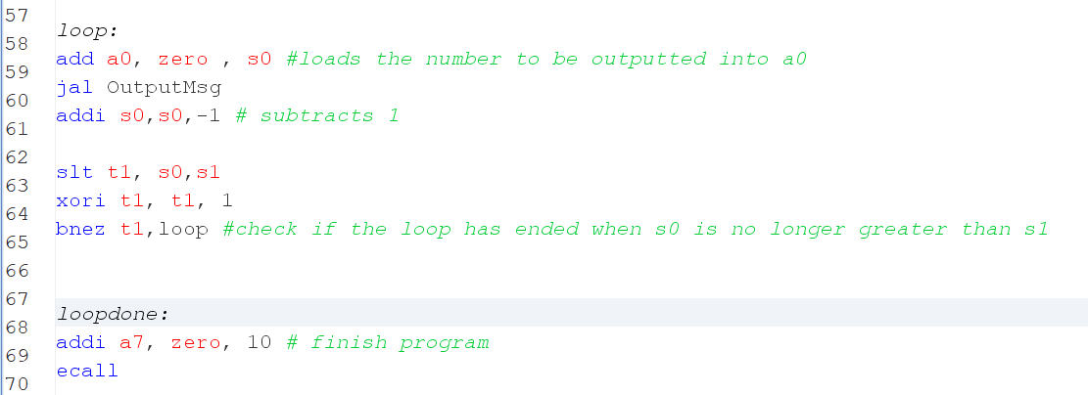

New code that was changed.
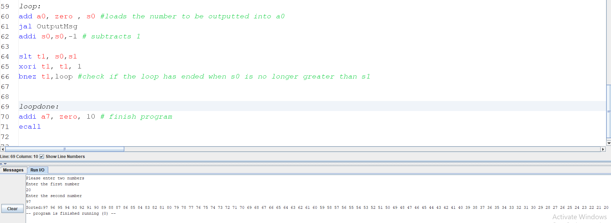
When the numbers are different.
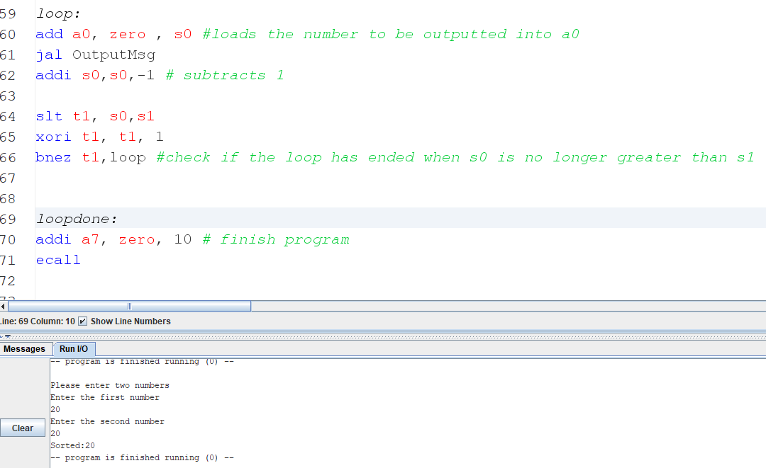
When the numbers are the same.

Explanation

The sgt approach will allow the loop output to range from the highest number inclusive to the lowest number exclusive, whilst the slt approach will allow the loop output to range from the highest number inclusive to the lowest number inclusive.
These different methods can both be useful depending on the context and what needs to be done.

The research has helped me understand different methods that a loop can be created using different value-setting ways. As well as helping me understand how I can flip a digit so that 1 becomes 0 and 0 becomes 1.

Making use of arrays

Pseudocode
In the loop that adds to the array instead of jumping and linking to output message it will jump to add to array

AddToArray:
Stores the value a0 which will store the value to be stored in base s6 which will start at the start of the array memory

Add 4 to s6 to access the next memory location in the array
Return to the the place that called it in the loop
After all the numbers are added to the array loop done will be looped through

S6 will reset to store the beginning address of the array

loopDone:
load the word from s6 into a0
add 1 to s7 which is a counter
branch to the end if a0 is 0 to prevent outputting every value in the array
jump to Output message
set t1 to 1 if s7 is less than 101 else 0
branch to loopDone if t1 is not equal to zero else end the program

Expected Results
The numbers should first be stored in the array, and then the array will be looped through, and all the values in it will be outputted. In the run i/o, there will be no difference in the output from the previous task; it’s just that the way the result gets outputted is different.

More registers should be seen being used as I’m using some additional ones to store the index of the array as well as some counters. I should also see 400 bytes reserved to store the numbers in memory as well as the numbers being stored there.

Result

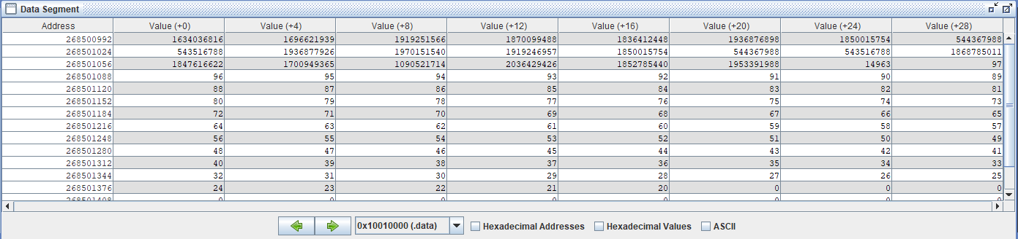

The result is as expected; all the numbers were displayed between the two entered numbers.

Explanation
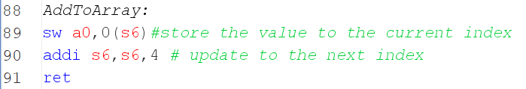
An array is a static data structure that can store a fixed number of elements. It can only store a specific type of element, e.g., an integer. All the elements are stored in continuous memory and can be accessed by their index, which is their position in the array.

This is how the array is added to; s6 stores the starting address at the beginning of the array, and a0 stores the value to be stored in the array. The item is added to the first address in the array, and then s6 is incremented by 4 to point to the next address to store the data in, so that the next time a value is added to the array, it's stored in the correct place.
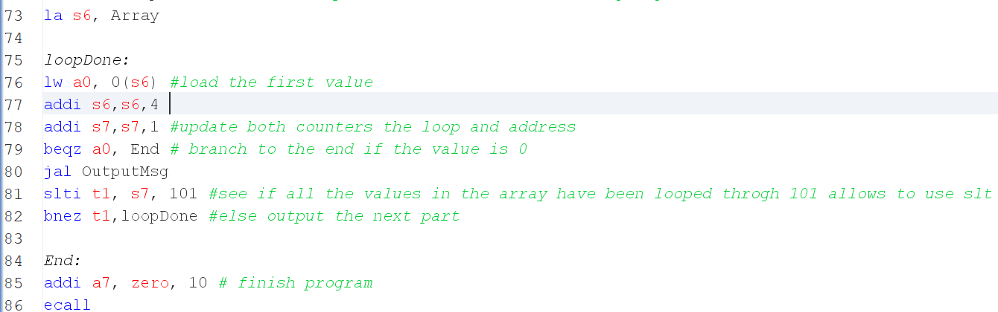

To loop through the array, the value of s6 needs to be reset to the starting address of the array so that all the values can be looped through. Then the first value is loaded into a0 so that it can be displayed.
S6 is incremented by 4 to point to the next address in the array and s7 is the loop counter which is as long as the length of the array which is 100 so s7 gets incremented by 1 each time to go through each element then it checks to see if it should loop again it compared against 101 so that slti can be used to save on the storage if it was compared against 100 the last element would have been missed as 100 is not less than 100. Before outputting the value it is check if the value is equal to zero if so all the values that were added to the array have been looped through and the only thing that is left is 0 which is unoccupied spaces in the array so it just jumps to the end if it’s not 0 then the message is outputted then at the end of the loop its checked if the entire array has been looped through if it hasn’t then it jumps back to the loop Done. No research was used.

Comparison
To use an array in the CPU simulation, it would be technically possible, as you can store multiple items in continuous memory locations (Kann, 2016); however, you would need to hard-code the values that need to be stored, which may not be that useful sometimes. The reason is that you can't store an address in memory only values, just to then be able to use it later. meaning you can't store where the array begins, so if you wanted to loop through the array, you wouldn’t know where to start. You also would not be able to add to the array to the next free address in the array, as it's not possible to store that, as well as increment that when something is added to the array. so, to be able to make an array in the CPU simulation, a method must be made where the value in the acc is used as the address to either load a value from memory or store a value to memory, which would be input 2 a memory address register(mar) and memory data register(mdr) would also need to be used the mar would store the address in which the data that’s needed to be fetched would be at whilst the mdr would store the data that was fetched the mar and mdr can be used in the same way but for storing to this allows for more registers other than the acc to be used and therefore would allow to fetch data from an address loaded into the mar and have the data stored in the mdr which is what the array would need.

It's also not possible to reserve memory for an array currently. To do that, you would need to store the address of where the array ends, and then if anything ever needs to be stored, it would be stored after the array ends

Research has shown me how it's possible to store different items in an array and what must be stored to ensure that items are added in the correct place in the array.

Designing a game

Naughts and Crosses (Tic Tac Toe) will be made. The rules are that it will be played by two players on the same computer on a 3x3 grid. The players will take turns placing their piece on the grid. A player wins when their pieces are in a diagonal, horizontal, or vertical position. A player will not be able to place a piece on an already occupied square.

This will be achieved by having a string that stores the entire grid. This can be achieved by using a new line every time the next segment of the grid needs to be drawn. The string can then store the entire game, and when I need to output the grid, I simply print the string.

To edit the string so that the players' pieces placed are visible, it can just use risc v store byte, which will just override anything in a specific grid position, allowing the player to see what they have placed.

It will also need a method to allow the player to input where they want to place their piece the way It will do this Is by having the player input an integer from 1-9 where 1 will be top left 2 will be top middle 3 will be top right etc. then It can take the number input and convert it into the string position to know which character in the string I need to override.

This will also allow me to check for a wins by just checking each character in the different grids against each other for example if It has a b and c a horizontal win It can just check if a and b and a and c are the same and if they are then the player has won It also need to make sure that a is not a space as this would mean that it would be a win even though it isn’t.

Stage 1

The string containing the grid will simply be outputted like this.
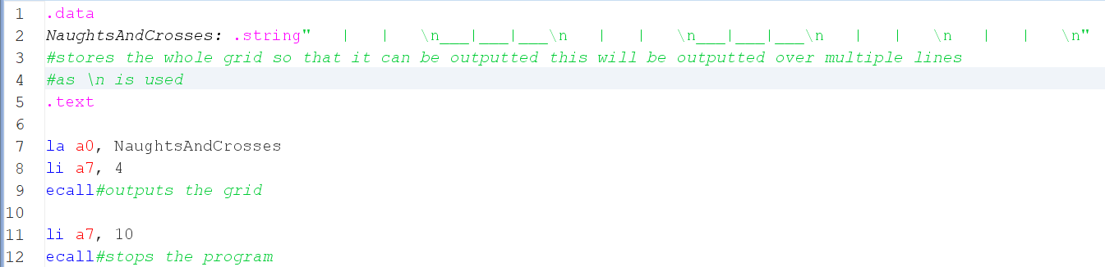

This is the output then

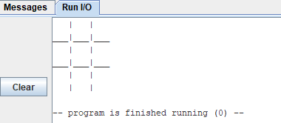

This grid was made entirely by me using the underscore character and the vertical line character and new lines to make the grid to ensure everything is evenly spread out. I made sure each line has the same number of characters. This will be useful later when a calculation is needed to calculate the position in the string from the player's input.

And then if I want to add something to the grid, I just need to replace the empty spaces with characters.

Then this is what it will look like in the game.

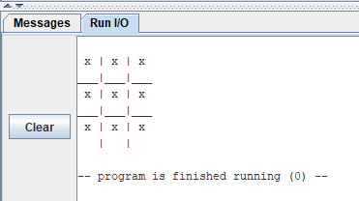

To override the character in a grid, I will just need to use store byte and then the address + the base, which will be the position of the character in the string

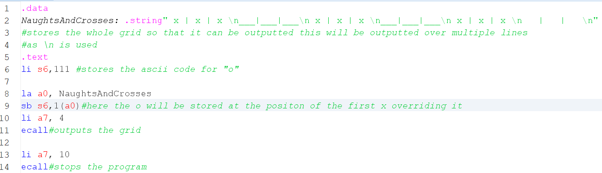
This is how this can be achieved.

Then this is the result of this code.

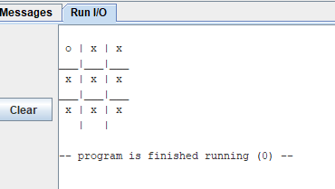

As shown, the original character “x” is gone and has been replaced by “o”.

This is everything for stage 1. It was more about setting it up and also seeing if my idea was possible, and now that it's proven to be possible. Stage 2 will now be done.

Stage 2

Now the player will be allowed to make an input by inputting a number from 0 to 9, and that will correspond to a grid, and the number they input will be the square that they place their piece on.
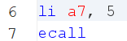

This is all that needs to be done to get the input from the player, and whatever the player inputs will be stored in a0.

However, there is currently no way to convert the player input to a string position.

There are two possible options for making this happen

- An array is made with each value already precalculated and stored inside the array.
And then when it needs to access the string position, it just gets it from the array.

- Make a formula that can calculate what needs to be accessed. This is possible as earlier each line had the same number of characters, and now it can take advantage of this, as all the rows and columns are evenly spread out, allowing me to calculate what needs to be accessed
It will also require about 3 or 2 registers to calculate
I chose to go with option 2 as it's quicker, which is needed for a game like mine, and more space efficient, as there is no array required.

To make the formula, I looked at the sequence of numbers and figured out that between the each number in a row there is a gap of 4 between the pieces however between each row there is a gap of 24 using this a formula can be made the calculation will start relative to 1 not 0 as that is where the first character is in the string and therefore the sequence so its calculated onwards from that
first of all to calculate how many times 24 is added on it need a formula that will do that so that if the number is 1-3 nothing is added on as it’s in the same row as 1 so there’s no need to go to the next row if the number is 4-6 then 24 needs to be added on as the second row is now accessed and 7-9 would be 24+24 so it would be 48 added on.
The formula for this is

(n / 3 * 24)

This formula almost works, however, when n is 9, I get 72, so to fix this, I will just do n = n-1 before the this calculation and that fixes it now I need to add another formula that will let me move along a row so for example if the the user enters 3 then I need to add 4 twice to get the result

(n %3*4)

This is what I can use to calculate it basically, if the number is 1 = +4 2 = +8 3 = +0 4 = +4 5 = +8 etc
This is what this formula does for this formula to work, it will also use the n = n-1 as this aligns the numbers correctly with 3
The last thing that is needed is to do +1, as it will start relative to the first position, which is 1
So, the final formula will be

n = number -1
(n / 3 * 24) + (n%3*4) + 2

And this is something I can make in RISC as I can use REM in risc, which stands for remainder, which is the same as modulo(%).

The values that I will use in this calculation will be defined at the start, not in the code. This is because It only needs to define them once, and if I ever need to change the values, as I add more characters to the string, it will be easier to change the values this way.

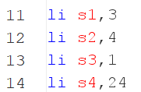

Then this is the complete function for the calculation. I will only need to store the user input in a0 and then call the function.

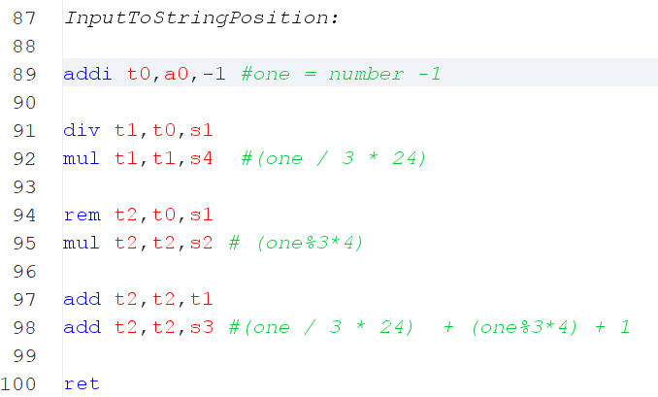

And now it is possible to override the string based on the player's input by calculating from the player's input the string position and just overriding it at that position.

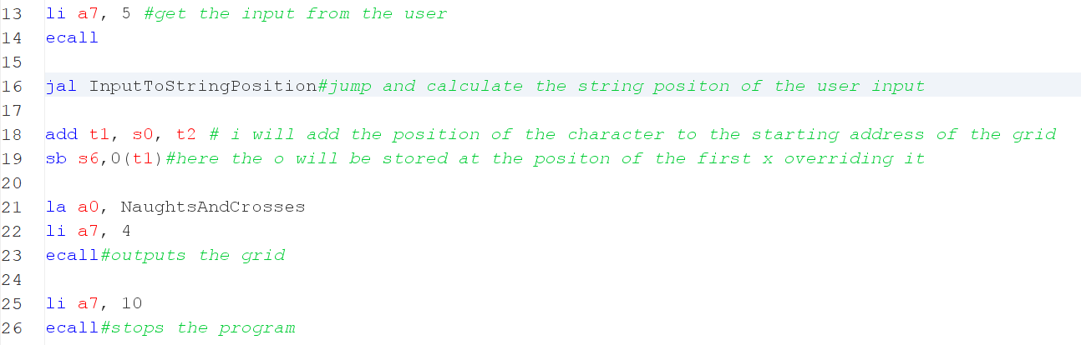
and this is the result of this.

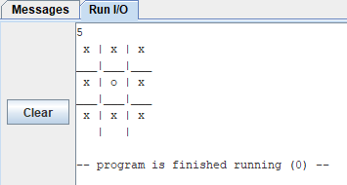

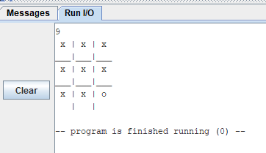

Stage 3

Currently, there is no way to check for a win; this feature will be added now.

There are 8 possible options for a win in tic-tac-toe.

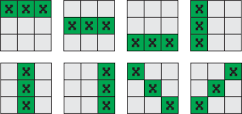

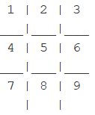
If it's assumed that each square is given a number like this, then the possible win options are:

1,2,3
4,5,6
7,8,9
1,4,7
2,5,8
1,5,9
3,5,7

However, it doesn’t always need to check all 8 possible combinations every single time, as that would be inefficient. Instead, it's possible to entirely skip some checks if the next check uses a square that cannot be a winning square; then there is no point in checking.
To do this, the sequences need to be put into groups with common numbers, and these groups look like this.

Group 1 common number(1)
1,2,3
1,5,9
1,4,7

Group 2 common number(5)
3,5,7
4,5,6
2,5,8

Group 3 common number(9)
7,8,9
3,6,9

And then check the wins in this sequence, this gives me an advantage as if 1 is a space character, that means nothing was placed there, therefore there is no point in checking 1,4,7 and 1,5,9 as
Those can’t win therefore it just branches to the next group which means the program can run faster as unnecessary checks don’t happen same thing happens with other groups however if 1 has a valid character and the first check with in the group is valid then the next check in the group will happen as the first check not being a win does not mean that the next check also won’t be a win.

This way, It can strategically check for a win.

The way that It will check for a win in one sequence is just doing two comparisons for example if 1,2,3 needs to be checked it will just check if 1,2 is equal and that 2,3 are equal and if both of these are true then a win has happened however a check first needs to be made to ensure that 1 isn’t a space character as without this check it could still count as a win even though it shouldn’t.

It will also store the character that every square stores in the registers. This is so that I can easily just compare the registers instead of going into data and using it in an array, as that would take longer, so I just use the registers, which indicate which square character is stored by which register.

a1 = (1)
a2 = (2)
a3 = (3)
a4 = (4)
a6 = (5)
t4 = (6)
a5 = (7)
t5 = (8)
t3 = (9)

however, since I already know the value that these registers will store, I don’t need to call the function to calculate the string position. I can just store the value directly, which is faster.

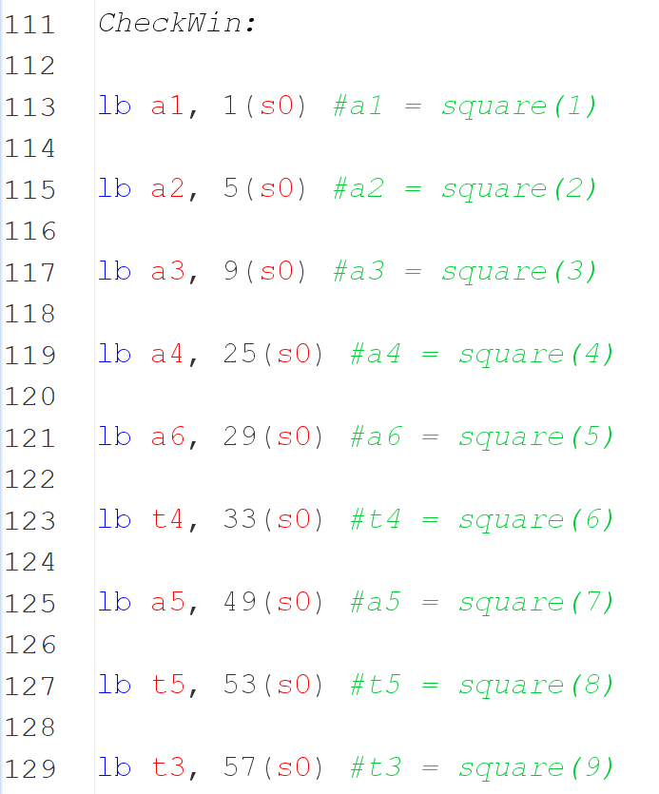

Now that it's known which character a square store, the registers can be compared to check for a win, and if it happened.

This is all the code used to make those comparisons, as well as branch to other groups.
S5 stores 32, which is the ASCII code for space, so that comparisons can happen.
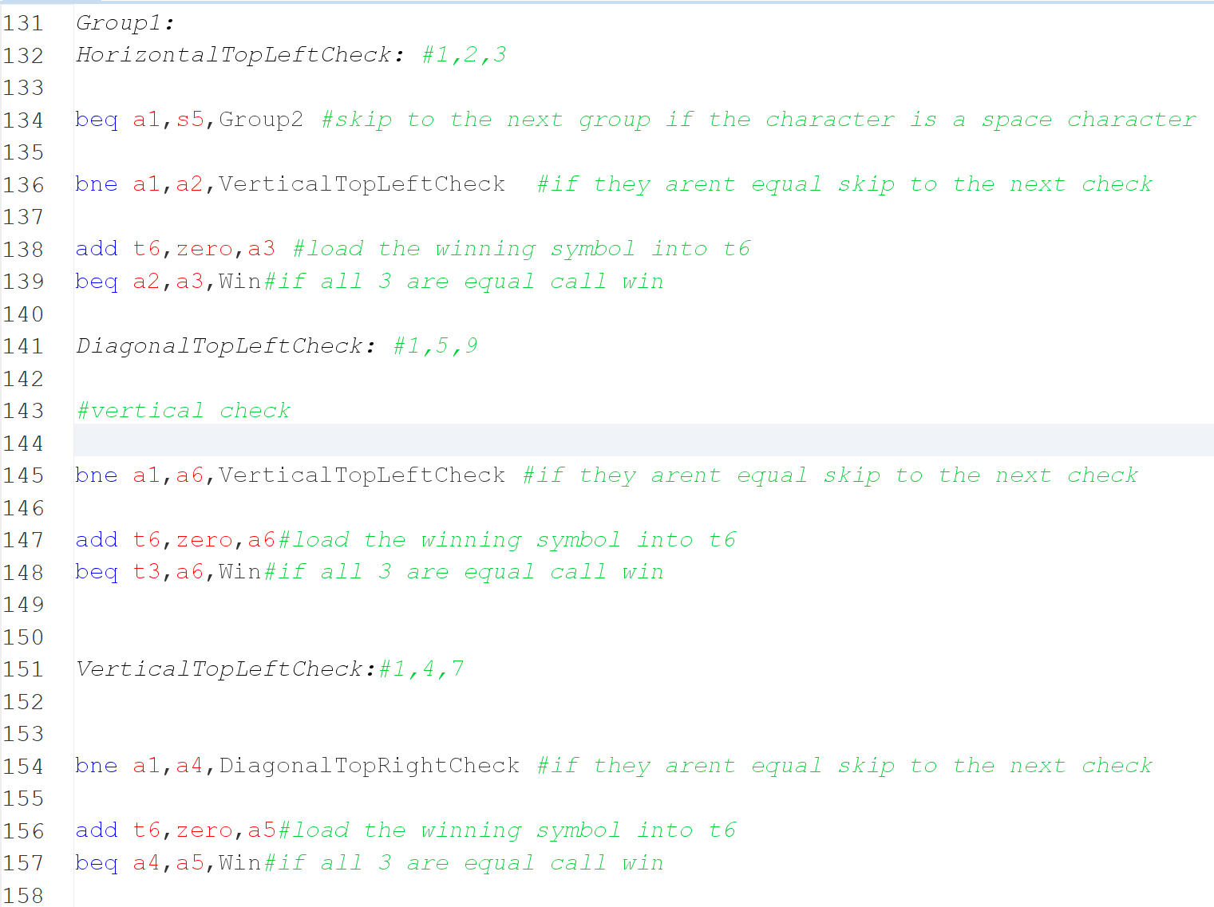

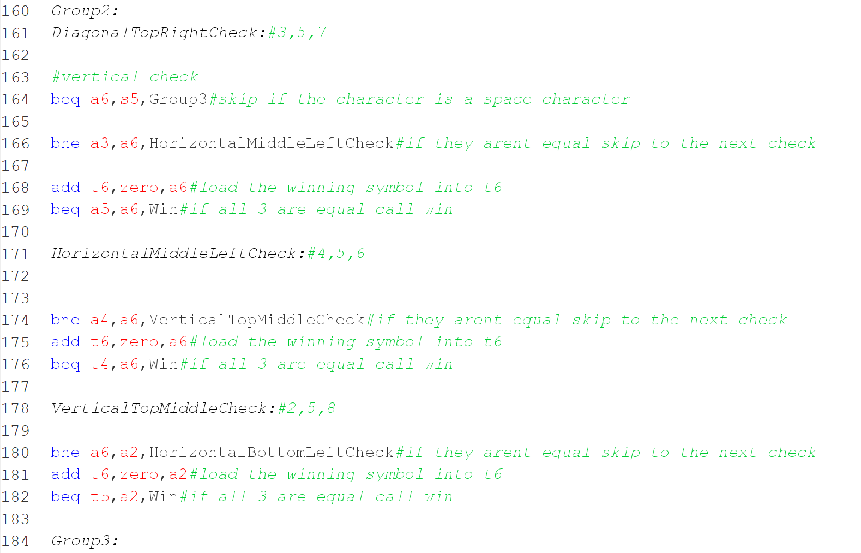

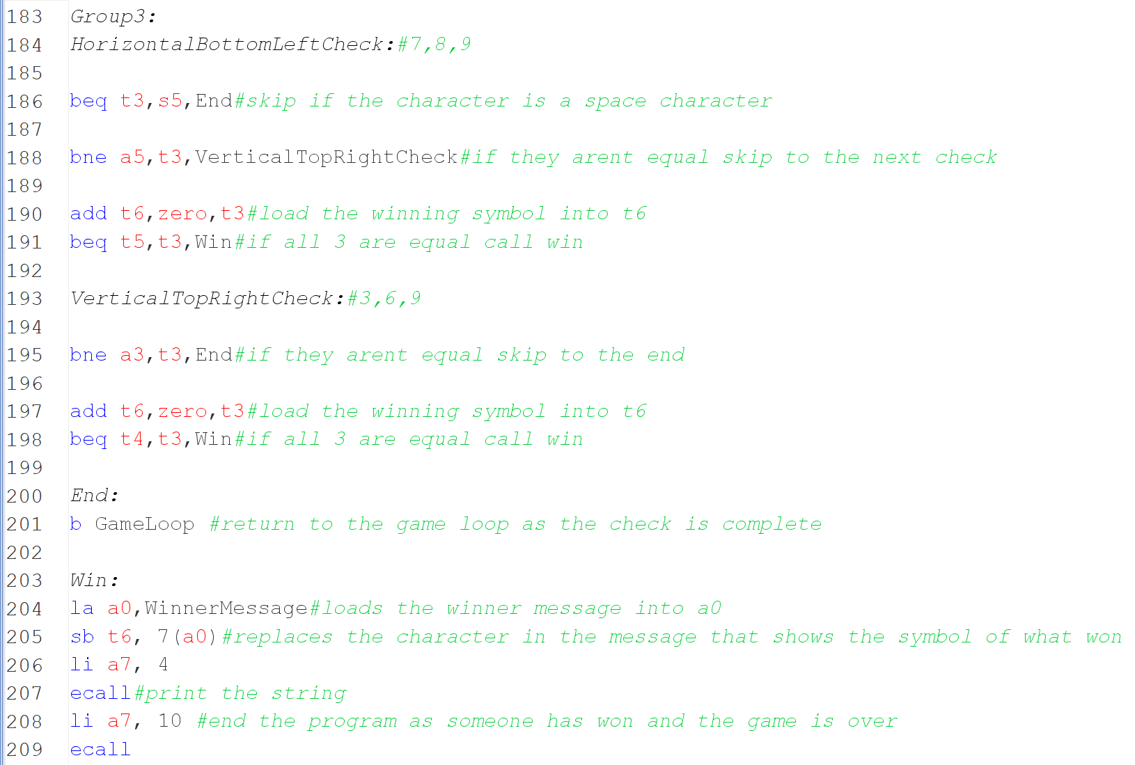

This is all the checks done in the order stated before. It’s possible to check every single number before doing a check and then branching if it’s not correct however if the branching doesn’t happen over more than 2 checks it’s not worth it as each check has 3 or 4 lines of code however the branching check would take 2 lines therefore having many would not have a big impact on performance but would increase the number of lines massively so it’s best to just branch from group to group rather than check to check.

This is the result.
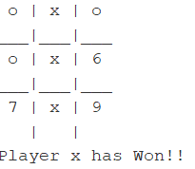
I have also replaced the empty spaces with the number of each square, making it easier for the player to pick a square.
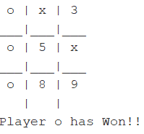

Something else that was added is the game loop. This is the loop that runs constantly during the game's execution and just uses a branch always at the end of the loop, so that the same instructions, such as asking for player input, happen many times until the game ends.

Currently, the game can allow the player to place the same pieces on the board and check for a win however something else that needs to be added is that different pieces can be placed on the board which are x and o and when the turns change from one player to another the piece placed also changes and so more constant registers needs to be defined 2 registers for storing x and o ascii code and also the current piece that is playing then when they change you can just output the current piece that is selected so the players know who is playing.

And also switching around the current piece allows the correct message to be output, as different branching will happen based on what is stored in the current.

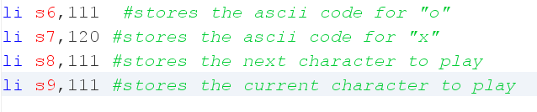

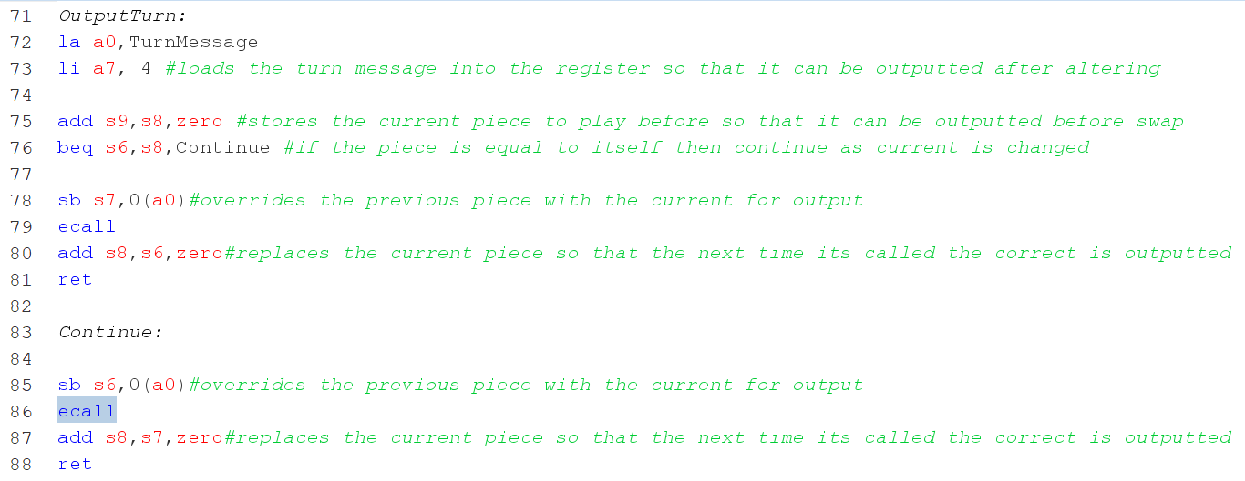

Now this is what the output looks like 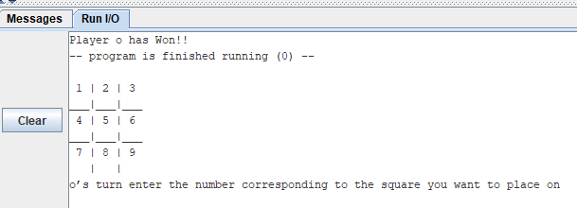

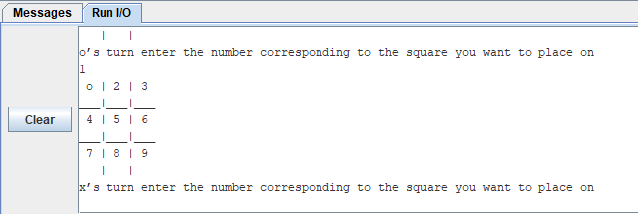

There will also be some error checking so that characters can't be placed on already existing characters on the grid; instead, a message is shown telling the player the input is incorrect.
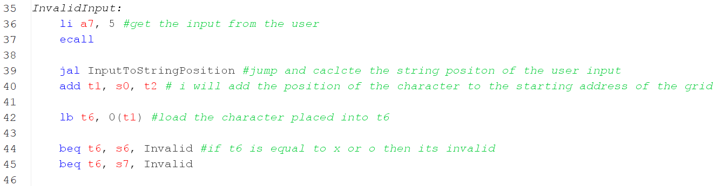

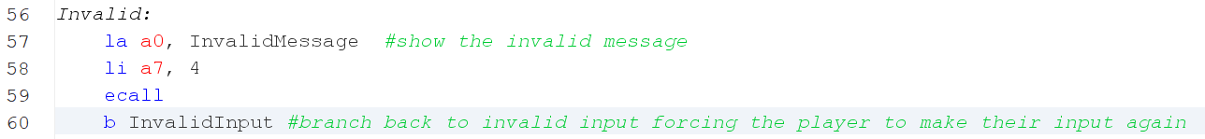

This also isn’t perfect yet, as the player can enter any number, not just 1-9, so that also needs to be prevented from happening by doing a simple check.

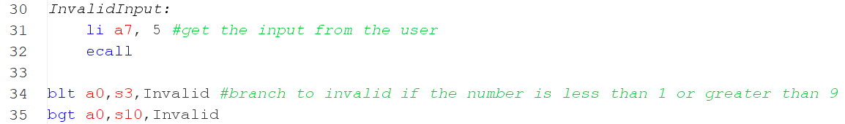

And now this is the output

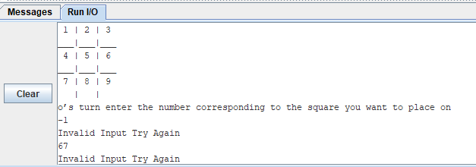

Another issue is that there is no drawing condition if all the squares are occupied, and no win happens, the game basically soft locks, where every input is invalid, but the game still runs.

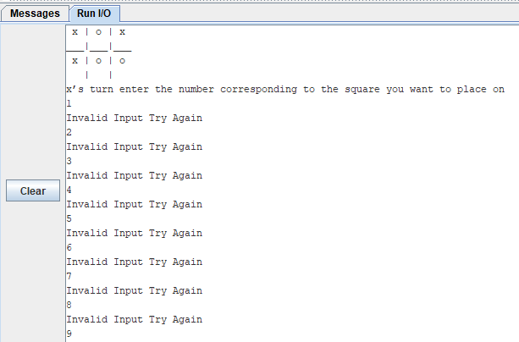
It will simply use s11 as a counter, and every time a piece is placed, 1 is added to s11. If s11 equals 9, it means all the squares are occupied, and it’s a draw. Therefore, it branches to another part of the code to end the game and display the draw message.

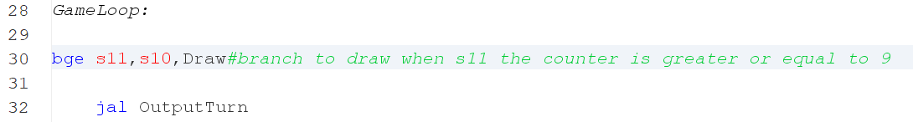

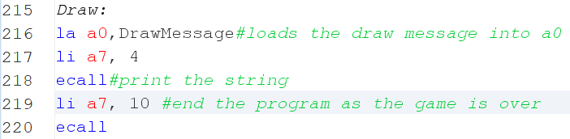

And then this is the result

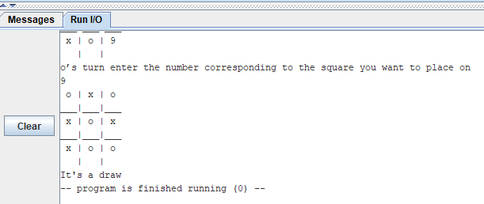

References

Webopedia Staff (2021) What is ASCII Available at: https://www.webopedia.com/definitions/extended-ascii/
(Accessed: 10 November 2025).

CSNewbs (2025) Assembly Language — Branching. Available at: https://www.csnewbs.com/assemblylanguage
Accessed 11 November 2025].

Rollins, D. (2009) Fast Hexadecimal Encode and Decode. Available at: https://www.experts-exchange.com/articles/1290/Fast-Hexadecimal-Encode-and-Decode.html [Accessed 11 November 2025].

Nelson Darwin Pak Tech (2021) Random binary numbers generation in Logisim Available at: https://www.youtube.com/watch?v=TIUbMvBUhOI [Accessed 12 November 2025].

BetterExplained. Swap two variables using XOR. Available at: https://betterexplained.com/articles/swap-two-variables-using-xor/ [Accessed: 1st December 2025].

DWF, 2022. Branches, decisions, and loops. Programmed Introduction to MIPS. Available at: https://courses.dwf.dev/docs/mips/programmed-introduction/branches-decisions-loops [Accessed 6 December 2025].

Holy Cross Computer Science Department, 1998. MIPS Instruction Reference. Available at: https://mathcs.holycross.edu/~csci226/MIPS/MIPS_InstructionReference.html [Accessed 6 December 2025].

Kann, C.W. (2016) Array Definition and Creation in Assembly. In: Introduction to MIPS Assembly Language Programming. Engineering LibreTexts. Available at: https://eng.libretexts.org/Bookshelves/Computer_Science/Programming_Languages/Introduction_To_MIPS_Assembly_Language_Programming_(Kann)/09%3A_Arrays/9.02%3A_Array_Definition_and_Creation_in_Assembly (Accessed: 10 December 2025).

Appendix A: The CPU Simulation Code

<?xml version="1.0" encoding="UTF-8" standalone="no"?>
<project source="4.0.0" version="1.0">
This file is intended to be loaded by Logisim-evolution v4.0.0(https://github.com/logisim-evolution/).

<lib desc="#Wiring" name="0">
<tool name="Pin">
<a name="appearance" val="classic"/>
</tool>
</lib>
<lib desc="#Gates" name="1"/>
<lib desc="#Plexers" name="2"/>
<lib desc="#Arithmetic" name="3"/>
<lib desc="#Memory" name="4"/>
<lib desc="#I/O" name="5"/>
<lib desc="#TTL" name="6"/>
<lib desc="#TCL" name="7"/>
<lib desc="#Base" name="8"/>
<lib desc="#BFH-Praktika" name="9"/>
<lib desc="#Input/Output-Extra" name="10"/>
<lib desc="#Soc" name="11"/>
<main name="CPU_main"/>
<options>
<a name="gateUndefined" val="ignore"/>
<a name="simlimit" val="1000"/>
<a name="simrand" val="0"/>
</options>
<mappings>
<tool lib="8" map="Button2" name="Menu Tool"/>
<tool lib="8" map="Button3" name="Menu Tool"/>
<tool lib="8" map="Ctrl Button1" name="Menu Tool"/>
</mappings>
<toolbar>
<tool lib="8" name="Poke Tool"/>
<tool lib="8" name="Edit Tool"/>
<tool lib="8" name="Wiring Tool"/>
<tool lib="8" name="Text Tool"/>
<sep/>
<tool lib="0" name="Pin"/>
<tool lib="0" name="Pin">
<a name="facing" val="west"/>
<a name="type" val="output"/>
</tool>
<sep/>
<tool lib="1" name="NOT Gate"/>
<tool lib="1" name="AND Gate"/>
<tool lib="1" name="OR Gate"/>
<tool lib="1" name="XOR Gate"/>
<tool lib="1" name="NAND Gate"/>
<tool lib="1" name="NOR Gate"/>
<sep/>
<tool lib="4" name="D Flip-Flop"/>
<tool lib="4" name="Register"/>
</toolbar>
<circuit name="CPU_main">
<a name="appearance" val="logisim_evolution"/>
<a name="circuit" val="CPU_main"/>
<a name="circuitnamedboxfixedsize" val="true"/>
<a name="simulationFrequency" val="2.0"/>
<comp lib="0" loc="(1210,10)" name="Pin">
<a name="appearance" val="NewPins"/>
<a name="label" val="GreaterThanButton"/>
</comp>
<comp lib="0" loc="(1210,40)" name="Pin">
<a name="appearance" val="NewPins"/>
<a name="label" val="LessThanButton"/>
</comp>
<comp lib="0" loc="(1280,350)" name="Constant">
<a name="facing" val="south"/>
<a name="value" val="0x0"/>
<a name="width" val="8"/>
</comp>
<comp lib="0" loc="(1300,350)" name="Constant">
<a name="facing" val="south"/>
<a name="width" val="8"/>
</comp>
<comp lib="0" loc="(210,100)" name="Constant">
<a name="width" val="8"/>
</comp>
<comp lib="0" loc="(360,120)" name="Constant"/>
<comp lib="0" loc="(460,450)" name="Clock">
<a name="appearance" val="classic"/>
<a name="facing" val="south"/>
</comp>
<comp lib="0" loc="(900,210)" name="Splitter">
<a name="bit1" val="0"/>
<a name="bit2" val="0"/>
<a name="bit3" val="0"/>
<a name="bit4" val="0"/>
<a name="bit5" val="0"/>
<a name="bit6" val="0"/>
<a name="bit7" val="1"/>
<a name="incoming" val="8"/>
</comp>
<comp lib="0" loc="(950,100)" name="Pin">
<a name="appearance" val="NewPins"/>
<a name="facing" val="west"/>
<a name="label" val="Clockk"/>
<a name="type" val="output"/>
</comp>
<comp lib="0" loc="(950,130)" name="Pin">
<a name="appearance" val="NewPins"/>
<a name="facing" val="west"/>
<a name="label" val="WriteEnable"/>
<a name="type" val="output"/>
</comp>
<comp lib="0" loc="(950,160)" name="Pin">
<a name="appearance" val="NewPins"/>
<a name="facing" val="west"/>
<a name="label" val="Clear_TTY"/>
<a name="type" val="output"/>
</comp>
<comp lib="0" loc="(950,70)" name="Pin">
<a name="appearance" val="NewPins"/>
<a name="facing" val="west"/>
<a name="label" val="TTY_Data"/>
<a name="radix" val="16"/>
<a name="type" val="output"/>
<a name="width" val="7"/>
</comp>
<comp lib="1" loc="(1230,350)" name="OR Gate">
<a name="facing" val="south"/>
<a name="size" val="30"/>
</comp>
<comp lib="1" loc="(450,190)" name="AND Gate">
<a name="facing" val="west"/>
<a name="size" val="30"/>
</comp>
<comp lib="1" loc="(470,490)" name="AND Gate">
<a name="facing" val="south"/>
<a name="size" val="30"/>
</comp>
<comp lib="2" loc="(1290,370)" name="Multiplexer">
<a name="facing" val="south"/>
<a name="size" val="20"/>
<a name="width" val="8"/>
</comp>
<comp lib="2" loc="(360,100)" name="Multiplexer">
<a name="width" val="8"/>
</comp>
<comp lib="2" loc="(480,400)" name="Multiplexer">
<a name="facing" val="south"/>
<a name="size" val="20"/>
</comp>
<comp lib="2" loc="(860,530)" name="Multiplexer">
<a name="selloc" val="tr"/>
<a name="width" val="8"/>
</comp>
<comp lib="3" loc="(270,90)" name="Adder"/>
<comp lib="4" loc="(1020,410)" name="Register">
<a name="appearance" val="logisim_evolution"/>
<a name="label" val="ACC"/>
</comp>
<comp lib="4" loc="(360,70)" name="Register">
<a name="appearance" val="logisim_evolution"/>
<a name="label" val="PC"/>
</comp>
<comp lib="4" loc="(550,450)" name="RAM">
<a name="appearance" val="classic"/>
<a name="asyncread" val="true"/>
<a name="clearpin" val="true"/>
<a name="label" val="Data_Memory"/>
<a name="labelfont" val="SansSerif bold 14"/>
<a name="labelvisible" val="true"/>
</comp>
<comp lib="4" loc="(600,30)" name="ROM">
<a name="appearance" val="classic"/>
<a name="contents">addr/data: 8 16
2022 10ff 3002 5048 5069 5067 5068 5065
5072 5020 506f 5072 5020 504c 506f 5077
5065 5072 500a 502d 5054 5077 506f 5020
506e 5075 506d 5062 5065 5072 5073 5020
5067 5065 506e 5065 5072 5061 5074 5065
5064 500a 502d 5059 506f 5075 5020 5073
5065 5065 5020 506f 506e 5065 502c 5020
5067 5075 5065 5073 5073 5020 5069 5066
5020 5068 5069 5064 5064 5065 506e 5020
5069 5073 5020 5068 5069 5067 5068 5065
5072 502f 506c 506f 5077 5065 5072 500a
502d 5052 5069 5067 5068 5074 5020 503d
5020 5063 506f 506e 5074 5069 506e 5075
5065 502c 5020 5057 5072 506f 506e 5067
5020 503d 5020 506c 506f 5073 5065 500a
502d 5050 5072 5065 5073 5073 5020 5061
506e 5079 5020 506b 5065 5079 5000 7000
1700 3000 1700 3001 2002 1101 3002 2000
2501 3003 6000 1069 5000 1073 5000 1020
5000 2000 1a64 1601 5000 2000 1a0a 1b0a
1601 5000 2000 1b0a 1601 5000 5020 5048
5069 5067 5068 5065 5072 5020 506f 5072
5020 504c 506f 5077 5065 5072 5020 7000
1800 2903 4088 6000 5047 5061 506d 5065
5020 504f 5076 5065 5072 5021 500a 5053
5063 506f 5072 5065 503a 5020 2002 1a64
1601 5000 2002 1a0a 1b0a 1601 5000 2002
1b0a 1601 5000 500a 5050 5072 5065 5073
5073 5020 5061 506e 5079 5020 506b 5065
5079 5020 5074 506f 5020 5070 506c 5061
5079 5020 5061 5067 5061 5069 506e 5000
7000 1001 6000 4000 f000
</a>
<a name="dataWidth" val="16"/>
<a name="label" val="Instruction_Memory"/>
<a name="labelfont" val="SansSerif bold 14"/>
<a name="labelvisible" val="true"/>
</comp>
<comp lib="8" loc="(1050,205)" name="Text">
<a name="font" val="SansSerif plain 20"/>
<a name="text" val="Student id: 25869720"/>
</comp>
<comp loc="(1160,240)" name="ALU"/>
<comp loc="(420,230)" name="Instruction_Decoding_Unit"/>
<wire from="(1000,360)" to="(1000,440)"/>
<wire from="(1000,360)" to="(1160,360)"/>
<wire from="(1000,440)" to="(1020,440)"/>
<wire from="(1020,480)" to="(1020,640)"/>
<wire from="(1080,440)" to="(1150,440)"/>
<wire from="(1150,440)" to="(1150,620)"/>
<wire from="(1160,240)" to="(1190,240)"/>
<wire from="(1160,260)" to="(1160,360)"/>
<wire from="(1190,240)" to="(1190,340)"/>
<wire from="(1210,10)" to="(1240,10)"/>
<wire from="(1210,40)" to="(1220,40)"/>
<wire from="(1220,40)" to="(1220,320)"/>
<wire from="(1230,350)" to="(1230,370)"/>
<wire from="(1240,10)" to="(1240,300)"/>
<wire from="(1240,300)" to="(1240,320)"/>
<wire from="(1240,300)" to="(1260,300)"/>
<wire from="(1260,300)" to="(1260,360)"/>
<wire from="(1260,360)" to="(1270,360)"/>
<wire from="(1290,370)" to="(1290,390)"/>
<wire from="(170,140)" to="(170,520)"/>
<wire from="(170,140)" to="(360,140)"/>
<wire from="(170,520)" to="(170,640)"/>
<wire from="(170,520)" to="(470,520)"/>
<wire from="(170,640)" to="(890,640)"/>
<wire from="(190,210)" to="(190,230)"/>
<wire from="(190,210)" to="(860,210)"/>
<wire from="(190,230)" to="(200,230)"/>
<wire from="(200,40)" to="(200,80)"/>
<wire from="(200,40)" to="(520,40)"/>
<wire from="(200,80)" to="(230,80)"/>
<wire from="(210,100)" to="(230,100)"/>
<wire from="(270,90)" to="(330,90)"/>
<wire from="(320,110)" to="(320,170)"/>
<wire from="(320,110)" to="(330,110)"/>
<wire from="(320,170)" to="(590,170)"/>
<wire from="(340,120)" to="(340,190)"/>
<wire from="(340,190)" to="(450,190)"/>
<wire from="(420,100)" to="(520,100)"/>
<wire from="(420,230)" to="(940,230)"/>
<wire from="(420,250)" to="(860,250)"/>
<wire from="(420,270)" to="(840,270)"/>
<wire from="(420,290)" to="(540,290)"/>
<wire from="(420,310)" to="(520,310)"/>
<wire from="(420,330)" to="(820,330)"/>
<wire from="(420,350)" to="(920,350)"/>
<wire from="(420,370)" to="(450,370)"/>
<wire from="(420,390)" to="(440,390)"/>
<wire from="(420,410)" to="(510,410)"/>
<wire from="(440,360)" to="(440,390)"/>
<wire from="(440,360)" to="(470,360)"/>
<wire from="(450,370)" to="(450,390)"/>
<wire from="(450,390)" to="(460,390)"/>
<wire from="(460,450)" to="(460,460)"/>
<wire from="(470,360)" to="(470,380)"/>
<wire from="(470,490)" to="(470,520)"/>
<wire from="(470,520)" to="(550,520)"/>
<wire from="(480,180)" to="(530,180)"/>
<wire from="(480,200)" to="(520,200)"/>
<wire from="(480,400)" to="(480,460)"/>
<wire from="(490,370)" to="(1230,370)"/>
<wire from="(490,370)" to="(490,380)"/>
<wire from="(510,410)" to="(510,460)"/>
<wire from="(510,410)" to="(590,410)"/>
<wire from="(510,460)" to="(550,460)"/>
<wire from="(520,200)" to="(520,310)"/>
<wire from="(520,40)" to="(520,100)"/>
<wire from="(520,40)" to="(600,40)"/>
<wire from="(530,180)" to="(530,340)"/>
<wire from="(530,340)" to="(1190,340)"/>
<wire from="(530,540)" to="(530,620)"/>
<wire from="(530,540)" to="(550,540)"/>
<wire from="(530,620)" to="(900,620)"/>
<wire from="(540,290)" to="(540,500)"/>
<wire from="(540,500)" to="(550,500)"/>
<wire from="(590,170)" to="(590,410)"/>
<wire from="(590,410)" to="(820,410)"/>
<wire from="(790,540)" to="(830,540)"/>
<wire from="(820,220)" to="(820,330)"/>
<wire from="(820,220)" to="(940,220)"/>
<wire from="(820,410)" to="(820,520)"/>
<wire from="(820,520)" to="(830,520)"/>
<wire from="(840,270)" to="(840,510)"/>
<wire from="(840,90)" to="(860,90)"/>
<wire from="(860,250)" to="(860,460)"/>
<wire from="(860,460)" to="(1020,460)"/>
<wire from="(860,530)" to="(880,530)"/>
<wire from="(860,90)" to="(860,210)"/>
<wire from="(880,280)" to="(880,530)"/>
<wire from="(880,280)" to="(940,280)"/>
<wire from="(890,100)" to="(890,300)"/>
<wire from="(890,100)" to="(950,100)"/>
<wire from="(890,300)" to="(890,640)"/>
<wire from="(890,300)" to="(940,300)"/>
<wire from="(890,640)" to="(1020,640)"/>
<wire from="(900,210)" to="(900,260)"/>
<wire from="(900,260)" to="(900,620)"/>
<wire from="(900,260)" to="(940,260)"/>
<wire from="(900,620)" to="(1150,620)"/>
<wire from="(920,210)" to="(920,350)"/>
<wire from="(920,210)" to="(930,210)"/>
<wire from="(920,70)" to="(920,190)"/>
<wire from="(920,70)" to="(950,70)"/>
<wire from="(930,160)" to="(930,210)"/>
<wire from="(930,160)" to="(950,160)"/>
<wire from="(930,320)" to="(930,390)"/>
<wire from="(930,320)" to="(940,320)"/>
<wire from="(930,390)" to="(1290,390)"/>
<wire from="(940,130)" to="(940,220)"/>
<wire from="(940,130)" to="(950,130)"/>
<wire from="(940,230)" to="(940,240)"/>
<wire from="(940,300)" to="(950,300)"/>
</circuit>
<circuit name="Instruction_Decoding_Unit">
<a name="appearance" val="logisim_evolution"/>
<a name="circuit" val="Instruction_Decoding_Unit"/>
<a name="circuitnamedboxfixedsize" val="true"/>
<a name="simulationFrequency" val="2.0"/>
<comp lib="0" loc="(160,170)" name="Pin">
<a name="appearance" val="NewPins"/>
<a name="label" val="Instruction"/>
<a name="labelfont" val="SansSerif bold 12"/>
<a name="radix" val="16"/>
<a name="width" val="16"/>
</comp>
<comp lib="0" loc="(170,170)" name="Splitter">
<a name="appear" val="right"/>
<a name="bit0" val="2"/>
<a name="bit1" val="2"/>
<a name="bit10" val="0"/>
<a name="bit11" val="0"/>
<a name="bit12" val="1"/>
<a name="bit13" val="1"/>
<a name="bit14" val="1"/>
<a name="bit15" val="1"/>
<a name="bit3" val="2"/>
<a name="bit4" val="2"/>
<a name="bit5" val="2"/>
<a name="bit6" val="2"/>
<a name="bit7" val="2"/>
<a name="bit8" val="0"/>
<a name="bit9" val="0"/>
<a name="fanout" val="3"/>
<a name="incoming" val="16"/>
<a name="spacing" val="3"/>
</comp>
<comp lib="0" loc="(600,140)" name="Pin">
<a name="appearance" val="NewPins"/>
<a name="facing" val="west"/>
<a name="label" val="Write_ACC"/>
<a name="labelfont" val="SansSerif bold 12"/>
<a name="type" val="output"/>
</comp>
<comp lib="0" loc="(600,190)" name="Pin">
<a name="appearance" val="NewPins"/>
<a name="facing" val="west"/>
<a name="label" val="Use_Memory"/>
<a name="labelfont" val="SansSerif bold 12"/>
<a name="type" val="output"/>
</comp>
<comp lib="0" loc="(600,250)" name="Pin">
<a name="appearance" val="NewPins"/>
<a name="facing" val="west"/>
<a name="label" val="Write_Memory"/>
<a name="labelfont" val="SansSerif bold 12"/>
<a name="type" val="output"/>
</comp>
<comp lib="0" loc="(600,280)" name="Pin">
<a name="appearance" val="NewPins"/>
<a name="facing" val="west"/>
<a name="label" val="BNEZ"/>
<a name="labelfont" val="SansSerif bold 12"/>
<a name="type" val="output"/>
</comp>
<comp lib="0" loc="(600,320)" name="Pin">
<a name="appearance" val="NewPins"/>
<a name="facing" val="west"/>
<a name="label" val="Output_Char"/>
<a name="labelfont" val="SansSerif bold 12"/>
<a name="type" val="output"/>
</comp>
<comp lib="0" loc="(600,350)" name="Pin">
<a name="appearance" val="NewPins"/>
<a name="facing" val="west"/>
<a name="label" val="Clear_TTY"/>
<a name="labelfont" val="SansSerif bold 12"/>
<a name="type" val="output"/>
</comp>
<comp lib="0" loc="(600,380)" name="Pin">
<a name="appearance" val="NewPins"/>
<a name="facing" val="west"/>
<a name="label" val="Get_Input"/>
<a name="labelfont" val="SansSerif bold 12"/>
<a name="type" val="output"/>
</comp>
<comp lib="0" loc="(620,60)" name="Pin">
<a name="appearance" val="NewPins"/>
<a name="facing" val="west"/>
<a name="label" val="ALU_Operation"/>
<a name="labelfont" val="SansSerif bold 12"/>
<a name="radix" val="16"/>
<a name="type" val="output"/>
<a name="width" val="4"/>
</comp>
<comp lib="0" loc="(630,640)" name="Pin">
<a name="appearance" val="NewPins"/>
<a name="facing" val="west"/>
<a name="label" val="NotStop"/>
<a name="labelfont" val="SansSerif bold 12"/>
<a name="type" val="output"/>
</comp>
<comp lib="0" loc="(630,690)" name="Pin">
<a name="appearance" val="NewPins"/>
<a name="facing" val="west"/>
<a name="label" val="Addr_or_Imm"/>
<a name="labelfont" val="SansSerif bold 12"/>
<a name="radix" val="16"/>
<a name="type" val="output"/>
<a name="width" val="8"/>
</comp>
<comp lib="1" loc="(510,160)" name="OR Gate">
<a name="size" val="30"/>
</comp>
<comp lib="1" loc="(570,190)" name="OR Gate">
<a name="size" val="30"/>
</comp>
<comp lib="1" loc="(580,140)" name="OR Gate">
<a name="size" val="30"/>
</comp>
<comp lib="1" loc="(630,640)" name="NOT Gate"/>
<comp lib="2" loc="(330,220)" name="Decoder">
<a name="select" val="4"/>
<a name="selloc" val="tr"/>
</comp>
<wire from="(160,170)" to="(170,170)"/>
<wire from="(190,180)" to="(250,180)"/>
<wire from="(190,210)" to="(330,210)"/>
<wire from="(190,240)" to="(190,690)"/>
<wire from="(190,690)" to="(630,690)"/>
<wire from="(250,60)" to="(250,180)"/>
<wire from="(250,60)" to="(620,60)"/>
<wire from="(330,210)" to="(330,220)"/>
<wire from="(350,230)" to="(400,230)"/>
<wire from="(350,240)" to="(420,240)"/>
<wire from="(350,250)" to="(530,250)"/>
<wire from="(350,260)" to="(530,260)"/>
<wire from="(350,270)" to="(460,270)"/>
<wire from="(350,280)" to="(500,280)"/>
<wire from="(350,290)" to="(490,290)"/>
<wire from="(350,370)" to="(370,370)"/>
<wire from="(370,370)" to="(370,640)"/>
<wire from="(370,640)" to="(600,640)"/>
<wire from="(400,130)" to="(400,230)"/>
<wire from="(400,130)" to="(550,130)"/>
<wire from="(420,150)" to="(420,180)"/>
<wire from="(420,150)" to="(480,150)"/>
<wire from="(420,180)" to="(420,240)"/>
<wire from="(420,180)" to="(540,180)"/>
<wire from="(460,170)" to="(460,270)"/>
<wire from="(460,170)" to="(480,170)"/>
<wire from="(460,270)" to="(510,270)"/>
<wire from="(490,290)" to="(490,380)"/>
<wire from="(490,380)" to="(600,380)"/>
<wire from="(500,280)" to="(500,350)"/>
<wire from="(500,350)" to="(600,350)"/>
<wire from="(510,160)" to="(540,160)"/>
<wire from="(510,270)" to="(510,320)"/>
<wire from="(510,320)" to="(600,320)"/>
<wire from="(530,200)" to="(530,250)"/>
<wire from="(530,200)" to="(540,200)"/>
<wire from="(530,250)" to="(600,250)"/>
<wire from="(530,260)" to="(530,280)"/>
<wire from="(530,280)" to="(600,280)"/>
<wire from="(540,150)" to="(540,160)"/>
<wire from="(540,150)" to="(550,150)"/>
<wire from="(570,190)" to="(600,190)"/>
<wire from="(580,140)" to="(600,140)"/>
</circuit>
<circuit name="ALU">
<a name="appearance" val="logisim_evolution"/>
<a name="circuit" val="ALU"/>
<a name="circuitnamedboxfixedsize" val="true"/>
<a name="simulationFrequency" val="2.0"/>
<comp lib="0" loc="(200,230)" name="Pin">
<a name="appearance" val="NewPins"/>
<a name="label" val="Clock"/>
<a name="labelfont" val="SansSerif bold 12"/>
</comp>
<comp lib="0" loc="(200,820)" name="Pin">
<a name="appearance" val="NewPins"/>
<a name="label" val="Button_Type"/>
<a name="radix" val="16"/>
<a name="width" val="8"/>
</comp>
<comp lib="0" loc="(210,110)" name="Pin">
<a name="appearance" val="NewPins"/>
<a name="label" val="From_ACC"/>
<a name="labelfont" val="SansSerif bold 12"/>
<a name="radix" val="16"/>
<a name="width" val="8"/>
</comp>
<comp lib="0" loc="(210,190)" name="Pin">
<a name="appearance" val="NewPins"/>
<a name="label" val="Input2"/>
<a name="labelfont" val="SansSerif bold 12"/>
<a name="radix" val="16"/>
<a name="width" val="8"/>
</comp>
<comp lib="0" loc="(210,30)" name="Pin">
<a name="appearance" val="NewPins"/>
<a name="label" val="ALU_Operation"/>
<a name="labelfont" val="SansSerif bold 12"/>
<a name="radix" val="16"/>
<a name="width" val="4"/>
</comp>
<comp lib="0" loc="(250,520)" name="Splitter">
<a name="bit2" val="1"/>
<a name="bit3" val="1"/>
<a name="bit4" val="1"/>
<a name="bit5" val="1"/>
<a name="bit6" val="1"/>
<a name="bit7" val="1"/>
<a name="incoming" val="8"/>
</comp>
<comp lib="0" loc="(320,550)" name="Constant">
<a name="value" val="0x0"/>
</comp>
<comp lib="0" loc="(320,560)" name="Constant"/>
<comp lib="0" loc="(330,370)" name="Constant">
<a name="value" val="0x4"/>
<a name="width" val="3"/>
</comp>
<comp lib="0" loc="(420,390)" name="Constant">
<a name="value" val="0x0"/>
<a name="width" val="7"/>
</comp>
<comp lib="0" loc="(420,420)" name="Constant">
<a name="value" val="0x0"/>
<a name="width" val="7"/>
</comp>
<comp lib="0" loc="(440,370)" name="Splitter">
<a name="bit2" val="1"/>
<a name="bit3" val="1"/>
<a name="bit4" val="1"/>
<a name="bit5" val="1"/>
<a name="bit6" val="1"/>
<a name="bit7" val="1"/>
<a name="facing" val="west"/>
<a name="incoming" val="8"/>
</comp>
<comp lib="0" loc="(440,400)" name="Splitter">
<a name="bit2" val="1"/>
<a name="bit3" val="1"/>
<a name="bit4" val="1"/>
<a name="bit5" val="1"/>
<a name="bit6" val="1"/>
<a name="bit7" val="1"/>
<a name="facing" val="west"/>
<a name="incoming" val="8"/>
</comp>
<comp lib="0" loc="(510,150)" name="Constant">
<a name="value" val="0x0"/>
<a name="width" val="8"/>
</comp>
<comp lib="0" loc="(680,130)" name="Pin">
<a name="appearance" val="NewPins"/>
<a name="facing" val="west"/>
<a name="label" val="ACC_NE_Zero"/>
<a name="type" val="output"/>
</comp>
<comp lib="0" loc="(680,270)" name="Pin">
<a name="appearance" val="NewPins"/>
<a name="facing" val="west"/>
<a name="label" val="ALU_to_ACC"/>
<a name="labelfont" val="SansSerif bold 12"/>
<a name="radix" val="10unsigned"/>
<a name="type" val="output"/>
<a name="width" val="8"/>
</comp>
<comp lib="1" loc="(380,310)" name="OR Gate">
<a name="size" val="30"/>
<a name="width" val="8"/>
</comp>
<comp lib="1" loc="(390,270)" name="NAND Gate">
<a name="size" val="30"/>
<a name="width" val="8"/>
</comp>
<comp lib="2" loc="(610,270)" name="Multiplexer">
<a name="select" val="4"/>
<a name="selloc" val="tr"/>
<a name="width" val="8"/>
</comp>
<comp lib="3" loc="(380,360)" name="Shifter">
<a name="shift" val="lr"/>
</comp>
<comp lib="3" loc="(380,410)" name="Comparator">
<a name="mode" val="unsigned"/>
</comp>
<comp lib="3" loc="(380,640)" name="Divider"/>
<comp lib="3" loc="(390,220)" name="Adder"/>
<comp lib="3" loc="(550,140)" name="Comparator"/>
<comp lib="4" loc="(320,520)" name="Random">
<a name="appearance" val="logisim_evolution"/>
</comp>
<comp loc="(530,450)" name="Convert_To_ASCII"/>
<wire from="(200,230)" to="(220,230)"/>
<wire from="(200,820)" to="(550,820)"/>
<wire from="(210,110)" to="(300,110)"/>
<wire from="(210,190)" to="(240,190)"/>
<wire from="(210,30)" to="(590,30)"/>
<wire from="(220,230)" to="(220,570)"/>
<wire from="(220,570)" to="(320,570)"/>
<wire from="(240,190)" to="(240,230)"/>
<wire from="(240,190)" to="(570,190)"/>
<wire from="(240,230)" to="(240,280)"/>
<wire from="(240,230)" to="(350,230)"/>
<wire from="(240,280)" to="(240,320)"/>
<wire from="(240,280)" to="(350,280)"/>
<wire from="(240,320)" to="(240,420)"/>
<wire from="(240,320)" to="(350,320)"/>
<wire from="(240,420)" to="(240,520)"/>
<wire from="(240,420)" to="(340,420)"/>
<wire from="(240,520)" to="(240,650)"/>
<wire from="(240,520)" to="(250,520)"/>
<wire from="(240,650)" to="(340,650)"/>
<wire from="(270,500)" to="(290,500)"/>
<wire from="(290,470)" to="(290,500)"/>
<wire from="(290,470)" to="(310,470)"/>
<wire from="(300,110)" to="(300,130)"/>
<wire from="(300,130)" to="(300,210)"/>
<wire from="(300,130)" to="(510,130)"/>
<wire from="(300,210)" to="(300,260)"/>
<wire from="(300,210)" to="(350,210)"/>
<wire from="(300,260)" to="(300,300)"/>
<wire from="(300,260)" to="(350,260)"/>
<wire from="(300,300)" to="(300,350)"/>
<wire from="(300,300)" to="(350,300)"/>
<wire from="(300,350)" to="(300,400)"/>
<wire from="(300,350)" to="(340,350)"/>
<wire from="(300,400)" to="(300,450)"/>
<wire from="(300,400)" to="(340,400)"/>
<wire from="(300,450)" to="(300,630)"/>
<wire from="(300,450)" to="(310,450)"/>
<wire from="(300,630)" to="(340,630)"/>
<wire from="(330,370)" to="(340,370)"/>
<wire from="(360,660)" to="(360,670)"/>
<wire from="(360,670)" to="(570,670)"/>
<wire from="(380,310)" to="(440,310)"/>
<wire from="(380,360)" to="(450,360)"/>
<wire from="(380,400)" to="(390,400)"/>
<wire from="(380,410)" to="(420,410)"/>
<wire from="(380,640)" to="(560,640)"/>
<wire from="(390,220)" to="(400,220)"/>
<wire from="(390,270)" to="(420,270)"/>
<wire from="(390,380)" to="(390,400)"/>
<wire from="(390,380)" to="(420,380)"/>
<wire from="(400,200)" to="(400,220)"/>
<wire from="(400,200)" to="(570,200)"/>
<wire from="(400,600)" to="(540,600)"/>
<wire from="(420,210)" to="(420,270)"/>
<wire from="(420,210)" to="(570,210)"/>
<wire from="(440,220)" to="(440,310)"/>
<wire from="(440,220)" to="(570,220)"/>
<wire from="(440,370)" to="(460,370)"/>
<wire from="(440,400)" to="(500,400)"/>
<wire from="(450,230)" to="(450,360)"/>
<wire from="(450,230)" to="(570,230)"/>
<wire from="(460,240)" to="(460,370)"/>
<wire from="(460,240)" to="(570,240)"/>
<wire from="(470,250)" to="(470,430)"/>
<wire from="(470,250)" to="(570,250)"/>
<wire from="(470,430)" to="(530,430)"/>
<wire from="(480,260)" to="(480,420)"/>
<wire from="(480,260)" to="(570,260)"/>
<wire from="(480,420)" to="(540,420)"/>
<wire from="(490,270)" to="(490,410)"/>
<wire from="(490,270)" to="(570,270)"/>
<wire from="(490,410)" to="(550,410)"/>
<wire from="(500,280)" to="(500,400)"/>
<wire from="(500,280)" to="(570,280)"/>
<wire from="(510,290)" to="(510,400)"/>
<wire from="(510,290)" to="(570,290)"/>
<wire from="(510,400)" to="(560,400)"/>
<wire from="(520,300)" to="(520,390)"/>
<wire from="(520,300)" to="(570,300)"/>
<wire from="(520,390)" to="(570,390)"/>
<wire from="(530,430)" to="(530,450)"/>
<wire from="(540,420)" to="(540,600)"/>
<wire from="(550,130)" to="(680,130)"/>
<wire from="(550,410)" to="(550,820)"/>
<wire from="(560,400)" to="(560,640)"/>
<wire from="(570,390)" to="(570,670)"/>
<wire from="(590,30)" to="(590,190)"/>
<wire from="(610,270)" to="(680,270)"/>
</circuit>
<circuit name="Convert_To_ASCII">
<a name="appearance" val="logisim_evolution"/>
<a name="circuit" val="Convert_To_ASCII"/>
<a name="circuitnamedboxfixedsize" val="true"/>
<a name="simulationFrequency" val="2.0"/>
<comp lib="0" loc="(140,260)" name="Pin">
<a name="appearance" val="NewPins"/>
<a name="label" val="WhichNibble"/>
</comp>
<comp lib="0" loc="(150,190)" name="Pin">
<a name="appearance" val="NewPins"/>
<a name="label" val="rawHex"/>
<a name="radix" val="10unsigned"/>
<a name="width" val="8"/>
</comp>
<comp lib="0" loc="(160,190)" name="Splitter">
<a name="bit1" val="0"/>
<a name="bit2" val="0"/>
<a name="bit3" val="0"/>
<a name="bit4" val="1"/>
<a name="bit5" val="1"/>
<a name="bit6" val="1"/>
<a name="bit7" val="1"/>
<a name="facing" val="south"/>
<a name="incoming" val="8"/>
</comp>
<comp lib="0" loc="(270,200)" name="Constant">
<a name="value" val="0xa"/>
<a name="width" val="4"/>
</comp>
<comp lib="0" loc="(320,180)" name="Constant">
<a name="value" val="0x0"/>
<a name="width" val="4"/>
</comp>
<comp lib="0" loc="(340,160)" name="Splitter">
<a name="bit1" val="0"/>
<a name="bit2" val="0"/>
<a name="bit3" val="0"/>
<a name="bit4" val="1"/>
<a name="bit5" val="1"/>
<a name="bit6" val="1"/>
<a name="bit7" val="1"/>
<a name="facing" val="west"/>
<a name="incoming" val="8"/>
</comp>
<comp lib="0" loc="(360,170)" name="Constant">
<a name="value" val="0x37"/>
<a name="width" val="8"/>
</comp>
<comp lib="0" loc="(360,190)" name="Constant">
<a name="value" val="0x30"/>
<a name="width" val="8"/>
</comp>
<comp lib="0" loc="(450,170)" name="Pin">
<a name="appearance" val="NewPins"/>
<a name="facing" val="west"/>
<a name="label" val="Ascii_Equivalent"/>
<a name="radix" val="10unsigned"/>
<a name="type" val="output"/>
<a name="width" val="8"/>
</comp>
<comp lib="2" loc="(230,220)" name="Multiplexer">
<a name="width" val="4"/>
</comp>
<comp lib="2" loc="(390,180)" name="Multiplexer">
<a name="width" val="8"/>
</comp>
<comp lib="3" loc="(330,210)" name="Comparator">
<a name="mode" val="unsigned"/>
<a name="width" val="4"/>
</comp>
<comp lib="3" loc="(450,170)" name="Adder"/>
<wire from="(140,260)" to="(210,260)"/>
<wire from="(150,190)" to="(160,190)"/>
<wire from="(170,210)" to="(170,220)"/>
<wire from="(170,220)" to="(190,220)"/>
<wire from="(180,210)" to="(180,230)"/>
<wire from="(180,230)" to="(200,230)"/>
<wire from="(190,210)" to="(190,220)"/>
<wire from="(190,210)" to="(200,210)"/>
<wire from="(210,240)" to="(210,260)"/>
<wire from="(230,220)" to="(240,220)"/>
<wire from="(240,170)" to="(240,220)"/>
<wire from="(240,170)" to="(320,170)"/>
<wire from="(240,220)" to="(290,220)"/>
<wire from="(270,200)" to="(290,200)"/>
<wire from="(330,200)" to="(370,200)"/>
<wire from="(340,160)" to="(410,160)"/>
<wire from="(390,180)" to="(410,180)"/>
</circuit>
<circuit name="Game_Higher_Or_Lower">
<a name="appearance" val="logisim_evolution"/>
<a name="circuit" val="Game_Higher_Or_Lower"/>
<a name="circuitnamedboxfixedsize" val="true"/>
<a name="simulationFrequency" val="2.0"/>
<comp lib="5" loc="(590,130)" name="Button">
<a name="label" val="GreaterThan"/>
</comp>
<comp lib="5" loc="(590,160)" name="Button">
<a name="label" val="LessThanOrEqual"/>
</comp>
<comp lib="5" loc="(640,230)" name="TTY">
<a name="bg" val="#adcee3"/>
<a name="color" val="#3b6587"/>
<a name="cols" val="39"/>
</comp>
<comp loc="(870,300)" name="CPU_main"/>
<wire from="(590,130)" to="(610,130)"/>
<wire from="(590,160)" to="(600,160)"/>
<wire from="(600,160)" to="(600,320)"/>
<wire from="(600,320)" to="(650,320)"/>
<wire from="(610,130)" to="(610,300)"/>
<wire from="(610,300)" to="(650,300)"/>
<wire from="(620,220)" to="(620,280)"/>
<wire from="(620,220)" to="(640,220)"/>
<wire from="(620,280)" to="(870,280)"/>
<wire from="(630,230)" to="(630,270)"/>
<wire from="(630,230)" to="(640,230)"/>
<wire from="(630,270)" to="(880,270)"/>
<wire from="(650,240)" to="(650,260)"/>
<wire from="(650,260)" to="(890,260)"/>
<wire from="(660,240)" to="(660,250)"/>
<wire from="(660,250)" to="(900,250)"/>
<wire from="(870,280)" to="(870,300)"/>
<wire from="(870,320)" to="(880,320)"/>
<wire from="(870,340)" to="(890,340)"/>
<wire from="(870,360)" to="(900,360)"/>
<wire from="(880,270)" to="(880,320)"/>
<wire from="(890,260)" to="(890,340)"/>
<wire from="(900,250)" to="(900,360)"/>
</circuit>
</project>

Appendix B: The RISC-V Assembly Language Code

Tasks 2.1 to 2.3
.data

enterMsg1: .string "Please use the last four digits of your student id as two 2-digit numbers \n"
enterMsg2: .string "Enter a two digit number\n"
enterMsg3: .string "Enter next number \n"
TotalMsg: .string "The total is: "
BitwiseOrMsg: .string "\nThe Bitwise OR is: "
BitwiseNandMsg: .string "\nThe Bitwise Nand is:"

.text

# output the first instruction text to the console
addi a7, zero, 4
la a0, enterMsg1
ecall

# output the second instruction text to the console
addi a7, zero, 4
la a0, enterMsg2
ecall

# read an integer from keyboard input and store in s0
addi a7, zero, 5
ecall
add s0, zero, a0

# output the text asking for the next number to the console
# then receive the input and store in s1

addi a7, zero, 4
la a0, enterMsg3
ecall

addi a7, zero, 5
ecall
add s1, zero, a0

# add the two values together and store in s2
add s2 , s0, s1

or s3, s0, s1
and s4, s0, s1
not s4, s4

#output the total
addi a7, zero, 4
la a0, TotalMsg
ecall

# output the value from s2
add a0, s2, zero
addi a7, zero, 1
ecall
# output message and value for bitwise OR

addi a7, zero, 4
la a0, BitwiseOrMsg
ecall
# output the value from s3
add a0, s3, zero
addi a7, zero, 1
ecall

# output message and value for bitwise NAND

addi a7, zero, 4
la a0, BitwiseNandMsg
ecall
# output the value from s4
add a0, s4, zero
addi a7, zero, 1
ecall

addi a7, zero, 10
ecall

Task 2.4 Including a subroutine

.data

enterMsg1: .string "Please use the last four digits of your student id as two 2-digit numbers \n"
enterMsg2: .string "Enter a two digit number\n"
enterMsg3: .string "Enter next number \n"
TotalMsg: .string "The total is: "
BitwiseOrMsg: .string "\nThe Bitwise OR is: "
BitwiseNandMsg: .string "\nThe Bitwise Nand is: "

.text

# output the first instruction text to the console
addi a7, zero, 4
la a0, enterMsg1
ecall

# output the second instruction text to the console
addi a7, zero, 4
la a0, enterMsg2
ecall

# read an integer from keyboard input and store in s0
addi a7, zero, 5
ecall
add s0, zero, a0

# output the text asking for the next number to the console
# then receive the input and store in s1

addi a7, zero, 4
la a0, enterMsg3
ecall

addi a7, zero, 5
ecall
add s1, zero, a0

# add the two values together and store in s2
add s2 , s0, s1

or s3, s0, s1
and s4, s0, s1
not s4, s4

# output message and value for total
la a0, TotalMsg
add a1, zero, s2
jal OutputMsg

# output message and value for bitwise OR

la a0, BitwiseOrMsg
add a1, zero, s3
jal OutputMsg

# output message and value for bitwise NAND

la a0, BitwiseNandMsg
add a1, zero, s4
jal OutputMsg

addi a7, zero, 10
ecall

OutputMsg:
addi a7, zero, 4
ecall #outputs the string
add a0, zero , a1 #loads the result into a0
addi a7, zero, 1 #outputs the integer result
ecall
ret#returns to the part of the program that called the subroutine

Task 2.5 Swapping numbers

.data

enterMsg1: .string "Please enter two numbers\n"
enterMsg2: .string "Enter the first number\n"
enterMsg3: .string "Enter the second number\n"
SortedMsg: .string "Sorted: "
Comma: .string ","

.text

# output the first instruction text to the console
addi a7, zero, 4
la a0, enterMsg1
ecall

la a0,enterMsg2
jal TakeInput
add s0, zero, a0 # takes in the first number and stores it

la a0,enterMsg3
jal TakeInput
add s1, zero, a0 # takes in the second number and stores it

sgt t1, s0 , s1
bnez t1,sorted # branch to the end if its sorted

xor s0, s0, s1
xor s1, s0, s1
xor s0, s0, s1 # else swap the values around

b sorted #after the values have been swapped around always branch to the end

sorted:
la a0, SortedMsg
add a1, zero , s0
jal OutputMsg #load the sorted message and the first number

la a0, Comma
add a1, zero , s1
jal OutputMsg #load the Comma and the second number

addi a7, zero, 10 # finish program
ecall

OutputMsg:
addi a7, zero, 4
ecall #outputs the string
add a0, zero , a1 #loads the result into a0
addi a7, zero, 1 #outputs the integer result
ecall
ret#returns to the part of the program that called the subroutine

TakeInput:
addi a7, zero, 4
ecall #outputs the string
addi a7, zero, 5 #stores the integer
ecall
ret#returns to the part of the program that called the subroutine

Task 2.6 Loop

.data

enterMsg1: .string "Please enter two numbers\n"
enterMsg2: .string "Enter the first number\n"
enterMsg3: .string "Enter the second number\n"
SortedMsg: .string "Sorted:"

.text

# output the first instruction text to the console
addi a7, zero, 4
la a0, enterMsg1
ecall

la a0,enterMsg2
jal TakeInput
add s0, zero, a0 # takes in the first number and stores it

la a0,enterMsg3
jal TakeInput
add s1, zero, a0 # takes in the second number and stores it

sgt t1, s0 , s1
bnez t1,sorted # branch to the end if its sorted

xor s0, s0, s1
xor s1, s0, s1
xor s0, s0, s1 # else swap the values around

b sorted #after the values have been swapped around always branch to the end

sorted:
la a0, SortedMsg
addi a7, zero, 4
ecall #outputs the string

jal loop

OutputMsg:
# print a space character

addi a7, zero, 1 # prints integer
ecall

addi a0, zero,32 # ASCII code for space
addi a7,zero, 11 # prints characters
ecall

ret

TakeInput:
addi a7, zero, 4
ecall #outputs the string
addi a7, zero, 5 #stores the integer
ecall
ret#returns to the part of the program that called the subroutine

loop:
add a0, zero , s0 #loads the number to be outputted into a0
jal OutputMsg
addi s0,s0,-1 # subtracts 1

sgt t1, s0,s1
bnez t1,loop #check if the loop has ended when s0 is no longer greater than s1

loopdone:
add a0, zero , s0
jal OutputMsg #output the final number as it wont be in the loop

addi a7, zero, 10 # finish program
ecall

Task 2.7 Array

.data

enterMsg1: .string "Please enter two numbers\n"
enterMsg2: .string "Enter the first number\n"
enterMsg3: .string "Enter the second number\n"
ArrayContentsMsg: .string "Array Contents:"
.align 2
Array: .space 400

.text

la s6, Array #store the starting point of the array

# output the first instruction text to the console
addi a7, zero, 4
la a0, enterMsg1
ecall

la a0,enterMsg2
jal TakeInput
add s0, zero, a0 # takes in the first number and stores it

la a0,enterMsg3
jal TakeInput
add s1, zero, a0 # takes in the second number and stores it

sgt t1, s0 , s1
bnez t1,sorted # branch to the end if its sorted

xor s0, s0, s1
xor s1, s0, s1
xor s0, s0, s1 # else swap the values around

b sorted #after the values have been swapped around always branch to the end

sorted:
la a0, ArrayContentsMsg
addi a7, zero, 4
ecall #outputs the string
add a0, zero , s0 #loads the number to be outputted into a0
jal loop

OutputMsg:
# print a space character

addi a7, zero, 1 # prints integer
ecall

addi a0, zero,32 # ASCII code for space
addi a7,zero, 11 # prints characters
ecall

ret

TakeInput:
addi a7, zero, 4
ecall #outputs the string
addi a7, zero, 5 #stores the integer
ecall
ret#returns to the part of the program that called the subroutine

loop:

jal AddToArray #add the value to the array
addi a0,a0,-1 # subtracts 1

slt t1, a0,s1
xori t1, t1, 1
bnez t1,loop #check if the loop has ended when s0 is no longer greater than s1
la s6, Array

loopDone:
lw a0, 0(s6) #load the first value
addi s6,s6,4
addi s7,s7,1 #update both counters the loop and address
beqz a0, End # branch to the end if the value is 0
jal OutputMsg
slti t1, s7, 101 #see if all the values in the array have been looped throgh 101 allows to use slt
bnez t1,loopDone #else output the next part

End:
addi a7, zero, 10 # finish program
ecall

AddToArray:
sw a0,0(s6)#store the value to the current index
addi s6,s6,4 # update to the next index
ret

Task 2.8 Creating a console based game

Stage 1
.data
NaughtsAndCrosses: .string" x | x | x \n___|___|___\n x | x | x \n___|___|___\n x | x | x \n | | \n"
#stores the whole grid so that it can be outputted this will be outputted over multiple lines
#as \n is used
.text

li s6,111 #stores the ascii code for "o"

la a0, NaughtsAndCrosses
sb s6,1(a0)#here the o will be stored at the positon of the first x overriding it
li a7, 4
ecall#outputs the grid

li a7, 10
ecall#stops the program

Stage 2

.data
NaughtsAndCrosses: .string" x | x | x \n___|___|___\n x | x | x \n___|___|___\n x | x | x \n | | \n"
#stores the whole grid so that it can be outputted this will be outputted over multiple lines
#as \n is used
.text
la s0, NaughtsAndCrosses
li s1,3
li s2,4
li s3,1
li s4,24 #store all the diffrent calcuation values
li s6,111 #stores the ascii code for "o"

li a7, 5 #get the input from the user
ecall

jal InputToStringPosition#jump and calculate the string positon of the user input

add t1, s0, t2 # i will add the position of the character to the starting address of the grid
sb s6,0(t1)#here the o will be stored at the positon of the first x overriding it

la a0, NaughtsAndCrosses
li a7, 4
ecall#outputs the grid

li a7, 10
ecall#stops the program

InputToStringPosition:

addi t0,a0,-1 #one = number -1

div t1,t0,s1
mul t1,t1,s4 #(one / 3 * 24)

rem t2,t0,s1
mul t2,t2,s2 # (one%3*4)

add t2,t2,t1
add t2,t2,s3 #(one / 3 * 24) + (one%3*4) + 1

ret

Stage 3

.data
NaughtsAndCrosses: .string" 1 | 2 | 3 \n___|___|___\n 4 | 5 | 6 \n___|___|___\n 7 | 8 | 9 \n | | \n"
#stores the whole grid so that it can be outputted this will be outputted over multiple lines
#as \n is used
newline: .string"\n"
WinnerMessage: .string"Player _ has Won!!"
TurnMessage: .string "o’s turn enter the number corresponding to the square you want to place on\n"
InvalidMessage: .string "Invalid Input Try Again\n"
DrawMessage: .string "It's a draw"
.text

la s0, NaughtsAndCrosses
li s1,3
li s2,4
li s3,1
li s4,24 #values used in the calculation
li s5,32 #ascii code for space
li s6,111 #stores the ascii code for "o"
li s7,120 #stores the ascii code for "x"
li s8,111 #stores the next character to play
li s9,111 #stores the current character to play
li s10,9
li s11,0
la a0, NaughtsAndCrosses
li a7, 4
ecall

GameLoop:

bge s11,s10,Draw#branch to draw when s11 the counter is greater or equal to 9

jal OutputTurn

InvalidInput:
li a7, 5 #get the input from the user
ecall

blt a0,s3,Invalid #branch to invalid if the number is less than 1 or greater than 9
bgt a0,s10,Invalid

jal InputToStringPosition #jump and caclcte the string positon of the user input
add t1, s0, t2 # i will add the position of the character to the starting address of the grid

lb t6, 0(t1) #load the character placed into t6

beq t6, s6, Invalid #if t6 is equal to x or o then its invalid
beq t6, s7, Invalid

ValidInput:

addi s11,s11,1
sb s9, 0(t1) #if its valid update the grid

la a0, NaughtsAndCrosses
li a7, 4
ecall #output the character

jal CheckWin #after placing the character check for a win

Invalid:
la a0, InvalidMessage #show the invalid message
li a7, 4
ecall
b InvalidInput #branch back to invalid input forcing the player to make their input again

#one = number -1
#(one / 3 * 24) + (one%3*4) + 2

OutputTurn:
la a0,TurnMessage
li a7, 4 #loads the turn message into the register so that it can be outputted after altering

add s9,s8,zero #stores the current piece to play before so that it can be outputted before swap
beq s6,s8,Continue #if the piece is equal to itself then continue as current is changed

sb s7,0(a0)#overrides the previous piece with the current for output
ecall
add s8,s6,zero#replaces the current piece so that the next time its called the correct is outputted
ret

Continue:

sb s6,0(a0)#overrides the previous piece with the current for output
ecall
add s8,s7,zero#replaces the current piece so that the next time its called the correct is outputted
ret

#one = number -1
#(one / 3 * 24) + (one%3*4) + 1

InputToStringPosition:

addi t0,a0,-1 #one = number -1

div t1,t0,s1
mul t1,t1,s4 #(one / 3 * 24)

rem t2,t0,s1
mul t2,t2,s2 # (one%3*4)

add t2,t2,t1
add t2,t2,s3 #(one / 3 * 24) + (one%3*4) + 1

ret

CheckWin:

lb a1, 1(s0) #a1 = square(1)

lb a2, 5(s0) #a2 = square(2)

lb a3, 9(s0) #a3 = square(3)

lb a4, 25(s0) #a4 = square(4)

lb a6, 29(s0) #a6 = square(5)

lb t4, 33(s0) #t4 = square(6)

lb a5, 49(s0) #a5 = square(7)

lb t5, 53(s0) #t5 = square(8)

lb t3, 57(s0) #t3 = square(9)

Group1:
HorizontalTopLeftCheck: #1,2,3

beq a1,s5,Group2 #skip to the next group if the character is a space character

bne a1,a2,VerticalTopLeftCheck #if they arent equal skip to the next check

add t6,zero,a3 #load the winning symbol into t6
beq a2,a3,Win#if all 3 are equal call win

DiagonalTopLeftCheck: #1,5,9

#vertical check

bne a1,a6,VerticalTopLeftCheck #if they arent equal skip to the next check

add t6,zero,a6#load the winning symbol into t6
beq t3,a6,Win#if all 3 are equal call win

VerticalTopLeftCheck:#1,4,7

bne a1,a4,DiagonalTopRightCheck #if they arent equal skip to the next check

add t6,zero,a5#load the winning symbol into t6
beq a4,a5,Win#if all 3 are equal call win

Group2:
DiagonalTopRightCheck:#3,5,7

#vertical check
beq a6,s5,Group3#skip if the character is a space character

bne a3,a6,HorizontalMiddleLeftCheck#if they arent equal skip to the next check

add t6,zero,a6#load the winning symbol into t6
beq a5,a6,Win#if all 3 are equal call win

HorizontalMiddleLeftCheck:#4,5,6

bne a4,a6,VerticalTopMiddleCheck#if they arent equal skip to the next check
add t6,zero,a6#load the winning symbol into t6
beq t4,a6,Win#if all 3 are equal call win

VerticalTopMiddleCheck:#2,5,8

bne a6,a2,HorizontalBottomLeftCheck#if they arent equal skip to the next check
add t6,zero,a2#load the winning symbol into t6
beq t5,a2,Win#if all 3 are equal call win

Group3:
HorizontalBottomLeftCheck:#7,8,9

beq t3,s5,End#skip if the character is a space character

bne a5,t3,VerticalTopRightCheck#if they arent equal skip to the next check

add t6,zero,t3#load the winning symbol into t6
beq t5,t3,Win#if all 3 are equal call win

VerticalTopRightCheck:#3,6,9

bne a3,t3,End#if they arent equal skip to the end

add t6,zero,t3#load the winning symbol into t6
beq t4,t3,Win#if all 3 are equal call win

End:
b GameLoop #return to the game loop as the check is complete

Win:
la a0,WinnerMessage#loads the winner message into a0
sb t6, 7(a0)#replaces the character in the message that shows the symbol of what won
li a7, 4
ecall#print the string
li a7, 10 #end the program as someone has won and the game is over
ecall

Draw:
la a0,DrawMessage#loads the draw message into a0
li a7, 4
ecall#print the string
li a7, 10 #end the program as the game is over
ecall

Appendix C: Use of Generative AI

ChatGPT (2025) Prompt: How do i extract digits from a number using mod and div i know to get the hundreds digit you just do n DIV 100 what about the rest [Accessed 14 November 2025].

To extract digits using DIV and MOD, the key idea is:
- DIV removes the right-most digits
- MOD removes the left-most digits
Let’s assume n is a non-negative integer.

- ✅ Examples by place value
- Units digit (ones place)
- n MOD 10
Example:
n = 583 → 583 MOD 10 = 3

- Tens digit
Remove the ones digit, then take MOD 10:
- (n DIV 10) MOD 10
Example:
583 DIV 10 = 58
58 MOD 10 = 8

- Hundreds digit
You already know this:
- (n DIV 100) MOD 10
Example:
583 DIV 100 = 5
5 MOD 10 = 5

- 🎯 General rule for the k-th digit from the right
Digit at position k (0 = ones, 1 = tens, 2 = hundreds, etc):
- (n DIV 10^k) MOD 10

- ✔️ Complete example
Let n = 48271
Place | Formula | Result
Ones | n MOD 10 | 1
Tens | (n DIV 10) MOD 10 | 7
Hundreds | (n DIV 100) MOD 10 | 2
Thousands | (n DIV 1000) MOD 10 | 8
Ten-thousands | (n DIV 10000) MOD 10 | 4

If you want, I can also show how to extract all digits in a loop or in a specific programming language.

